Investigating the Dispersion Capability of High Dose DPI Formulations Manufactured Through Isothermal Dry Particle Coating (iDPC™)

Rhys Jones¹, Amandip Gill¹, David Wyatt^{1,2}, Afzal Mohammed^{1,2} & Jasdip S Koner¹

¹Aston Particle Technologies, Aston Triangle, Birmingham, B4 7ET, United Kingdom

²Aston University, School of Life & Health Sciences, Birmingham, B4 7ET, United Kingdom

Summary
Isothermal Dry Particle Coating (iDPC) technology is a proprietary powder blending/coating technology highly suitable for the development and manufacture of DPI formulations The object of this study was to investigate the delivery performance of concentrated dispersions (containing 75%^{w}/_{w} active material) in a range of in different size Monodose RS01™ devices and at different capsule fill volumes. The active materials investigated were micronised fluticasone propionate (FP) and micronised salmeterol xinafoate (SX) which were dispersed by iDPC separately in alpha-lactose monohydrate (Lactohale® 100 (LH100)) and in spray-dried mannitol (Pearlitol® 200 SD (P200SD) model carriers. Aerodynamic particle size distribution data for all formulations demonstrated the iDPC uniformly dispersed FP and SX across both carriers, with highly efficient delivery observed. Fine particle doses demonstrated linear increases when FP and SX was formulated with lactose for all delivery systems. A similar pattern was observed with mannitol based formulations for both FP and SX with size 2 and 3 capsules, with relative doses being higher than lactose. However at size 0 a large reduction in emitted dose was observed at 60% fill volume, FPF performance was high across the board, highlighting the capability of iDPC to develop highly efficient high dose DPI formulation. Lactose based formulations highlighted a negative correlation to fill volume, with higher volumes lowering FPF. Mannitol based formulations displayed no particular pattern, with FPF remaining high even at 60% fill volume where FPD performance was disrupted. This work demonstrates that when concentrated iDPC formulations are coupled to the appropriate carrier and Monodose RS01 architecture excellent DPI performance can be achieved.
Key Message
When Monodose RS01™ is used with high concentration DPI formulations manufactured by iDPC™ high Fine Particle Dose can be achieved across a range of capsule sizes and fill volumes. Excellent APSD performance may be achieved at lower capsule fill volume.

Introduction
Isothermal Dry Particle Coating (iDPC™) is a novel advanced manufacturing technology for the manufacture of dry powder inhalers (DPIs), The technology utilises a high-speed rotating vessel coupled to a fluidising air-blade. It requires no solvents or heat input and operates at ambient temperature, creating an ultra-low shear manufacturing environment [1]. A schematic of the process is shown in Figure 1. The operating principle of iDPC is termed thin layer fluidisation, encompassing three critical steps: 1) deagglomeration of API and carrier into individual particles; 2) dispersion of fine API particles through the coarser particles and 3) adsorption of the fine API particles onto the surface of the carrier particles. The fluidisation of the powders in a centrifugal field during blending renders the process low shear as there is little highly energetic solid/solid interaction or friction, little/no heat generation and no triboelectrification of the powders.
High dose administration of APIs to the lung offers advantages for the direct treatment of a range of respiratory conditions including infection, cystic fibrosis and lung cancer, with systemic treatment also possible [2]. However, delivering high doses of APIs to the lung presents challenges as the low potency of APIs requires patients to inhale large lung doses of powder to effectively treat the disease [3]. As fine particles are cohesive and have a tendency to agglomerate, a significant challenge arises in their deagglomeration and dispersion even at low concentration. At high concentration, standard shear blending techniques are unsuitable so industry has moved towards smart particles prepared by techniques such as spray drying [4]. In contrast iDPC, is designed to handle high levels of cohesive materials with traditional carrier materials [5].
In this study, the performance of high concentration (75%^{w}/_{w}) formulations was investigated using variants of Monodose RS01™ Inhaler using different device and capsule sizes, and different capsule fill volumes.

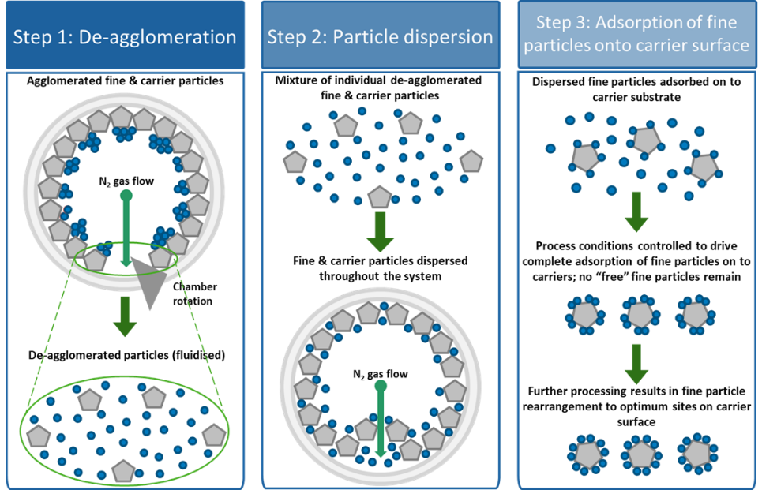

Figure 1. Schematic diagram of the three critical steps in the dry particle coating process

Experimental Materials and Methods
Materials
Micronised fluticasone propionate (FP) (d₅₀ – 2.47 μm ± 0.12 μm) (Sterling S.p.A, Italy) and salmeterol xinafoate (SX) (d₅₀ – 1.73 μm ± 0.03 μm) (Discovery Fine Chemicals, UK) were used as model active pharmaceutical ingredients (APIs). Alpha-lactose monohydrate (Lactohale® 100 (LH100), DFE Pharma, Goch, Germany) and spray-dried mannitol (Pearlitol® 200SD (P200SD), Roquette, Lestrem, France) were used as model carriers in DPI formulations.
Methods
A benchtop iDPC was used to manufacture 1g powder blends of FP and SX (75% ^{w}/_{w}) in LH100 and P200SD, respectively. Formulations were manufactured with iDPC process parameters of 1500rpm rotation speed, 10mins process time and 35L/min nitrogen flow rate. Each blend was tested for content uniformity through assay of 10 micro-samples. Device performance and Aerodynamic Particle Size Distribution (APSD) for each configuration were determined using a Next Generation Impactor (NGI) (Copley Scientific, Nottingham, UK) and high-resistance Monodose RS01 (Berry Healthcare., Milano, Italy) capsule-based systems (Size 0, 2 and 3) at a 4Kpa pressure drop. Aliquots of each blend were manually filled into HPMC capsules (Qualicaps V-I, Qualicaps, Madrid, Spain) to achieve capsule fill volumes of 2%, 25% and 60% (Fill weights are shown in Table 1). 25% and 60% fill weight were selected to represent typical high payload delivery, 2% fill weight was selected to understand the capability of iDPC to reduce lactose load and deliver the required fine particle dose for typical low dose DPI formulations.
Table 1; Fill weights and corresponding capsules used for APSD assessment
Capsule Size | 2% Fill Weight | 25% Fill Weight | 60% Fill Weight
Size 3 | 1.0mg (6) | 12.5mg (4) | 30mg (2)
Size 2 | 1.3mg (6) | 16.4mg (4) | 40mg (2)
Size 0 | 2.4mg (4) | 29.6mg (2) | 71mg (1)

Results and Discussion
The content uniformity of each formulation was measured to be below 5% RSD, indicating that the blends were homogeneous.
The fine particle dose (FPD) from each formulation is recorded in Figure 2 plotted against the capsule fill volume in each of the three capsule/device sizes. For the lactose (LH100) based formulations the FPD increases in a linear manner as fill volume increased for each of the capsule sizes. The FPD is high in all cases for each of the fill volumes. The 60% fill volume had the highest FPD, with the highest performing formulation in a size 0 capsule presenting the opportunity to deliver ~14mg of FP or ~16mg of SX in a single inhalation respectively,
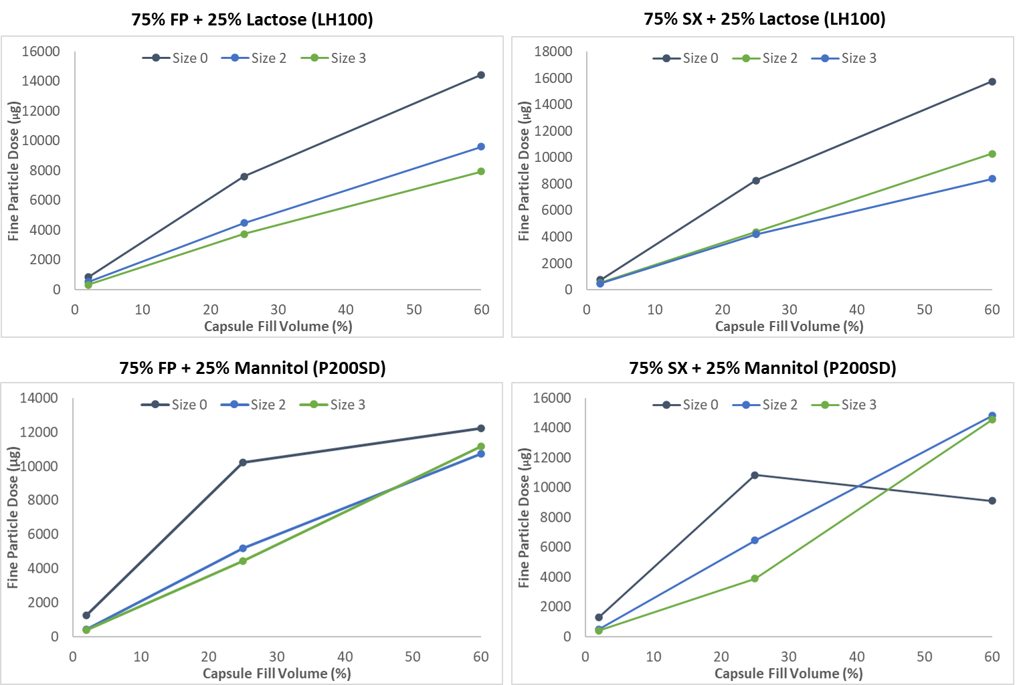
Figure 2. Fine particle dose as a function of capsule fill volume and capsule size
With the mannitol) based formulations, in size 2 and 3 capsules, FPD performance shows a similar trend to the lactose formulations with a relatively linear increase in performance as the fill volume is increased. The FPD is also higher than the corresponding lactose formulation. With SX, the FPD obtained with either capsule size delivers ~15mg at a 60% fill volume. P200SD is a spray dried mannitol grade, with uniform almost spherical particles with a d₅₀~150µm. The uniformity of the mannitol appears to provide an excellent substrate for processing by thin layer fluidisation (iDPC) except at the highest fill volume studied. When delivered in RS01/size 0 capsule combination, the increase in FPD between a 2% and 25% fill volume, does not carry forward to 60% fill volume. At this fill volume a non-linear change in the FPD is seen for both FP and SX formulations. FP delivery is found to plateau and SX deliver actually decreases. This possibly reflects insufficient aerosolisation force at the highest formulation loading to fully disperse the mannitol formulations.
The fine particle fraction (FPF) from the emitted dose of each of the formulations is plotted as a function of capsule fill volume is shown in Figure 3. The first observation is that the iDPC formulations containing 75% API all perform extremely efficiently. The FPF performance with the high concentration lactose formulation shows a clear trend with the FPF of the emitted dose decreasing with increased fill volume. Despite the fact that the FPF remains >50% at all fill volumes for each capsule size, the mass median aerodynamic diameter (MMAD) increases with increasing fill volume (FP from 2.7µm to 5.5µm and SX from 2.7µm to 5.6µm) reflecting that the RS01 delivers slightly less efficient aerosolisation of this API/Carrier powder combination as the fill volume increases, due to a combination of the dispersion force available to aid redispersion within the free space available in the punctured capsule.
In contrast, the FPF performance of the mannitol formulations shows no discernible FPF trend with fill volume or capsule size and is approximately 75% for both FP and SX. This is reflected in consistent performance delivering very fine dispersion of both FP (MMAD ~2.2µm) and SX (MMAD ~2.3µm). This suggests the dispersion forces drawn through the RS01 are sufficient to fully disperse the powder. An interesting observation is that even at the 60% fill volume, high FPF performance (~70% with FP and 60% with SX) is observed even when the FPD is lower than anticipated.
If the lactose and mannitol formulation performance characteristics in RS01 are compared, it appears that the mannitol in this case may provide formulation advantages over the lactose although it should be stressed that none of the formulations studied has been subjected to full optimisation studies that would be required for full product definition.
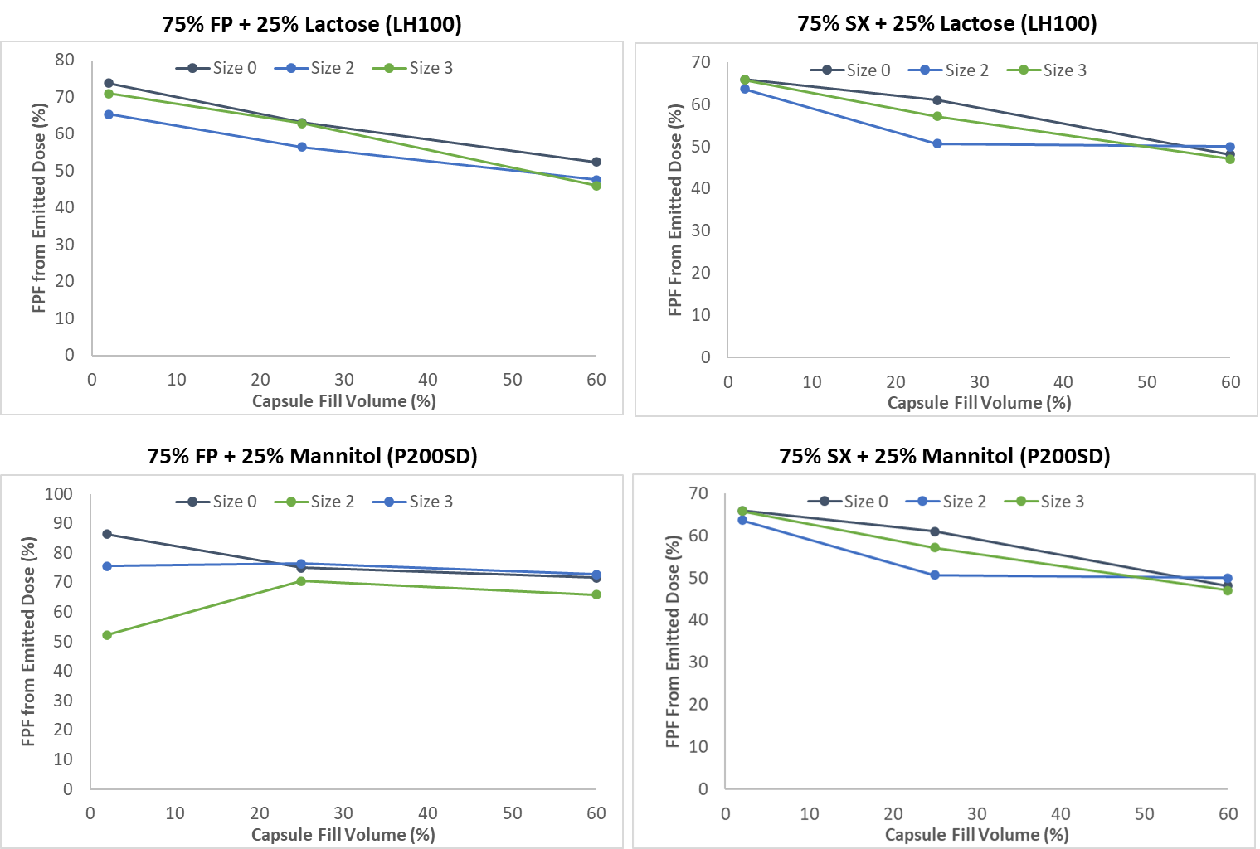
Figure 3: Fine Particle Fraction as a function of capsule fill volume and capsule fill size
Conclusion
This study highlights the capability of iDPC formulation coupled to RS01 to deliver high doses of respirable APIs. Inhaler performance utilising concentrated formulations (75%^{w}/w) of FP and of SX in both lactose (Lactohale® 100) and mannitol (Pearlitol® 200 SD) carriers has been accessed across different capsule fill volumes and capsule sizes. Highly efficient aerosolisation was measured with all combinations studied. This work demonstrates that efficient delivery of APIs can be achieved utilising a proven inhalation device (Monodose RS01), and formulations of conventional micronised APIs and proven inhalation grade carriers processed by isothermal Dry Particle Coating

References
[] Mohammed A R, Dahmash E, Ahmed J, Drew T: Patent WO2016066462A1 Coating apparatus and method. 2016
[2] Scherlieβ R, Eschmann C: DPI formulations for high dose applications – Challenges and opportunities, Int J Pharm 2018; 548 (1): pp49-53.
[3] Hoppentocht M, Hagedoorn P, Frijlink H.W, de Boer A.H: Technological and practical challenges of dry powder inhalers and formulations, Adv Drug Deliv Rev 2014; 75: pp18-31.
[4] Momin M.A.M, Tucker I.G, Das S.C: High dose dry powder inhalers to overcome the challenges of tuberculosis treatment, Int J Pharm 2018; 550 (1-2): pp398-417.
[5] Koner J S, Wyatt D A, Lungare S, Jones R J, Mohammed A R: Extending the Capability of High Dose DPI Formulation Using a New Blending Technology; DDL 2019

