Novel Inhalable Formulations for Targeted Delivery of Antibiotics to the Lung:
A Response to the Global Tuberculosis Commitment

Sharareh Salar-Behazdi^{1,2}, Carolina Corzo¹, Eleonore Fröhlich^{1,3}, Dirk Lochmann⁴, Sebastian Reyer⁴, Andreas Zimmer²

¹Research Center Pharmaceutical Engineering GmbH, Inffeldgasse 13, 8010, Graz, Austria

²Institute of Pharmaceutical Sciences, Department of Pharmaceutical Technology and Biopharmaceutics, University of Graz, Universitätsplatz 3, 8010, Graz, Austria

³Center for Medical Research, Medical University of Graz, Stiftingtalstraße 24, 8010, Graz, Austria

⁴IOI OLEO GmbH, Arthur-Imhausen-Straße 92, 58453, Witten, Germany

Summary
This work is a response to the significant increasing demand on the inhalable antibiotic drugs for efficient localized delivery to the lung. We aimed to engineer safe and novel lipid-microparticles loaded with rifampicin via spray-drying, to be administered as a carrier-free dry powder for inhalation.
Despite the well-known strong technical limitations of spray-drying of lipids, a completely lipid-based formulation was successfully developed, using diglycerol full ester of behenic acid and glyceryl stearate citrate as emulsifier.
Exceptional thermal and solid-state properties of lipid as a homogeneous system with high melting temperature, low super-cooling (ΔT=T_{m}-T_{c}) and absence of polymorphism were the key factors to avoid softening of material during spray drying and to gain a high yield of 83%. The achieved mass median aerodynamic diameter and median geometric size of particles were 2.36 µm and 2.05 µm, respectively. Those properties together with the negative surface (-50.03 mV) of particles were defined as critical factors for deposition in the deep lung and targeted delivery of rifampicin to alveolar macrophages. The fine particle fraction was 79.5%. The in vitro uptake of particles into THP-1 macrophages was confirmed by fluorescence imaging and by determination of the rifampicin content inside the alveolar macrophages. The in vitro safety of particles was confirmed based on cytotoxicity studies on alveolar and bronchial epithelial cells ((A549 and Calu-3 cell lines, respectively), as well as on alveolar macrophages (THP-1 cells).
This study paves the way to extend the use of lipid-based formulations for advanced targeted delivery to the lung.

Key Message
Highly processable lipid-based excipients were used for engineering of advanced lipid-microparticles loaded with rifampicin via spray-drying for targeted delivery to the lung macrophages. This study is the response to the increasing demand on the extension of effective formulations with functionalized materials for localized delivery of antibiotics to the lung.

Introduction
Infectious respiratory diseases, among them tuberculosis (TB), have long had a threatening impact on the global health. According to WHO global report of 2022, TB is still one of the leading causes of death worldwide [1]. Therefore, innovative and patient-driven strategies, such as developing inhalable antibiotics, are of utmost importance for radical improvement of therapeutical regimen and dealing with the ongoing crisis [2]. Targeted delivery of antibiotics to the lung can extremely minimize the patient burden compared to the conventional oral therapy, reduce the severe systemic side effects and improve the bioavailability, due to exclusion of hepatic first-pass effect. The efficient localized delivery of antibiotics to the lung can be achieved by using advanced technology platforms to produce carrier free dry powder for inhalation (DPI), with increased fine particle fraction (FPF) and possibility of particle engineering for deposition in the deep lung [3]. Examples of such successful approaches are the following lipid-based technology platforms available at the market: Arcus®, Pulmosphere®, Technosphere®, Acusphere® and iSPERSE®, among others,
In spite of the evidenced functionality and suitable safety profile of lipid-based excipients (LBEs), only four LBEs are approved by FDA for inhalation: Dipalmitoylphosphatidylcholine (DPPC), distearoylphosphatidylcholine (DSPC), cholesterol, and oleic acid. This is mostly due to the challenging processability of LBEs because of their polymorphic transformation, and existing of heterogeneous phases with low melting minor fractions. Expanding the portfolio of safe and biocompatible excipients such as lipid-based materials, is critical for new developments.

In a previous work, we have shown the advanced behaviour of polyglycerol esters of behenic acid for processing via spray-drying of their solutions in organic solvents [4]. The current work shows the extension of their application towards aqueous-based feedstocks for encapsulation of rifampicin and spray-drying of loaded lipid particles for targeted delivery to the alveolar macrophages [5].

Experimental methods
Materials
Diglycerol full ester of behenic acid, PG2-C22 full (Witepsol® PMF222) was used as LBE. Glyceryl stearate citrate (GSC) (Imwitor®372P) was used as natural lipid-based anionic o/w emulsifier. Both PG2-C22 full and GSC were from IOI OLEO GmbH (Germany). Rifampicin (RIF) was supplied by Olon Active Pharmaceutical Ingredients (India). 1-amino-4-methyl piperazine (Sigma Aldrich, Austria) was used as degradation inhibitor for RIF. A549 cells (Deutsche Sammlung für Mikroorganismen und Zellkulturen GmbH, Germany), Calu-3 cells (LGC Standards GmbH, Germany) and THP-1 human acute monocytic leukemia cells (Cell Line Services, Germany) were used for in vitro cell studies. Oil-Red-O (ORO) was used as a dye for staining the spray-dried particles for the cellular uptake studies.
Methods
Preparation of feed stock and spray drying: A minimum of 2.5% w/w loading of active pharmaceutical ingredient (API) on the matrix was envisaged to reach 1.5 to 3.0 mg of RIF as inhaled daily dose [6].
Feedstock: The lipid phase was prepared by mixing the molten lipid matrix (PG2-C22 full and GSC, with a 1:1 mass ratio) at 80 °C, and adding rifampicin to reach 2.5 % of lipid matrix under continuous stirring. The aqueous phase composing of pre-heated water with 1-amino-4-methyl piperazine (pH 5) was added to the molten lipid phase. The mixture was cooled down to form the aqueous-based suspension as feedstock.
Spray drying: The process was carried out in a Procept 4 M8-Trix (Procept, Belgium), under exclusion of light and using nitrogen as drying and atomizing gas in a closed-loop configuration to avoid the oxidation of rifampicin. The feedstock was atomized through a bi-fluid nozzle of 0.4mm (1.14 bar) at 2 g/min into the spray-drying chamber at inlet temperature (Tin) of 75°C. The gas to liquid ratio (GLR) was screened by varying the atomizing gas flow through the nozzle (mA).
Characterization of spray-dried particles
Powder characterisation: The particle size distribution of spray dried powder was measured via laser diffraction. Bulk and tapped densities were determined using a modified method based on European Pharmacopeia with a PT-TD200 (Pharma Test Apparatebau AG), to calculate the Hausner ratio.
The content uniformity of the powder was determined using a HPLC method as follows: mobile phase was a mixture of 55:45 phosphate buffer 30 mM pH 4.0 and acetonitrile (ACN) at 0.6 ml flow, the column was SunFire C18 (3.5 µm 4.6 × 150 mm) (Waters, USA). The samples were prepared with methanol as diluent. The wavelength of detection was 236 nm. The solid state of the powder was characterised via differential scanning calorimetry (DSC) and small- and wide-angle x-ray diffractometry (SWAXD). The surface charge was measured using a Zetasizer. The morphology of spray dried particles was determined by providing SEM images.
Aerodynamic performance: The in vitro inhalability was assessed using a next generation impactor (NGI, Copley Scientific, United Kingdom). The Aerolizer® was used as dry powder inhaler with hypromellose capsules size 3 (V-Caps®Plus, Capsugel). The NGI stages were coated in advance with an ethanolic solution of Tween 20 (2 %w/w). The air flow of the NGI was adjusted to 60 l/min. A total number of 6 capsules, each filled with 20 mg of powder were released for each experiment. Each capsule was released for 4 seconds. The particles deposited in each stage were collected carefully and the API was detected via HPLC. Emitted fraction, in vitro lung deposition, FPF, mass median aerodynamic diameter (MMAD) and geometric standard deviation (GSD) were obtained according to the European Pharmacopeia.
API retention: The retention of API in the lipid matrix was determined by exposing the spray dried particles to simulated lung fluid (SLF), composed of Dulbecco’s phosphate buffer and 0.02 %w/w DPPC, at 37 °C. Samples were withdrawn in defined intervals during 24 hours to quantify the API via HPLC.
In vitro cytotoxicity: A549 were cultured in DMEM + 10% FBS + 1% P/S and Calu-3 in MEM (with Earlés salts) + 10% FBS + 1% L-Glutamine + 1% P/S + 1 mM sodium pyruvate. 12-well polyethylene polycarbonate Transwell inserts (pore size 0.4 µm, Greiner Bio-one, Austria) were used and cells seeded with a density of 0.25x106 and 0.5x106 for A549 and Calu-3 cells per insert, respectively, as described in [7]. Calu-3 cells were exposed to the samples immediately after reaching a transepithelial electrical resistance (TEER) of at least 300 Ω*cm2. A-549 cells were exposed to samples after 7 days of air–liquid interface (ALI) cultivation [7]. The samples consisted of the spray-dried particles, pure lipid, GSC, and RIF at two concentrations (3 mg RIF as nominal dose and 10 times higher [30 mg]) dispersed in SLF. Cell viability was determined after two hours by quantification of cellular dehydrogenase using CellTiter 96 Aqueous Non-Radioactive Proliferation Assay (Promega, US) [5]. THP-1 cells (Cell Line Services, Germany) were differentiated, using the protocol described in [8]. Samples were dispersed in the medium, consisting of Roswell Park Memorial Institute medium (RPMi, Thermo-Fisher Scientific, US), 10% FBS, 2 mM L-glutamine, and 1% Penicilin. Increasing concentrations of RIF from 0.00014 to 1400 µg/ml were prepared. Spray-dried particles containing the equivalent amount of RIF were dispersed in the same medium. Cells were exposed to a sample of 100 µl of suspension. After 24 h exposure, plasma membrane integrity was evaluated by LDH release and cell viability by ATP content.
Particle uptake by macrophages: Particle uptake by THP-1 macrophages was assessed through the uptake of fluorescently labelled particles via fluorescence microscopy, and by extraction of RIF from the cells, as follows: THP-1 cells were seeded in 6-well plates and exposed for 24 hours to 3 ml of spray-dried particles suspended in RPMI medium with 10% FBS at a RIF concentration of 14 µg/ml equivalent to the highest non-cytotoxic concentration scaled to a cell growth area of 9.6 cm2. Cells were washed, harvested in 300 µl trypsin for 10 min, scrapped down, transferred to a second well, and deep-frozen with 50 µl fresh trypsin. After thawing and removing the cell debris by centrifugation, the API content in supernatant was quantified via HPLC as described above [5].

Results and discussion
The targeted delivery of spray dried particles to the alveolar macrophages can be performed by achieving a MMAD between 1 – 5 µm to ensure the deep lung deposition, a volume median diameter around 2 µm and the negative surface charge of particles to ensure the activation and uptake by macrophages [9]. In this study, a drug loading of 2.5 % was also required to ensure the required dose.
Characteristics of engineered particles: The adjusted ratio of 1:1 between PG2C22 full as lipid and GSC as emulsifier provided an improved solubility of RIF in the lipid matrix and a homogeneous micro-suspension as feedstock. The improved solubility of RIF in lipid matrix, which led to a drug loading of 2.5 %, was confirmed with DSC and SWAXD analyses. The critical spray drying process parameters, i.e., the inlet temperature, GLR ratio, and resulted outlet temperature were adjusted by considering the thermal behaviour of lipid matrix and physical characteristics of feedstock, which resulted in a process yield of 83.0 ± 4.1%. Particles with the MMAD of 2.36 ± 0.19 µm, the zeta potential of − 50.03 ± 0.06 mV, and GSD of 2.03 ± 0.06 could be achieved. The negative surface charge of spray dried particles (− 50.03 ± 0.06 mV) was due to the available carbonyl groups in lipid matrix and the anionic structure of GSC. The FPF was 79.5 ± 13.3 %. The morphologies of spray dried API-loaded lipid matrix and RIF as raw material are depicted in Figure 1a&b.
Figure 1- (a): The SEM image of spray dried lipid matrix loaded with rifampicin. The spherical form with rough morphology of particles is visible. (b): The SEM image of raw rifampicin as received.
b)
a)

Particle uptake by alveolar macrophages: Negatively charged surface and a particle size below 4 µm can trigger the uptake by alveolar macrophages as described in [10]. This characteristic together with the geometric size of 2.03 ± 0.06 resulted in the uptake of particles by THP-1 microphages. The internalization was confirmed based on the fluorescence microscopy images of THP-1 cells after uptake of stained particles as shown in Figure 2a-c, and quantification of internalized encapsulated RIF in the macrophages. A significantly higher uptake of encapsulated RIF was quantified compared to the uptake of RIF as raw API. Additionally, the investigation of the API release from engineered lipid particles in SLF showed negligible API release outside the alveolar macrophages (below 15 %) during 24 hours. These data show the achievement of desired conditions for a targeted delivery of antibiotics to the alveolar macrophages.
In vitro cytotoxicity of engineered particles: The in vitro safety of the spray dried particles was confirmed based on the cytotoxicity studies. The amount of three mg RIF was considered as the nominal dose according to [6]. The A549, Calu-3, and THP-1 cells were exposed to the spray dried particles as well as to each single compound of the formulation equivalent to the nominal dose and 10 times higher for 24 hours. Excipients and spray dried particles had no cytotoxic effect on the cells.
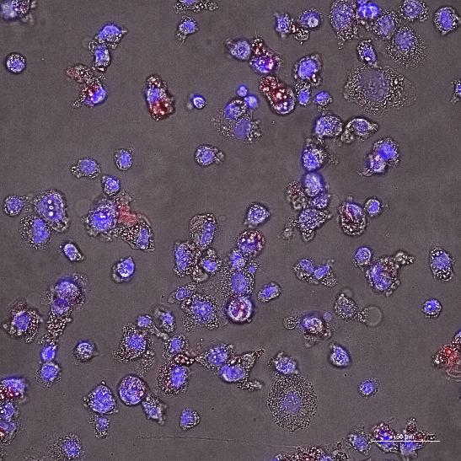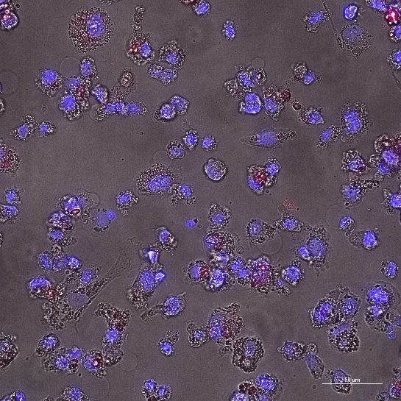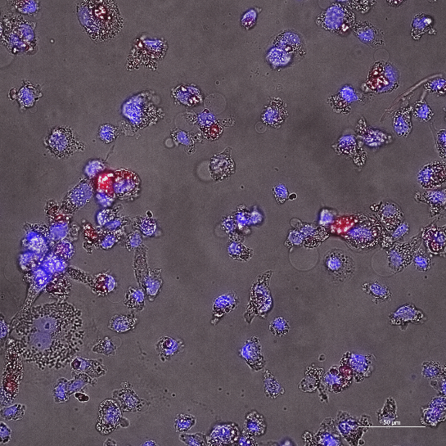
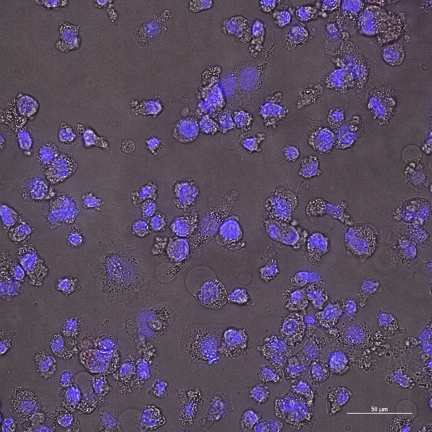
c)
b)
e)
Figure 2- (a - c): THP-1 cells (nuclear stain, blue) after uptake of fluorescence-labelled spray dried API-loaded particles (red), (d) cells without particle exposure, (e) the fluorescence-labelled particles.
d)
a)

Conclusion and outlook
Novel lipid-microparticles loaded with rifampicin were engineered via spray-drying, to be administered as a carrier-free dry powder for inhalation. The safety of engineered particles was determined based on in vitro cytotoxicity studies. The results of this work pave the way for extending the
portfolio of lipid-based excipients for developing effective inhalable antibiotic products.
The next important step of this research work is the investigation of the biodegradation of spray dried particles and the API release inside the macrophages, as the target site of Mycobacterium tuberculosis infection.

Acknowledgement
IOI Oleo GmbH, the Austrian Funding Agency (FFG) and the Doctoral Academy NanoGraz.
References
[] Global tuberculosis report 2022. Geneva: World Health Organization; 2022. Licence: CC BY-NC-SA 3.0 IGO. Access: August 2023.
[2] Li, J., Zheng, H., Leung, S.S.Y. Pulmonary Delivery of Emerging Antibacterials for Bacterial Lung Infections Treatment. Pharm Res 2023; 40: 1057–1072. https://doi.org/10.1007/s11095-022-03379-8
[3] Lechanteur, A., Evrard, B., Influence of composition and spray-drying process parameters on carrier-free DPI properties and behaviors in the lung: A review. Pharmaceutics. 2020; 12 https://doi.org/10.3390/pharmaceutics12010055.
[4] Corzo, C., Fuchsbichler, A., Savencu, I., Afonso Urish, J., Zimmer, A., Salar-Behzadi, S. Lipid-microparticles for pulmonary delivery of active pharmaceutical ingredients: Impact of lipid crystallization on spray-drying processability. Int J Pharm. 2021; 61: 121259, https://doi.org/10.1016/j.ijpharm.2021.121259
[5] Corzo, C., Crvenjak, D., Sotirov, K., Afonso Urich, J., Öhlinger, K., Meindl, C., Lochmann, D., Reyer, S., Fröhlich, E., Zimmer, A., Salar-Behzadi, S., Lipid-based particle engineering via spray-drying for targeted delivery of antibiotics to the lung. Int J Pharm 2023; 642: 123201, https://doi.org/10.1016/j.ijpharm.2023.123201
[6] Katiyar, S., Bihari, S., Prakash, S., Low-dose inhaled versus standard dose oral form of anti-tubercular drugs: Concentrations in bronchial epithelial lining fluid, alveolar macrophage and serum. J Postgrad Med. 2008; 54, 3. https://doi.org/10.4103/0022- 3859.41823
[7] Corzo, C., Meindl, C., Lochmann, D., Reyer, S., Salar-Behzadi, S. Novel approach for overcoming the stability challenges of lipid-based excipients. Part 3: Application of polyglycerol esters of fatty acids for the next generation of solid lipid nanoparticles. Eur J Pharm Biopharm 2020; 152. doi: 10.1016/j. ejpb.2020.04.027.
[8] Steiner, V., Öhlinger, K., Corzo, C., Salar-Behzadi, S., Fröhlich, E. Cytotoxicity screening of emulsifiers for pulmonary application of lipid nanoparticles. Eur J Pharm Sci. 2019; 136 https://doi.org/10.1016/j. ejps.2019.104968.
[9] Lawlor, C., Kelly, C., O’Leary S., O’Sullivan, M.P., Keane, J., Cryan, S.A., Cellular targeting and trafficking of drug delivery systems for the prevention and treatment of MTb. Tuberculosis 2011; 91: 93-97. https://doi.org/10.1016/j.tube.2010.12.001

