Pulmonary delivery of Lactobacillus rhamnosus GG with vibrating mesh and jet nebulisers

Alex Seungyeon Byun¹, Luis Vitetta¹, Hak-Kim Chan¹ & Philip Chi Lip Kwok¹

¹School of Pharmacy, Faculty of Medicine and Health, The University of Sydney, New South Wales 2006, Australia

Summary
Probiotics are commonly used to improve gastrointestinal symptoms and maintain health. Studies have frequently demonstrated the positive effects that oral probiotics exert not only in the gastrointestinal tract but also the respiratory tract. There is sufficient evidence to support that oral probiotics can reduce the incidence and severity of upper respiratory tract infections, thereby reducing antimicrobial use. In the past decade, some animal studies have examined the effects of intranasal probiotics on the respiratory tract, but nebulised probiotics have not yet to be explored. Therefore, this study compared the dose output and aerosol performance of probiotics nebulised from vibrating mesh and jet nebulisers. The vibrating mesh nebuliser (VMN) consistently produced a higher output than the jet nebuliser (JN) for Lactobacillus rhamnosus GG in both phosphate-buffered saline (PBS) and normal saline (0.9% w/v sodium chloride in water) at 23.18 ± 0.99% and 10.43 ± 3.99%, respectively. For both nebulisers, probiotic in PBS outperformed its saline counterpart. A similar trend was observed with the fine particle fraction as it was higher for PBS (12.95 ± 0.96% for VMN; 11.21 ± 0.18% for JN) than normal saline (7.51 ± 2.01% for VMN; 7.03 ± 2.48% for JN) for both nebulisers, suggesting that aerosol performance of nebulised probiotics may also depend on the medium in which the probiotics were suspended in. Therefore, this study demonstrated that the type of nebuliser as well as the vehicle of the probiotic suspension affected the effectiveness of nebulisation.

Key Message
The type of nebuliser and the medium in which Lactobacillus rhamnosus GG was suspended determined the effectiveness of nebulisation. L. rhamnosus GG suspended in phosphate-buffered saline nebulised using a vibrating mesh nebuliser produced the highest output and fine particle fraction.

Introduction
Probiotics are microorganisms that confer health benefits. They have been widely used for maintaining gut health, but recent research has found that their benefits are not only limited to the gut [1]. Common genera of probiotics include Lactobacillus, Bifidobacterium, and Strepcococcus that have been reported to impose favourable effects against upper respiratory infections (URI) in animals [2,3] and humans [4,5]. The Cochrane systematic review concluded that there were moderate-certainty of evidence that oral delivery of probiotics is likely to reduce the number of participants diagnosed with URI and was likely to reduce the number of participants needing antibiotics for URI [6]. Although not highlighted, the probiotics used in the analysed studies in the systematic review [6] were all given orally. A comparison of the oral and intranasal routes of administration in mice [2,3] demonstrated that intranasal probiotics resulted in higher survival rates after influenza infection [2] and promoted a more effective clearance of the influenza virus [3]. Direct administration into the respiratory tract is non-invasive and may produce a faster onset of therapeutic action. Despite its advantages, the respiratory route is underexplored for the administration of probiotics. Nebulisation is a method of choice for pulmonary delivery in the clinical setting as it is easy to operate, able to deliver large doses, and can be inhaled by tidal breathing. Nebulisation of biological materials such as bacteriophages showed that the choice of the nebuliser is crucial in minimising titre reduction [7]. Therefore, this study compared the effectiveness of a VMN and a JN in delivering a commonly used probiotic species, L. rhamnosus GG. This is the first published study that examined the nebulisation of a probiotic bacterium.

Materials and Methods
Probiotic Culture
Lactobacillus rhamnosus GG (reference strain ATCC 53103) (LGG) suspension was prepared by incubating LGG colonies in de Man Rogosa Sharpe (MRS) broth at 37°C in 5% CO₂ for 24-48 hours. Colony forming units (CFU)/mL was determined by counting the colonies after plating out serial dilutions of the suspension onto MRS agar plates. The suspension was then adjusted to 4 x10⁸ CFU/mL in phosphate-buffered saline (PBS) or normal saline (0.9% w/v sodium chloride in water) so that the nebulisation volume of 2.5 mL contained 10⁹ CFU of LGG.
Dose Output
An Aerogen® Solo nebuliser (serial number: C191059-0565, Aerogen, Galway, Ireland) coupled to an Aerogen® Ultra aerosol chamber and a Pari LC Sprint® jet nebuliser (Part Respiratory Equipment, Inc., Midlothian, VA, USA) coupled to a Pari Boy SX compressor (Pari GmbH, Starnberg, Germany) were used for the nebulisation experiments. The dose output of LGG suspensions from the Aerogen nebuliser were collected by connecting SureGard® filters (Bird Healthcare, Bayswater, VIC, Australia) as shown by Tai et al [8]. The jet nebuliser was setup in a similar way, with a filter at the exhaust, and another filter at the mouthpiece (output) connected with a silicon adaptor. The experimental procedure followed the United States Pharmacopeial (USP) method, but the filters were not changed to avoid losing the probiotic dose. A PWG-33 breathing simulator (Piston Medical, Budapest, Hungary) was connected to the output filter to produce a sinusoidal breathing pattern at 15 cycles/minute, with a 1:1 inhalation-to-exhalation ratio and a tidal volume of 500 mL. The output filter captured the droplets during inhalation and the exhaust filters captured them during exhalation. Two and a half millilitres of the probiotic suspension were pipetted into the nebuliser. The nebuliser was then operated until no more droplets were produced from the VMN or until sputtering from the jet nebuliser. The experimental setup was left to stand for 20 minutes after nebulisation was complete to allow the droplets to settle in the nebuliser and filters before dismantling the setup. The openings of all filters were sealed with Parafilm after adding 10 mL of PBS. The filters were rinsed by shaking for 1 minute. The Aerogen Solo nebuliser was rinsed with PBS and the rinsing was collected and topped up in a 10 mL volumetric flask. The Aerogen Ultra aerosol chamber was rinsed by sealing the openings with Parafilm after adding approximately 10 mL of PBS. For the jet nebuliser, the Pari LC Sprint nebuliser was rinsed with PBS and the rinsing was collected and topped up in a 25 mL volumetric flask. Other parts were rinsed with 10 mL of PBS. This process was repeated until the rinsing was collected and topped up in a 50 mL volumetric flask. The samples were serially diluted then plated out on MRS agar plates and incubated at 37°C in 5% CO₂ for 24-48 hours to determine the CFU/mL.
Cascade Impaction
The aerosol performance of nebulised LGG was measured by the USP method using a Next Generation Impactor (NGI; USP Apparatus 5; Copley, Nottingham, UK) without a pre-separator (11). The NGI and throat were cooled at 4°C for at least 90 minutes before the experiment. A SureGard filter was connected to the NGI after the micro-orifice collector to capture droplets that may have passed beyond it. A vacuum leak test was performed to check the sealing of the apparatus before use. Two and a half millilitres of the probiotic suspension were added into the nebuliser. An airflow rate of 15 L/min through the NGI was generated by a vacuum pump. The duration of nebulisation was the same as that of the dose output runs. The nebulisers were assayed using the same method as that for dose output. The throat, impactor stages, and filter were assayed with 10 mL, 4 mL, and 4 mL of PBS, respectively. The CFU/mL was determined using the same method as dose output.
Results and Discussion
Dose Output
The deposition of nebulised LGG in the dose output experiments differed between the two nebulisers due to structural and mechanistic differences (Figure 1). For both nebulisers, the doses collected at the exhaust filters were minimal indicating that the dose exiting the nebuliser during the exhalation cycle was very low. The aerosols released into the environment during nebulisation could be of concern especially if the duration of nebulisation is long [7]. In another study which nebulised albuterol sulfate, the VMN achieved a higher inhaled dose but a lower dose released into the environment compared to the a jet nebuliser [7]. A similar trend was observed in this study with the exhaust filters of the VMN collecting a lower recovered dose for both PBS and normal saline (0.22 ± 0.43% and 0.33 ± 0.20%, respectively) compared to that of the jet nebuliser (13.31 ± 2.68% and 8.83 ± 1.54%, respectively). Hence, the potential contamination of the environment by VM nebulised probiotics may be minimal.
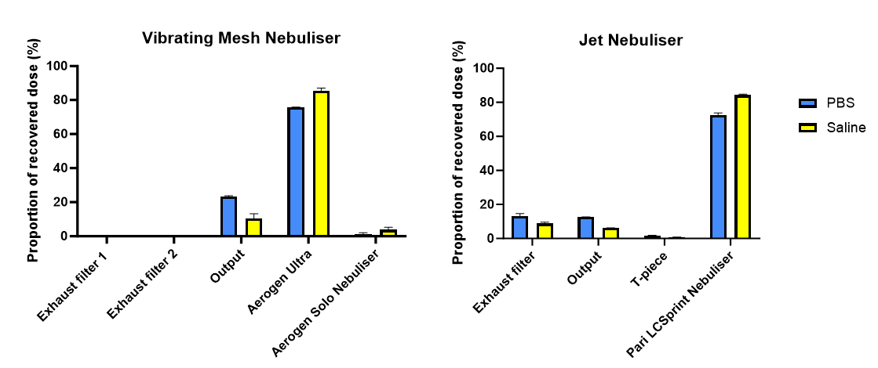
Figure 1 – Deposition of nebulised LGG from the dose output experiments (n = 2 ± standard error).

For the VMN, the majority of the dose was collected in the output filter and Aerogen® Ultra aerosol chamber, similar to the findings by Tai et al [8]. Between the nebulisers, the VMN produced a higher output for both PBS and normal saline. A similar observation was reported in Carrigy et al. [7], where the delivered dose with respect to the loaded dose of VM nebulised bacteriophage D29 in isotonic saline was higher than that by jet nebulisation (39.7% vs 0.012%). JN produce droplets using pressurised air. The smaller droplets between 1-5 µm are emitted and inhaled but the larger droplets impact onto the baffle in the nebuliser and are recycled [10]. The constant impaction and shear impart physical stress to the bacteriophages, leading to structural changes that markedly decreased the viable bacteriophage output [7]. As probiotics are also microbes, the shearing stress can negatively affect the titre or even result in changes to its biological function. In fact, the recovery of LGG in normal saline decreased after nebulisation, with the jet nebuliser at 73.33 ± 2.48% and VM nebuliser at 87.71 ± 9.42%. Interestingly, when LGG was suspended in PBS, the recovered dose was higher than the loaded dose for both nebulisers (VM nebuliser 193.37 ± 15.53%; jet nebuliser 112.96 ± 12.29%). A similar observation was reported by Su et al. [11] as the viability of LGG increased to approximately 135% after atomisation during spray-drying. Although it is yet to be confirmed, the chain arrangement between Lactobacilli bacterial cells may have been disturbed by nebulisation, resulting in a higher CFU/mL. Furthermore, LGG, being a Gram-positive bacterium, may be more stable in PBS than normal saline as Gram-positive species had higher survivability in PBS than in sterile water over 4 weeks [12]. Consequently, the output of LGG suspended PBS was higher than that in normal saline (Figure 1).

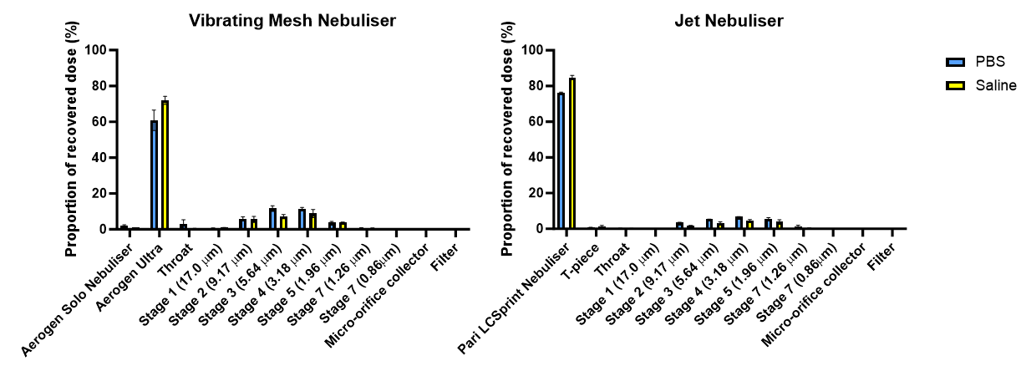
Figure 2 – Deposition of nebulised LGG from the cascade impaction experiments (n = 2 ± standard error).

Cascade Impaction
Similar to the distribution of nebulised probiotics in the dose output runs, the majority of the dose was recovered in the aerosol chamber of the VMN and the nebuliser of the JN (Figure 2). The VM nebulised fine particle fraction (FPF) < 5 µm for PBS was higher than that for normal saline (12.95 ± 0.96% vs 7.51 ± 2.01%). The same trend was observed in the jet nebulised FPF for PBS and normal saline (11.21 ± 0.18% vs 7.03 ± 2.48%). These FPFs were lower than those of nebulised bacteriophages despite being nebulised by the same nebulisers as those in the current study [13]. The reason for the low FPFs of LGG was due to the majority of the dose being retained in the aerosol chamber of the VMN. This may be due to the mass of Lactobacilli bacterial cells being 10 to 100 times higher than that of a bacteriophage. Hence, despite the vacuum pump, the weight of the nebulised probiotic droplet may have been too heavy and became trapped in the body due to gravity. However, a FPF of 10% of the loaded dose (10⁹ CFU) is equivalent to a fine particle dose of 10⁸ CFU, which is within the dose range commonly used in animal studies on intranasal probiotics against URIs [2,3]. Therefore, the nebulised dose output and aerosol performance achieved in the current study are still relevant.
Conclusion
The effectiveness of nebulisation of probiotics depended on the nebuliser type as the VMN produced a higher dose output than the JN. Additionally, LGG in PBS resulted in higher FPFs than those in normal saline, suggesting that the probiotic medium also affected the effectiveness of nebulisation.

References
[1] Markowiak P, Slizewska K: Effects of probiotics, prebiotics and synbiotics on human health, Nutrients 2017; 9: 9: pp 1021.
[2] Youn H, Lee D, Lee Y, Park J, Yuk S, Yang S, Lee H, Woo S, Kim H, Lee J, Park S, Choi I, Song C: Intranasal administration of live Lactobacillus species facilitates protection against influenza virus infections in mice, Antivir Res 2012; 93: 1: pp 138-43.
[3] Park M, Ngo V, Kwon Y, Lee Y, Yoo S, Cho Y, Hong S, Hwang H, Ko E, Jung Y, Moon D, Jeong E, Kim M, Lee Y, Jang J, Oh J, Kim C, Kang S: Lactobacillus plantarum DK119 as a probiotic confers protection against influenza virus by modulating innnate immunity, PLoS ONE 2013; 8: 10: e75368; DOI: 10.1371/journal.pone.0075368 (online only)
[4] Tran D, Tran T, Phung T, Bui H, Nguyen P, Vu T, Ngo T, Nguyen M, Nguyen A, Nguyen A: Nasal-spraying Bacillus spores as an effective symptomatic treatment for children with acute respiratory syncytial virus infection, Sci Rep 2022; 12: pp 12402.
[5] Lee C, Choi Y, Seo S, Kim S, Kim I, Kim S, Lee S, Lee S: Addition of probiotics to antibiotics improves the clinical course of pneumonia in young people without comorbidities: a randomised controlled trial, Sci Rep 2021; 11: pp 926.
[6] Zhao Y, Dong B, Hao Q: Probiotics for preventing acute upper respiratory tract infection, Cochrane Database Syst Rev, 2022; 8: CD006895; DOI: 1 0.1002/14651858.CD006895.pub4 (online only).
[7] Carrigy N, Chang R, Leung S, Harrison M, Petrova Z, Pope W, Hatfull G, Britton W, Chan H, Sauvageau D, Finlay W, Vehring R: Anti-tuberculosis bacteriophage D29 delivery with a vibrating mesh nebuliser, jet nebuliser, and soft mist inhaler, Pharm Res 2017; 34: 10: pp 2084-2096.
[8] Tai W, Chow M, Chang R, Tang P, Gonda I, MacArthur R, Chan H, Kwok P: Nebulised isotonic hydrochloroquine aerosols for potential treatment of COVID-19, Pharmaceutics 2021; 13: 8: 1260. DOI: 10.3390/pharmaceutics13081260 (online only).
[9] McGrath J, O’Sullivan A, Bennett G, O’Toole C, Joyce M, Byrne M, MacLoughlin R: Investigation of the quality of exhaled aerosols released into the environment during nebulisation, Pharmaceutics 2019; 11020075. DOI:10.3390/pharmaceutics11020075
[10] O’Callaghan C, Barry P: The science of nebulised drug delivery, Thorax 1997; 52 (Suppl 2): S31-S44.
[11] Su Y, Zheng X, Zhao Q, Fu N, Xiong H, Wu W, Chen X: Spray drying of Lactobacillus rhamnosus GG with calcium-containing protectant for enhanced viability, Powder Technol 2019; 358: pp 87-94.
[12] Liao C, Shollenberger L: Survivability and long-term preservation of bacteria in water and in phosphate buffered saline, Lett Appl Microbiol 2003; 37: pp 45-50.
[13] Lin Y, Chang R, Britton W, Morales S, Kutter E, Chan H: Synergy of nebulised phage PEV20 and ciprofloxacin combination against Pseudomonas aeruginosa, Int J Pharm 2018; 551: pp 158-165.

