Developing a Combined Calu-3 Barrier and Smooth Muscle Model of the Airways Utilising a Perfused Microphysiological System

Adeel A. Ahmed¹, Emily L. Richardson², Tomasz Kostrzewski² & Darragh Murnane¹

¹University of Hertfordshire, Hatfield, AL10 9AB, UK

²CN Bio Innovations Limited, Cambridge, CB4 0WN, UK
Summary
Successfully incorporating medium perfusion into the standard insert-based air-liquid (ALI) Calu-3 model has resulted in a more physiologically representative pre-clinical In-Vitro model. The perfusion led to a tight epithelial monolayer working as an effective barrier to paracellular permeability and was maintained for up to 28 days. This tight barrier was established 7 days quicker than the static equivalent. qPCR analysis showed an increase in ZO1 and Claudin-1 expression in the perfused model between days 7 and day 14, showing barrier formation was still occurring between the two timepoints. Using immunofluorescent staining, ZO1 was also shown to be significantly increased in expression in the perfused model at day 7 compared to the static model. Significantly, at day 7 the expression of the OCT1 cation transporter was greater in the perfused model than in the static model. Concurrently, airway smooth muscle cells were cultured in the basolateral face of an insert membrane to examine the feasibility of a micro-physiological airways tissue co-culture model. Cell population expansion and functionality was demonstrated using alpha-smooth muscle actin staining with microscopy revealing the formation of a differentiated smooth muscle architecture. Culturing Calu-3 under perfused conditions resulted in faster formation of a permeability barrier than static. Furthermore, bronchial smooth muscle cells were successfully cultured on both the underside of the insert and the base of the well plate. Together, the construction of these models will allow more advanced and predictive models suitable for bioavailability studies and disease modelling.
Key Message
Perfusion using a microphysiological system led to a more physiologically relevant In-Vitro airway model faster than traditional static insert-based ALI models. This can lead to higher throughput and create a more efficient model for the evaluation of inhaled drug candidates, hence potentially reducing the need for exploratory animal studies. Successful culture of smooth muscle cells on the underside of a Transwell leads to exciting new avenues of co-culture for a more complex and dynamic In-Vitro model than the traditional 2D cell culture.
Introduction
Producing physiologically relevant In-Vitro models for pre-clinical pulmonary drug assessment is an area of continuing advancement and improvement. Microphysiological models (MPS), also known as organ-on-a-chip (OOC), have essential features for modelling the In-Vivo micro-environment such as: micro-fluidic channels and mimicry of organ-specific tissue architecture.[1,2] The CN Bio PhysioMimix® MPS consists of an insert-based plate which contains microfluidic pumps within each well. The action of the microfluidic pumps cause perfusion of media around the basolateral side of the well, circulating nutrients, oxygen and chemicals and induces shear stress on cells as they would experience in the human body. Models of the lung epithelium are grown at an air-liquid interface (ALI) with media in the basal chamber with the apical cells surface exposed to air. Calu-3 models in ALI exhibit characteristics of differentiated, functional human epithelia [3]. ALI models have proven importance of the epithelial barrier for permeability and maintenance of apical-basal cell polarity.[4] Organic Cation Transporter (OCT) subtypes seen in Calu-3 are the same as seen on the apical side of normal human bronchial epithelial (NHBE) cell layers. These OCT subtypes have been suggested to facilitate the transport of salbutamol and other cationic inhaled bronchodilators.[5]
Current pre-clinical models that adopt a co-culture of smooth muscle and epithelium cells lack the direct crosstalk between the two cell types. Typically, these models are not grown together in culture. They are grown for the specific assay duration rather than during epithelial differentiation. These models are grown with the epithelium on the insert and the smooth muscle on the baseplate.[6,7] By growing the cell types together under perfused conditions, more physiologically relevant tissue can be developed through crosstalk between cell types and increased nutrient availability. In turn, this could lead to the development of a more powerful pre-clinical model with more complexity and physiological relevance. This paper will explore the effect of perfusion in the basal chamber on a Calu-3 model grown at ALI on a Transwell® support. The model will be characterised and compared to a static model and functionality of the model will be explored. The movement of small molecules will be highlighted to qualify the Calu-3 MPS model as a barrier model for pulmonary drug exposure. We will also explore the opportunities of culturing Primary Bronchial Smooth Muscle Cells (BSmCs) on the underside of a Transwell membrane.
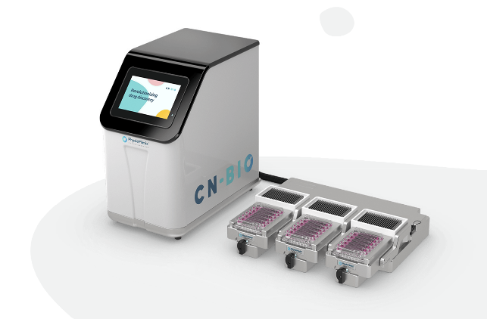
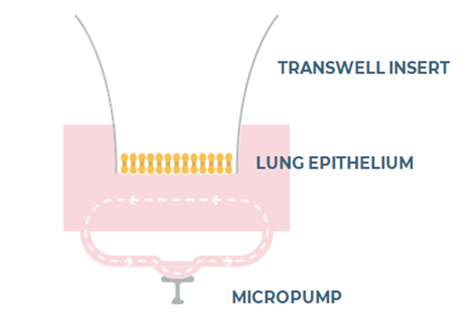
Methods
Calu-3 cells (Passage 24) were seeded at a density of 5 x10⁵ cells/cm² in 200 μL cell media on the apical compartment of a Collagen Coated (Rat Tail Type 1) 24-well 0.4-μm pore polycarbonate Transwells (Corning Incorporated, USA). 600 μL of cell media in the basal compartment. The medium used was DMEM/F12 (Thermo-Fisher, USA) supplemented with 1% Glutamax (Thermo-Fisher, USA), 1% Penicillin/Streptomycin (Thermo-Fisher, USA) and 1% Non-Essential Amino Acids (Thermo-Fisher, USA). The Transwells were placed in the static 24 well plate (Corning, USA) in or in the MPS Barrier PhysioMimix plate (CN Bio Innovations, UK, Figure 1). The flow rate was set at 0.5 μL/s with 600 μL of DMEM/F12 media in the basal chamber for the perfusion plate. After 48 h post seeding, the apical media was removed, and the Calu-3 cells raised to ALI. Every 2-3 days, Trans-Epithelial Electrical Resistance (TEER) measurement was taken with basal media changes. At days 7,14, 21 and 28 the cells were measured for apparent permeability (Papp) using sodium fluorescein (NaFL) (Sigma-Aldrich, UK), where 200 µL of 10 µg/mL NaFL in Reagent A (HBSS + 2.5% D-glucose + 1% HEPES buffer) was added to the apical compartment and 50 µL samples were taken in triplicate from the basolateral compartment containing 750 µL Reagent A before the chamber was replenished with 150 µL Reagent A. Samples were taken at 30, 60, 120 and 180 min. Samples were run on FLx800 Fluorescence Microplate Reader (Bio Tek, USA) at excitation 490 nm and emission 515 nm. Samples were quantified using a calibration curve of NaFL from 10 µg/mL to 10 ng/mL. Cells were fixed in 4% PFA for immunohistochemistry (IHC) staining of DNA (Hoechst 33342) ZO-1 tight junction protein (Alexa Fluor 488) and MUC5AC mucin (Alexa Fluor 594). Samples were imaged using the Axio Imager M2 microscope (Carl Zeiss, Germany) processed using the ZEN Lite software (Carl Zeiss, Germany). Images were taken as a Z-stack with 15 slices (1.78 µm) across 26.74 µm distance. The images were then compiled into a single image. This imaging was performed on all three channels to then compile all 3 images into a single merged image. Additionally, samples were taken at these timepoints for quantitative polymerase chain reaction (qPCR) and mucus quantification.
A
B
Figure 1: (A) Schematic of the fluid flow in a single well in the perfusion plate. (B) The PhysioMimix MPS system, with controller, docking station and drivers depicted.
Primary Bronchial Smooth Muscle cells (BSmC) (Lonza, UK) were seeded at 3 densities (3,000, 15,000 and 30,000 cells/well) on the basolateral face of the Transwell insert membrane and on the baseplate of the Transwell insert plates. CytoTox 96® Non-Radioactive Cytotoxicity Assay (Promega, UK) to monitor cell stress/death and CellTiter-Glo® Luminescent Cell Viability Assay (Promega, UK) was used to evaluate cell health. At day 7, the cells were fixed and stained with Hoechst 33342 rabbit alpha-smooth muscle actin (Alex Fluoro 488) (Sigma, UK) and TRITC Phalloidin (Sigma, UK).
Results
TEER measurements were used to determine barrier integrity of the Calu-3 monolayer in the perfused and static condition. Across all timepoints, the perfused model had a lower TEER measurement than the static model (Figure 3A). However, the trend in the measurements were the same across 28 days for both the static and perfused. The lower TEER measurements would indicate a more permeable barrier. However, this was not the case as shown in Apparent Permeability (Papp) values (Figure 3B). The Papp for the perfused model was significantly lower than the static model at day 7 showing a more functional formation of tight junctions in the perfused model despite the lower TEER values at day 7. By day 14, the static model has formed a similarly tight barrier (Figure 3B). The perfused and static model maintain the tight tissue barrier from day 7 until day 28 with similar increases in Papp between the timepoints.
qPCR showed no significant differences in ZO1 tight junction expression and MUC5AC mucin expression between the two models. However, there was a significantly higher cation transport OCT1 expression in the perfused model showing a significant difference in differentiation at day 7 in the perfused condition (Figure 3C and 3D). Immunofluorescence (IF) exhibited a higher ZO1 tight junction intensity in the perfused model (Figure 2A) than the static model (Figure 2B) at day 7, supporting the evidence of a more functional barrier in the perfused model than in the static model. The images also show the differences in morphology of the two models after just 7 days. The perfused model shows a tighter more cohesive monolayer of cells whereas the static model presents a tissue formation with more patches of cells as is typical of Calu-3 cells. These patches also have more distance between the top and the bottom of the cell layer and the mucus production is localised to around these patches. The perfused model shows a more even spread of mucin across the tissue.
By day 7, all wells reached 100% confluency and there is a significant increase in the quantity of cells in the baseplate-seeded compared to the Transwell basolateral-seeded cells at each density (Figure 4A). However, there was no significant difference in the metabolic activity of cells seeded at different densities on the baseplate nor between different seeding densities of cells on the basolateral face of the insert membrane. The higher metabolic activity of the baseplate compared to insert configuration is attributed to a larger surface area on the baseplate (1.9 cm²) compared to the Transwell (0.33 cm²), leading to an understandably higher cell number and consequently higher mitochondrial activity. The cells appeared to be more stressed in the higher densities, especially 30K seeding density compared to the 3K seeding density as indicated by the normalised LDH values in Figure 4D. This may be due to the higher seeding densities reaching confluency before the 3K seeding density resulting in some cells reaching the death phase of their cycle, releasing more LDH. This trend of increasing LDH release was seen in the Transwell seeded BSmC for 30K and 15K seeded cells across the 7 days (Figure 4B).
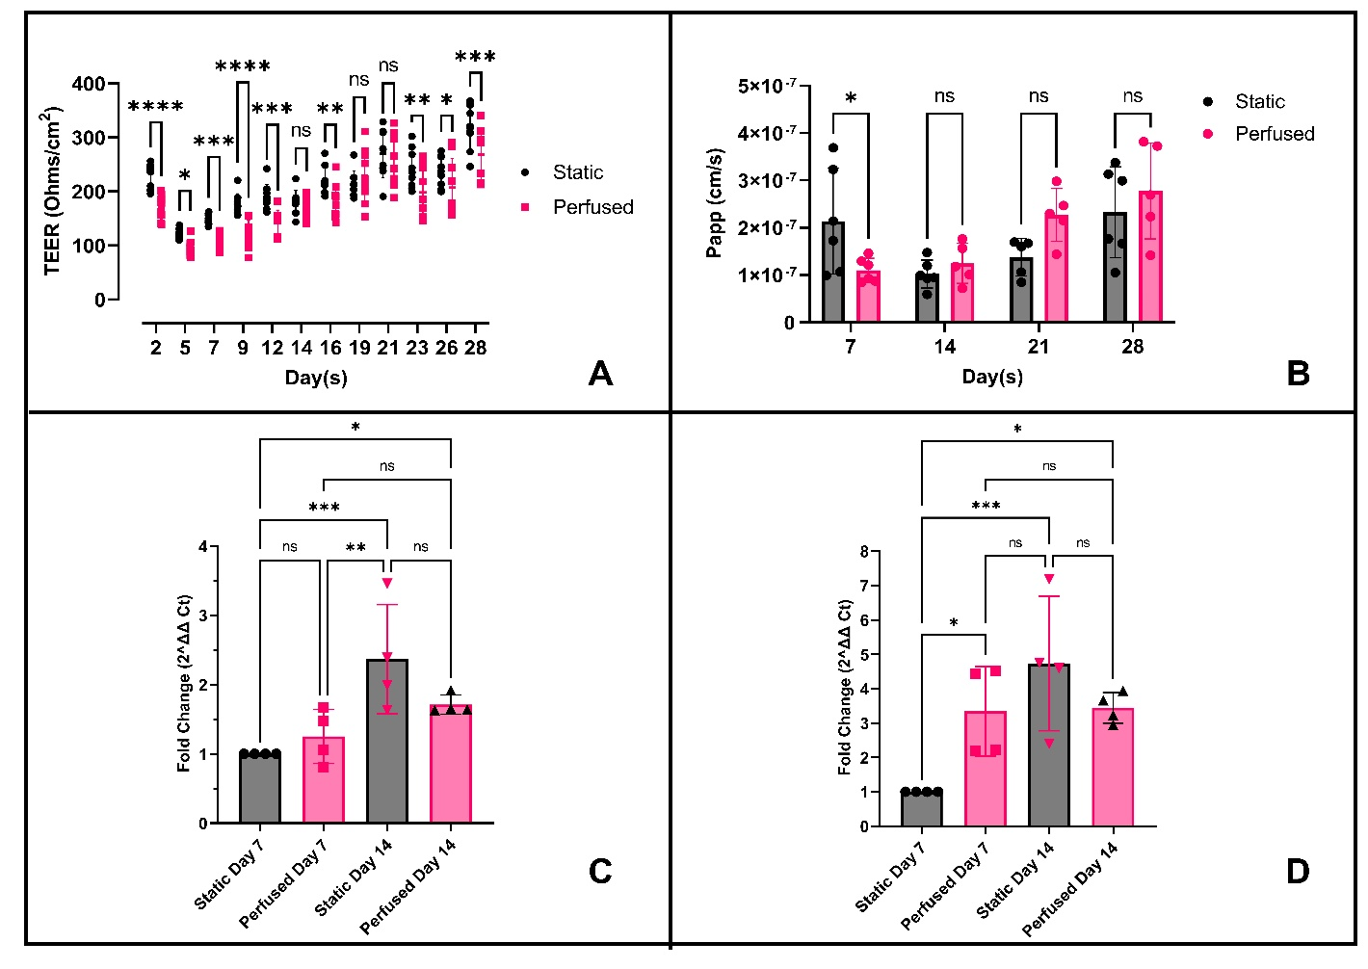
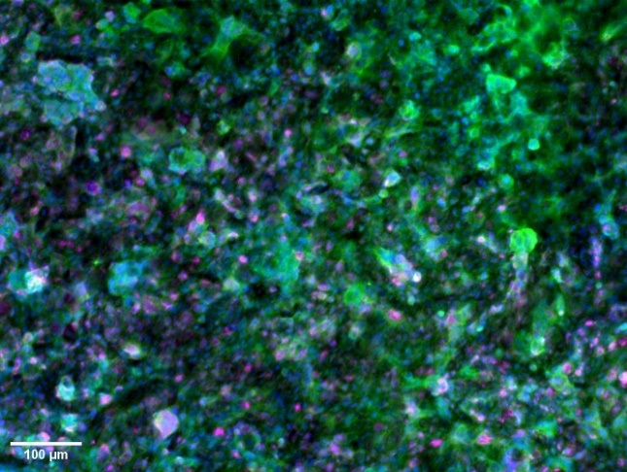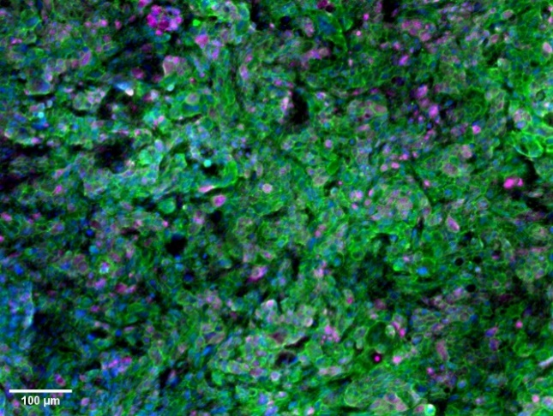
Figure 3: Calu-3 cells form a differentiated barrier tissue more efficiently compared to static cultured cells. (A) Comparing the Transepithelial Electrical Resistance (TEER) measurement of the Calu-3 cell in the static and perfused model across 28 days. (B) Apparent Permeability (Papp) of the static and perfused models using Sodium Fluorescein (NaFL) every 7 days. (C) Fold expression of the ZO1 gene. (D) and the OCT1 gene in the Calu-3 monolayers in the static and perfused model on days 7 and 14 compared to Calu-3 static model at Day 7 (2^{-ΔΔCt}).

Figure 2: Perfusion enhances Calu-3 barrier formation. Day 7 images at x10 objective of the Calu-3 cell monolayer on a Transwell insert membrane in the perfused model (A) and static model (B) showing ZO1 protein (green), MUC5AC mucin (magenta) and DNA (blue) Scale = 100 µm.

B
A

Immunofluorescence (IF) imaging was performed using alpha-smooth muscle actin (α-SMA) as a positive marker for smooth muscle (Figure 5). α-SMA was present in all seeding densities and on both the Transwell and baseplate configurations. Interestingly, there was a significantly higher intensity of α-SMA in the 3K seeded BSmC on the Transwell than the other densities. This significance was not seen in the baseplate. This could imply that the 3,000 cells/well density resulted in the most functionally active smooth muscle cells seeded on the basolateral face of a Transwell insert.
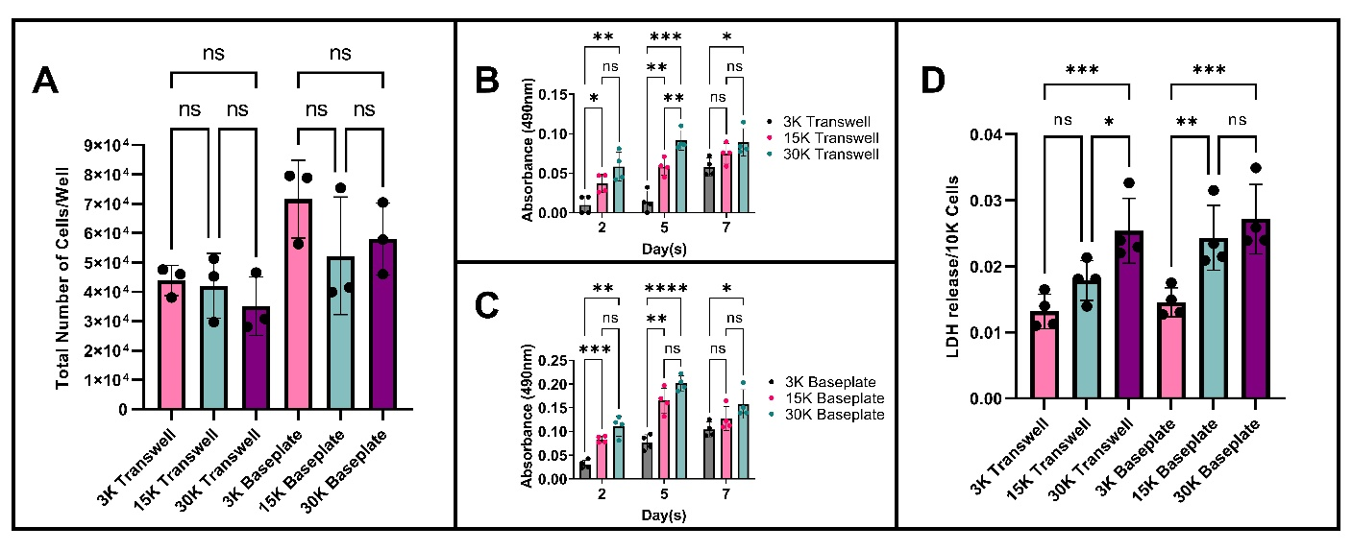
Conclusions
The use of MPS has led to a faster formation of the Calu-3 epithelial model and maintains the barrier functionality over 28 days for use in the assessment of pre-clinical drug compounds. Successfully seeding smooth muscle cells on the basolateral face of a Transwell insert leads to avenues of incorporating smooth muscle cells in this model to create a more complex model for the assessment of efficacy and pharmacodynamics of drug compounds. Incorporating this complex model in a perfusion system such as CN Bio’s PhysioMimix MPS could add a whole layer of physiological complexity, whilst reducing time restrictions, to produce more clinically relevant data for translation into In-Vivo assessment of drugs.
Figure 5: BSmC form a confluent layer with higher expression of key functionality markers when seeded on Transwell membranes. (A) Immunofluorescent (IF) images of the BSmC on the Transwell and the baseplate (B) at 3,000 cells/well. Stained for alpha-Smooth Muscle Actin (green), Actin (red) and DNA (Blue). Scale bar=100 µm.
Figure 4: Smooth muscle cells optimally seed at 3,000 cells per well. (A) The number of metabolically active cells was calculated using the Cell Titre Glo Assay. (B) LDH release was used as a marker for cell stress at days 2,5 and 7. Raw values shown for the Transwell seeded and (C) the baseplate seeded. (D) Normalised LDH release per 10,000 cells as calculated in (A).

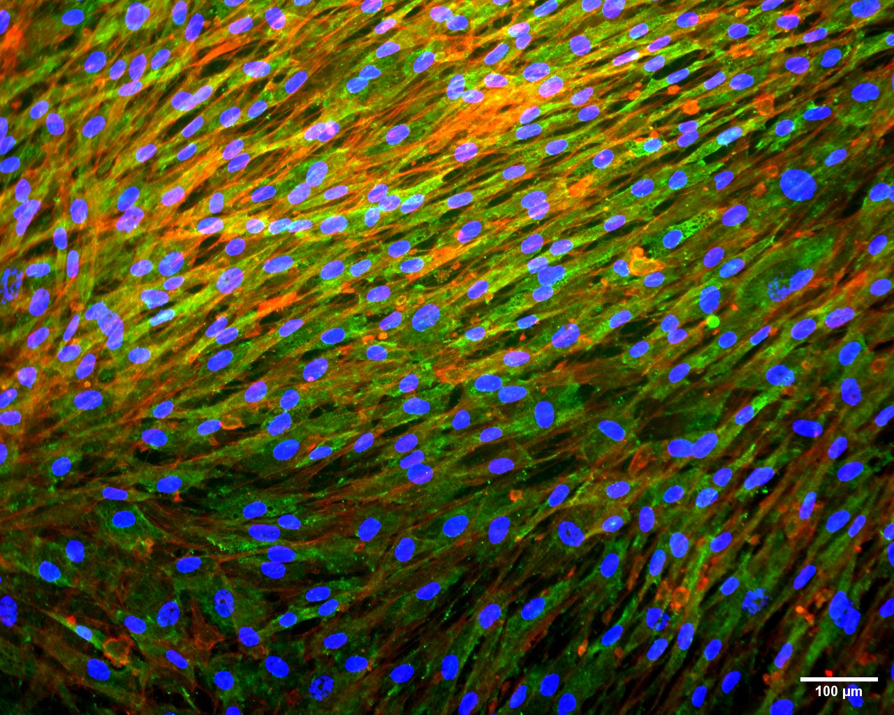
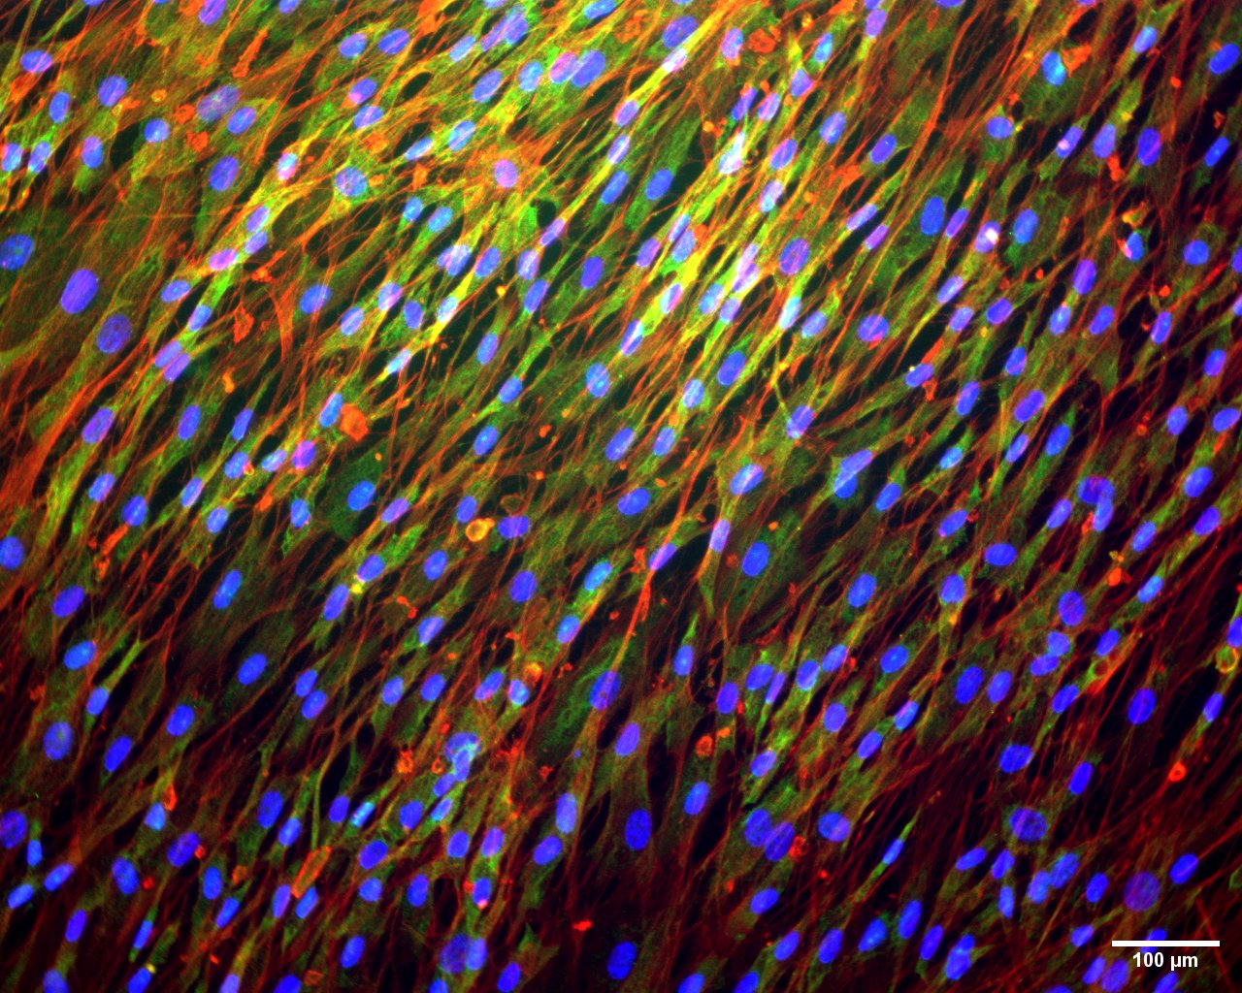

References
1. Lagowala DA, Kwon S, Sidhaye VK, Kim D-H. Human microphysiological models of airway and alveolar epithelia. American Journal of Physiology-Lung Cellular and Molecular Physiology [Internet]. 2021 [cited 2022 Jan 19];321:L1072–88. Available from: https://journals.physiology.org/doi/abs/10.1152/ajplung.00103.2021
2. Wu Q, Liu J, Wang X, Feng L, Wu J, Zhu X, et al. Organ-on-a-chip: recent breakthroughs and future prospects. BioMedical Engineering OnLine 2020 19:1 [Internet]. 2020 [cited 2023 Jan 17];19:1–19. Available from: https://biomedical-engineering-online.biomedcentral.com/articles/10.1186/s12938-020-0752-0
3. Rudder C de. Donor-Derived Microbiota and THP-1 Macrophages To Mimic. 2020;1–19.
4. Nawijn MC, Hackett TL, Postma DS, van Oosterhout AJM, Heijink IH. E-cadherin: gatekeeper of airway mucosa and allergic sensitization. Trends Immunol. 2011;32:248–55.
5. Mukherjee M, Cingolani E, Pritchard DI, Bosquillon C. Enhanced expression of Organic Cation Transporters in bronchial epithelial cell layers following insults associated with asthma – Impact on salbutamol transport. European Journal of Pharmaceutical Sciences. 2017;106:62–70.
6. Muddle J, Kanabar V, Brown M, Page C, Forbes B. An in vitro bioassay for evaluating the effect of inhaled bronchodilators on airway smooth muscle. Pulm Pharmacol Ther. 2020;63:101943.
7. O’Sullivan MJ, Jang JH, Panariti A, Bedrat A, Ijpma G, Lemos B, et al. Airway Epithelial Cells Drive Airway Smooth Muscle Cell Phenotype Switching to the Proliferative and Pro-inflammatory Phenotype. Front Physiol [Internet]. 2021 [cited 2022 Jan 19];12:687654. Available from: /pmc/articles/PMC8290262/

