Repurposing bacterial lysates: an inhalation approach for respiratory infection management

Joana Pinto-da-Silva¹, Melibea Berzosa², Alberto Delgado-López³, Carlos Gamazo³ & Ana Grenha^{1,4}

¹Centre for Marine Sciences, Universidade do Algarve, Campus Gambelas, Faro, 8005-139, Portugal

²Wellcome Wolfson Institute for Experimental Medicine, Queen's University Belfast, Belfast, BT9 5AL, United Kingdom;

³Department of Microbiology, University of Navarra, Pamplona, 31008, Spain

⁴Faculdade de Ciências e Tecnologia, Universidade do Algarve, Campus Gambelas, Faro, 8005-139, Portugal

Summary
Bacterial lysates (BL) are commonly used as immunomodulators in respiratory tract infection prevention. However, there is conflicting evidence for clinical efficacy, with the typical practice of oral administration limiting the potential to generate adequate lung protection. To improve the prospect of BL delivery inducing a beneficial immune response, a novel approach involving inhalation is proposed. Spray-dried locust bean gum (LBG) microparticles (MP) were used to encapsulate BL and confer suitable properties for lung delivery. Furthermore, as a galactomannan, LBG will facilitate targeting of antigen presenting cells in the lungs through interaction with mannose surface receptors. The preservation of BL antigenicity was confirmed by direct agglutination using specific antibodies. A release assay was performed upon dry powder which was aerosolized onto a membrane in contact with a dissolution medium to represent lung conditions. A sustained release was observed with 80% release of BL after 6 h, reaching 85% release over 24 h. These data encourage the approach of repurposing BL for inhalation, with the aim of preventing respiratory infections.

Key Message
Spray-dried microencapsulated bacterial lysates were demonstrated to be suitable for lung delivery as immunomodulatory aerosols. Antigen stability was preserved and 70-80% of lysate was released over 4-6 h, which are suitable attributes for the proposed application in respiratory infection prevention.

Introduction
Bacterial lysates (BL) containing a variety of antigenic components from pathogenic bacteria commonly associated with respiratory tract infections have been used as immunomodulators to prevent respiratory infections []. Usually delivered orally, the clinical purpose of BL administration is to minimize the risk of recurrent respiratory infections []. However, the clinical benefit in terms of therapeutic outcomes is uncertain because of contradictory evidence between different trials [1]. BL have been shown to generate specific responses in the mucosal immune system []. Given that the lungs are the primary site of respiratory infection, the immune response could potentially be improved through the administration of these immunomodulators via inhalation.
Locust bean gum (LBG), a polysaccharide composed of galactose and mannose units (galactomannan), exhibits a high affinity for phagocytic cells []. This makes LBG microparticles (MP) a means of targeting antigen-presenting cells (APCs), with mannose residues acting as the ligands, and potentiating immunomodulation. Furthermore, LBG may act as a protective matrix around BL, and can provide stabilisation during spray-drying [4]. In fact, throughout this process, antigens present in BL were subject to shear stress and high temperatures, and air-water interfaces produced during droplet formation, any of which may result in antigen denaturation []. Therefore, it is important to ensure the preservation of the immunomodulatory activity.
This work entails the repurposing of BL for an alternative delivery route using inhalation with the aim of prevention of respiratory infections by benefiting from the induction of an immune response in the primary site of the infection. After obtaining MP with suitable properties for lung delivery [], the preservation of BL antigenicity after spray-drying was evaluated using antigen diagnostic tests, and the release profile of BL was determined in an assay designed to mimic relevant aspects of the lung environment.

Experimental methods
Microparticle production and characterisation
Broncho-Vaxom® capsules (OM Pharma, Switzerland) were used as model source of BL, containing extracts of eight bacterial species responsible for respiratory infections: Staphylococcus aureus, Streptococcus viridans, Streptococcus pyogenes, Diplococcus pneumoniae, Klebsiella pneumoniae, Klebsiella ozaenae, Neisseria catarrhalis, and Haemophilus influenzae. LBG (1%, w/v) was mixed with BL at LBG:BL mass ratios ranging from 10:0.2 to 10:1.2. BL-loaded microparticles were produced using a mini spray-dryer (B-290, Buchi Labortechnik AG, Switzerland) equipped with a high-performance cyclone. The spray-dryer was operated with compressed air, using the following conditions: air fluid rate - 473 L/h, inlet temperature - 130 ºC, aspirator - 100%, feed flow - 1 mL/min. Fine particle fraction (FPF) smaller than 5 µm and mass median aerodynamic diameter (MMAD) were determined from the Andersen cascade impactor (Copley Scientific Ltd., Nottingham, UK) stage deposition, through the quantification of protein content (Bradford protein assay) [6] .
The microparticle loading capacity (LC) was calculated based on the determination of the protein amount pertaining to the BL and the manufacturer indication that 1 capsule has 7 mg of BL. Protein quantification was done through the Bradford protein assay, after dissolution of the microparticles.
$$\text{LC }\left(\text{\%}\right)\text{ = }\frac{\text{loaded BL mass}}{\text{total microparticle mass}}\text{ × 100}$$
Serum agglutination and immunochromatography tests
A commercial freeze-dried sample of S. pyogenes was incubated in agar-blood (BD Agar Columbia BBL™ with 5% sheep blood, BD Biosciences, USA) at 37 ºC for 24 h. This preculture was used to inoculate flasks containing 50 mL of Blood Heart Infusion (BHI) medium (BD BBL™, BD Biosciences, USA) at 37 ºC for 3 h. From this, 20 mL were inoculated in 3 L of BHI at 125 rpm at 37 ºC for 24 h. The inactivation of the bacterial cells was achieved by adding 2-bromoethylamine hydrobromide - formaldehyde (BEI-FA) medium. Specific antibodies against S. pyogenes were obtained by immunizing New Zealand White rabbits with the inactivated bacteria. Two immunisations (days 1, 14) were performed by intramuscular injection using Freund's incomplete adjuvant at a 1:1 volume ratio. In a microplate agglutination test, dispersions of all the formulations of MP at 1 mg/mL were incubated with the rabbit serum samples in phosphate buffer saline (PBS, 1:20; v/v). Samples were incubated at 37 ºC for 24 h and then centrifuged (100 g, 5 min.) to facilitate the antibody-antigen interaction. In addition, a commercial immunochromatographic test for the detection of S. pyogenes capsule (CerTest Strep A, Certest Biotec, Spain) was used with 1.4 mg/mL of MP LBG:BL = 10:0.2 (w/w) dispersed in the commercial buffer provided (2M sodium nitrate and 0.15M acetic acid).
Aerosolisation
A new prototype device for powder dispersion, developed by our research group [], was used herein to disperse powders for the release assays. Preliminary tests were performed to assess the yield of the aerosolisation as a function of weighed powder, further testing two device bodies having different inner entry diameters (Figure 1A, Ø = 1.5 or 2.5 mm). MP corresponding to LBG:BL = 10:0.7 were selected for this test as representative MP. Before the assay, a Petri dish suitable for cell culture was weighed and placed under the device body, as shown in Figure 1. MP masses of 1, 5 and 10 mg were tested, being weighed in the weighing head. The device was assembled, and the dry powder dispersed after actuation of the manual pump. The yield of aerosolisation was calculated as follows:
$$\text{Yield of }\text{aerosolisation} \left(\text{\%}\right)\text{ = }\frac{\text{Amount of powder on the Petri dish}}{\text{Total amount of powder weighed}}\text{ × 100}$$
In vitro release profile
To study the release profile of BL, MP (LBG:BL = 10:1.2, w/w) were dispersed onto a membrane (glass microfiber filter, pore size: 1.5 μm) using the aerosolisation device described above. The amount of powder deposited on the membrane was determined and adjusted to reach a total around 30 mg. After the aerosolisation, the membrane with the deposited MP was prewetted with 0.2 mL PBS pH 7.4 and transferred to an adapted Transwell insert (housing only, no membrane). The insert was transferred to a 6-well plate containing 1.5 mL PBS pH 7.4 and kept under horizontal shaking (OS-20 Orbital Shaker, Biosan, Latvia) at 60 rpm and 37 ºC. At fixed time intervals up to 24 h, medium samples were collected and replaced by the same volume of fresh medium. The release profile of BL was determined based on the calculation of the protein amount pertaining to the BL, through a Bradford protein assay (calibration curves of 8–80 µg/mL protein in PBS pH 7.4 were established). The cumulative drug release was calculated as the percentage ratio between the amount of released drug in each time interval and the total amount of BL present in the weighed powder (n = 6).
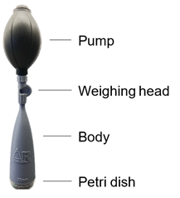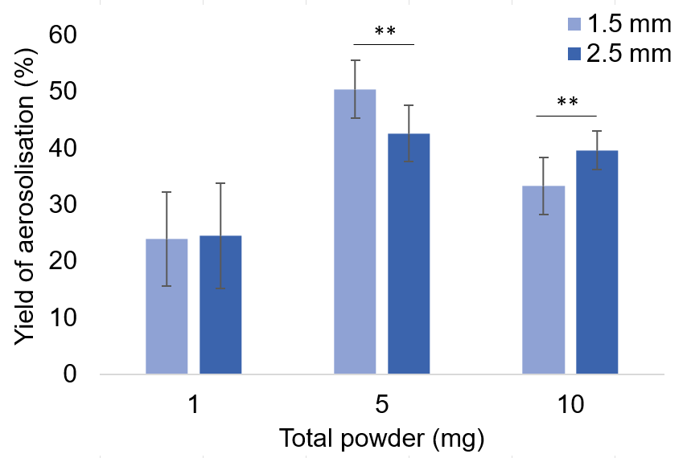
A
B

Figure 1 – A. Aerosolisation device and its parts (the body can have different inner entry diameters). B. Insufflation yields for locust-bean gum microparticles (LBG:BL = 10:0.7, w/w) using two device bodies with different inner entry diameters (Ø = 1.5 or 2.5 mm). Results represent mean ± SD, n = 10. Statistical significance levels are indicated as ** p ≤ 0.01
Statistical Analysis
T-test was used to compare data of aerosolisation studies. The analyses were run using GraphPad Prism® (GraphPad Software, version 9.3.1 (471)), and differences considered significant at p < 0.05.

Results
The prepared MP exhibited MMAD between 4.6 and 8.1 μm and FPF up to 29%. The best formulation was selected as LBG:BL = 10:0.2 (MMAD of 4.6 μm; FPF of 29%), showing potential to reach the lung [6]. The MP were tested in a serum agglutination assay to determine the effect of spray-drying on BL antigenicity. The incubation of MP with specific antibodies against S. pyogenes indicated a clear reaction of agglutination with all the MP containing BL, which was evident in comparison to the control (Figure 2A). Additionally, a positive result was observed in an immunochromatography test, indicating the specific reaction between MP and monoclonal antibodies against the S. pyogenes capsule (Figure 2B).
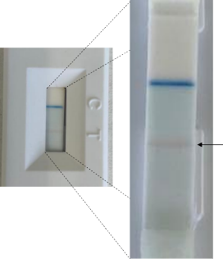
B
A
LBG:BL (w/w) MP | 10:0.0 | 10:0.2 | 10:0.5 | 10:0.7 | 10:1.2
Negative control (no serum) | 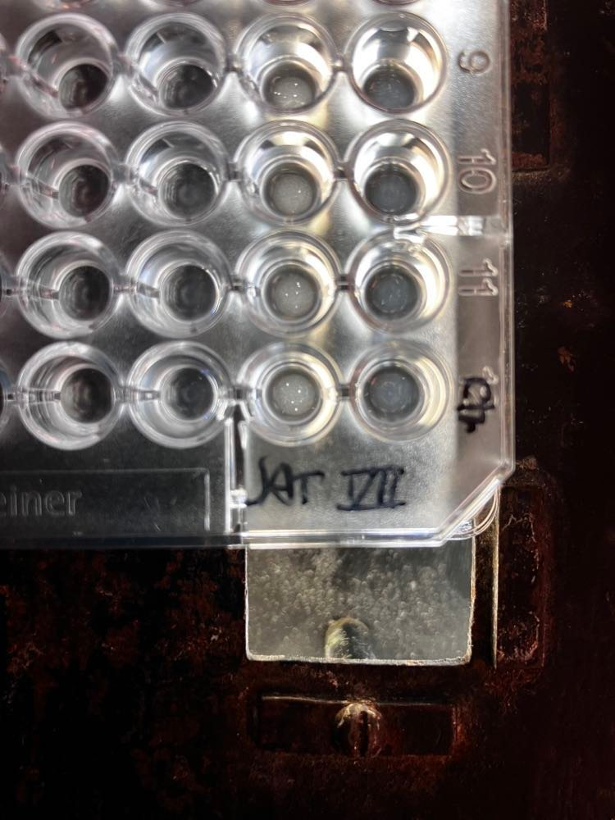 |  | 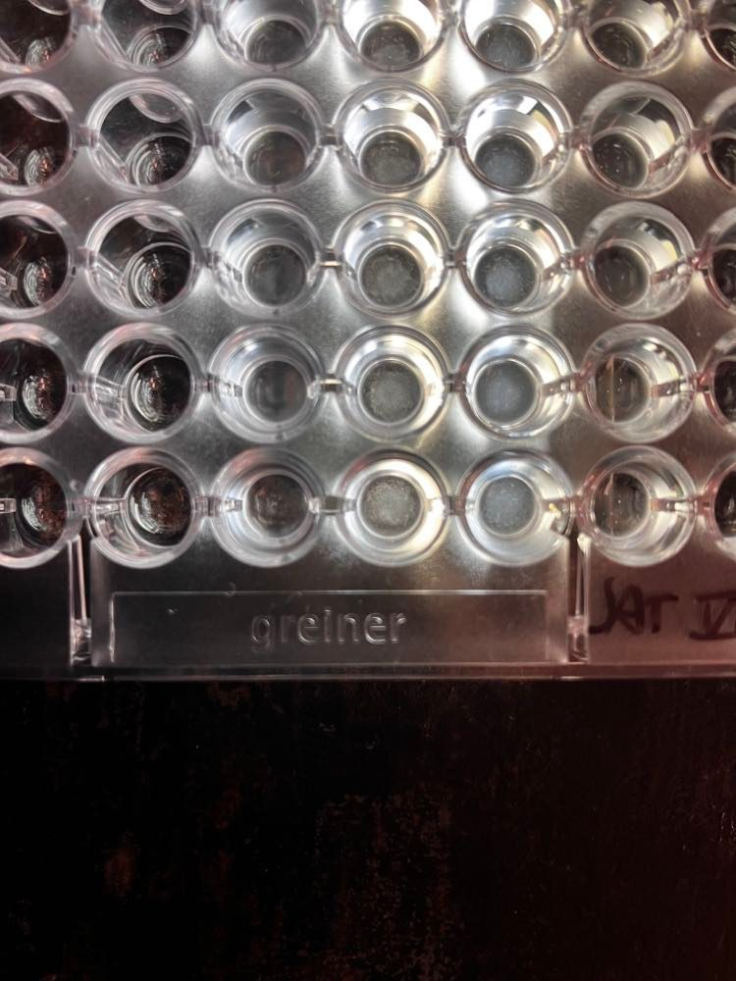 |  | 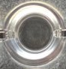
Immunisation serum (1:20; v/v) | 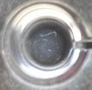 | 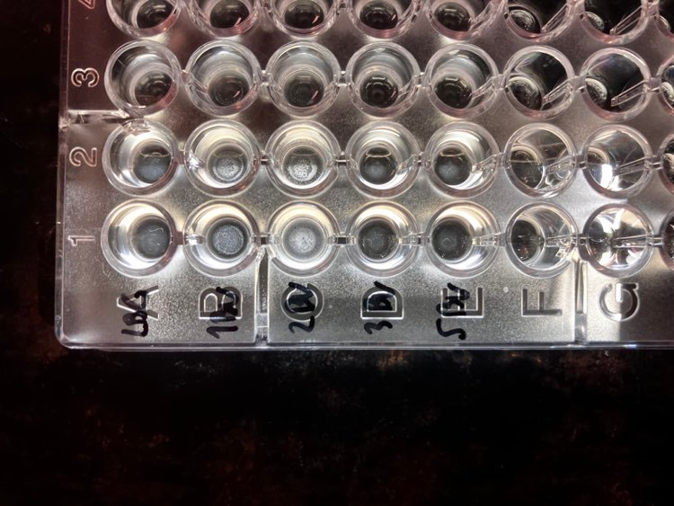 |  | 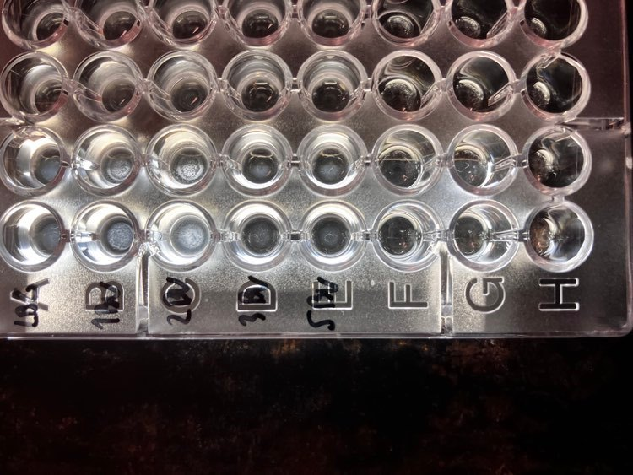

Figure 2 – A. Microplate agglutination test with the various microparticles (MP; 1 mg/mL) and the immunised rabbit serum with Streptococcus pyogenes bacterins [in PBS (1:20; v/v) at 37 ºC for 24 h]. B. Immunochromatography assay against S. pyogenes capsule with LBG:BL = 10:0.2 (w/w) MP at 1.4 mg/mL.
In preparation for the release assays, where the MP were dispersed using an in-house developed aerosolisation device [7], the yield of aerosolisation was determined. The tests performed with different device bodies (Figure 1A; two different inner entry diameters of the body were tested) indicated that this parameter significantly affected the yield of aerosolisation (p ≤ 0.01) when higher amounts of MP are used (5 mg and 10 mg), although there was not a consistent correlation (Figure 1B). The dispersion of 1 mg yielded around 25% for both tested conditions. Higher amount of MP yielded 35% - 50%, suggesting that masses around 5 mg are necessary to have more efficient aerosolisation.
The release profile of BL was determined in vitro for a representative microparticle formulation, LBG:BL = 10:1.2 (w/w). Approximately 50% of BL were released in 2 h, reaching around 80% after 6 h and slightly increasing to around 85% after 24 h.
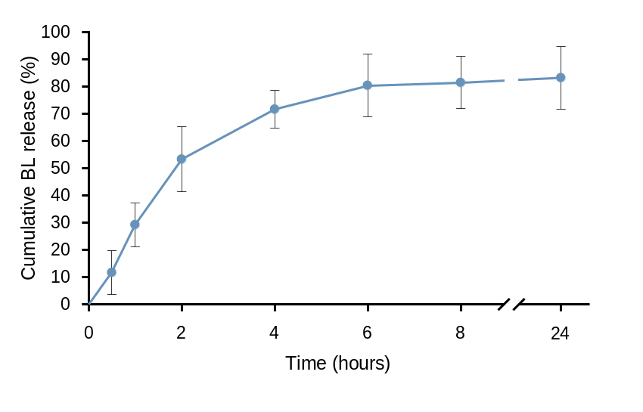

Figure 3 - In vitro release profile of BL from LBG:BL = 10:1.2 (w/w) MP in PBS (pH 7.4). Data represents mean ± SD (n = 6).

Discussion and Conclusion
The results of serum agglutination and immunochromatography demonstrated the presence of native antigens on the three formulations of BL-loaded MP developed. This indicates that the conditions used during MP preparation, including the spray-drying process, did not compromise the antigenicity. The BL released from MP gradually reached about 80% after 6 h, which only slightly changed until the 24 h timepoint, as determined in vitro. The aerosolisation device used to disperse the powder in the release assay was clearly shown to have a performance dependent on both the weighed mass of dry powder and, to some extent, the inner entry diameter of the device body. The reported findings are supportive of continuing the research regarding the repurposing of BL for the management of respiratory infections.

Acknowledgements
Funding from the Portuguese Foundation for Science and Technology (UIDB/04326/2020, UIDP/04326/2020, LA/P/0101/2020) and the PhD scholarship to Joana Pinto da Silva (2021.05769.BD) are acknowledged.

References

- Kearney S C, Dziekiewicz M, Feleszko W: Immunoregulatory and immunostimulatory responses of bacterial lysates in respiratory infections and asthma, Annals of Allergy, Asthma & Immunology 2015; 114(5): pp 364-369.
- Jurkiewicz D, Zielnik-Jurkiewicz B: Bacterial lysates in the prevention of respiratory tract infections, Otolaryngol Pol 2018; 72(5): pp 1-8.
- Suarez N, Ferrara F, Rial A, Dee V, Chabalgoity J A: Bacterial Lysates as Immunotherapies for Respiratory Infections: Methods of Preparation, Front Bioeng Biotech 2020; 8: p 545.
- Alves A D, Cavaco J S, Guerreiro F, Lourenco J P, Rosa da Costa A M, Grenha A: Inhalable Antitubercular Therapy Mediated by Locust Bean Gum Microparticles, Molecules 2016; 21(6): p 702.
- Kanojia G, Have R T, Soema P C, Frijlink H, Amorij J P, Kersten G: Developments in the formulation and delivery of spray dried vaccines, Hum Vaccin Immunother 2017; 13(10): pp 2364-2378.
- Pinto-da-Silva J, Cruz J, Grenha A: Locust bean gum microparticles as carriers for lung delivery of bacterial lysates. (Abstract). Presented at: Drug Delivery to the Lungs 2023, Edinburgh, Scotland, December 7-9, 2022; DDL2022 Digital Book of Proceedings; pp 544-547.
- Grenha A, Pontes J F, Borges dos Santos R M, Conceição E, Diogo H. Portable device to study the exposure of cells to dry powders. WO/2023/073658, PCT/IB2022/060464 (patent pending).

