Amorphous Spray Dried Microparticles for Nasal Delivery: Tackling Solubility Challenges while Targeting Systemic Nasal Absorption

Patricia Henriques^{1,2}, Cláudia Costa¹, António Serôdio¹, Ana Fortuna^{2,3}, Slavomíra Doktorovová¹

¹ Hovione FarmaCiência SA, Lumiar, 1649-038, Portugal
² Faculty of Pharmacy, University of Coimbra, 3000-548 Coimbra, Portugal
³ Coimbra Institute for Biomedical Imaging and Translational Research (CIBIT), Institute of Nuclear Sciences Applied to Health (ICNAS), University of Coimbra, 3000-548 Coimbra, Portugal

Summary
Dry powder formulations for nasal drug delivery can be manufactured by spray drying, a technology that allows particle size control and the generation of amorphous solid dispersions for drug solubility enhancement. Targeting the turbinate area of the nasal cavity is relevant for drugs intended for systemic delivery that benefit from the fast absorption and quick onset of action provided by the vascularised nasal mucosa. Despite the current knowledge on spray dried powders for nasal delivery, the impact of different polymers on drug release performance is still not clear, as well as the deposition profile of this formulation strategy. Herein, amorphous spray dried microparticles were evaluated regarding their supersaturation behaviour and drug release performance, comparing with the corresponding physical blends. The lead formulation was additionally assessed regarding nasal deposition profile using the Alberta Idealized Nasal Inlet, while evaluating the impact of the angle of actuation from horizontal plane and inhalation flow rate. The results showed enhanced drug release performance for the amorphous formulations, where the polymer that sustained supersaturation for a longer period of time resulted in higher drug release. Nasal deposition studies with an angle of actuation of 45º and inhalation flow rate of 15 L/min showed high mass balance of 97% and high turbinate deposition of 55%. Overall, the results support that spray drying is an adequate strategy to manufacture microparticles with high turbinate deposition. Moreover, the combined performance evaluation strategy using dissolution, drug release and nasal deposition methodologies was adequate to characterise and select lead formulation candidates.
Key Message
Amorphous spray dried microparticles for nasal delivery improve the drug release performance of poorly soluble drugs and can target turbinate nasal deposition, where systemic absorption occurs. The drug release performance depends on the ability of the polymer to achieve and maintain supersaturation.

Introduction
Powders for nasal delivery have increased nasal residence time and stability than liquid forms [1]. Manufacturing by spray drying is a scalable process that allows particle size control and generation of amorphous solid dispersions (ASD), enhancing the dissolution of formulations containing poorly soluble drugs [2]. The turbinate region of the nasal cavity is described as target area for systemic delivery, due to its large surface area and high vascularisation [3]. Therefore, it is crucial to guarantee powder deposition on the turbinate area.
Despite the current knowledge on spray dried powders for nasal delivery, the impact of different polymers on drug release performance is still not clear and there are no standard methodologies to evaluate the behaviour of these formulations. Accordingly, the objective of this study was to characterise the dissolution and drug release performance of amorphous spray dried microparticles (SDM) comprising a model poorly soluble drug piroxicam (PXC) and two different polymers, while comparing with the corresponding physical blends. The lead formulation was further characterised regarding nasal deposition using the Alberta Idealized Nasal Inlet (AINI).

Materials and Methods
PXC (abcr GmbH, Karlsruhe, Germany) was selected as the model drug for systemic delivery, and polyvinylpyrrolidone/vinyl acetate (PVP/VA) (Ashland Specialties, Beveren, Belgium) and hydroxypropyl methylcellulose E3 (HPMC) (Dow Europe, Horgen, Switzerland) as polymers. Spray-drying was performed after dissolving the materials in dichloromethane:methanol (80:20 w/w) at 5% (w/w) solids, using an ultra-sonic nozzle (48kHz) to produce microparticles within the nasal size range of 10 to 45 µm [1] in a Büchi model B-290 unit Advanced. The outlet temperature was set at 60ºC and liquid feed rate at 1.5kg/h. Corresponding physical blends were obtained by mixing neat polymer microparticles with PXC raw material (crystalline) in a Turbula blender (Willy A Bachofen AG, Muttenz, Switzerland) at 32 rpm for 10 minutes. All formulations were produced at 20% (w/w) drug load. Particle size of the powder formulations was assessed by laser diffraction in a Sympatec dry dispersion unit (Sympatec HELOS/BR Rodos/M Aspiros Sympatec GmbH, Clausthal-Zellerfeld, Germany), using a R4 (1.8-350 µm) lens, 18 mm/s feed velocity and 1 bar pressure. Crystallinity of the samples was evaluated by X-ray powder diffraction (XRPD) in an Empyrean® II diffractometer (Malvern Panalytical, Malvern, UK) using a PIXcel1D detector with a copper radiation source, a voltage of 45 kV, and a filament emission of 40 mA. The samples were measured over a 2θ interval of 5-40º with a step size of 0.0131º and time per step of 99.45 s.
Dissolution studies were conducted using a MicroDiss Profiler (Pion Inc., MA, USA) to determine the dissolution, supersaturation and solubility behaviour of the formulations. Powders (20 mg) were firstly placed on the bottom of each dissolution vessel, and 20 mL of Simulated Nasal Fluid (SNF, 8.77 mg/mL NaCl, 2.98 mg/mL KCl, 0.78 mg/mL CaCl₂.2H₂O, pH=6.0) were added. Stirring speed was set at 150 rpm and the medium maintained at 32 ± 0.5 ºC by a thermostatic water pump. PXC concentration was determined using ultraviolet (UV) probes (5 mm path length) after individual calibration with standard concentrations (5 to 200 µg/mL), by subtracting the absorbance from a non-absorbing wavelength (500 nm) to the absorbance from a selective wavelength for PXC (312 nm). UV spectra were collected every 5 seconds in the first 0.28 hours, every minute for the following 3.32 hours and then every 5 minutes until the end of the experiment in a total of 6 hours.
Drug release studies were performed to evaluate drug dissolution and diffusion through an artificial membrane using static vertical Franz diffusion cells (PermeGear, Inc., USA) with a 5 mL receptor compartment (600 rpm, 37 ºC) with SNF medium and a diffusion area of 0.636 cm². Powders (5 mg) were manually placed on dialysis cellulose membranes (MWCO ~ 14k). The receptor compartment was sampled (400 µL) at predetermined timepoints (up to 6 hours), and the quantification was performed by High Performance Liquid Chromatography (HPLC) with UV absorbance detector (337 nm).
For assessment of nasal deposition, QUALI-V®-I capsules size 3 were filled with 20 mg of powder. One capsule was placed in the active device Miat® nasal insufflator (Figure 1). Nasal deposition was evaluated using the AINI accessory, after coating the interior with Brij solution (0.15 g/mL Brij in ethanol) in glycerol (1mL Brij solution for 5 g glycerol) to mitigate particle bouncing [4]. The AINI was coupled with a Fast Screening Impactor (FSI), and the impact of angle of actuation from horizontal plane (45º and 70º) and inhalation flow rate (7.5 L/min and 15 L/min) were evaluated in 3 actuations of 2 seconds each for each capsule. Absence of airflow could not be tested since the large tip of the device could not be fully inserted in the nostril, and great losses of powder were observed. Drug quantification was performed by HPLC-UV. Experiments were carried out in triplicate.
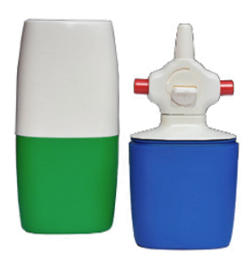
Figure 1 - Active device Miat® nasal insufflator.

Results and Discussion
SDM and blends presented a Dv50 within the nasal size range of 10 to 45 µm (Table 1), and X-ray powder diffraction (XRPD) analysis confirmed the SDM as amorphous.

Table 1 – Particle size and morphology description of the powder formulations.
Formulation | Dv10 (µm) | Dv50 (µm) | Dv90 (µm) | Solid state (XRPD)
SDM PVP/VA | 13.10 ± 0.39 | 28.40 ± 0.62 | 50.31 ± 0.61 | Amorphous
SDM HPMC | 17.43 ± 0.47 | 44.60 ± 0.33 | 82.92 ± 0.29 | Amorphous
Blend PVP/VA | 2.98 ± 0.02 | 20.72 ± 0.05 | 47.29 ± 0.73 | Crystalline
Blend HPMC | 3.95 ± 0.03 | 16.42 ± 0.05 | 33.66 ± 0.13 | Crystalline
HPMC – hydroxypropyl methylcellulose; PVP/VA - polyvinylpyrrolidone/vinyl acetate SDM – spray dried microparticles; XRPD – X-ray powder diffraction.
Small volume dissolution testing was carried out to investigate the supersaturation potential of systems varying in the type of polymer. The results (Figure 2A) showed that the amorphous formulations comprising PVP/VA or HPMC generated a supersaturated solution when in contact with the medium (the saturation solubility of crystalline PXC is 26.2 ± 2.2 µg/mL as experimentally determined in SNF pH=6 at 32ºC). A PXC concentration of approximately 130 µg/mL was attained for both SDM formulations at 5 minutes, which was about 7 times higher than the concentration attained with the blends. However, this supersaturated state was transient with recrystallisation of metastable supersaturated PXC. For PVP/VA SDM, this occurred quickly, with an abrupt reduction of dissolved PXC after 5 minutes leading to low PXC concentrations which were similar to blends after 4 hours. For HPMC SDM, the decrease was slower and concentrations were maintained higher than blends for the 6 hours of the test. This indicates that HPMC has higher capacity to maintain the supersaturated state of PXC in solution.
Franz diffusion cells were applied to study the drug release profile of the PXC powder formulations. Contrary to the dissolution experiment, this methodology allows to mimic physiological conditions of the nasal cavity, including temperature, medium and slow powder hydration in a humid environment similar to that encountered in the nasal cavity [5]. The percentage of PXC released was plotted as a function of time (Figure 2B). The PVP/VA based SDM showed higher percentages of drug release than the corresponding blend for the first 3 hours, while for the HPMC based SDM this was valid for the 8 hours of the test. Additionally, from the 20 minutes timepoint onwards, SDM of HPMC exhibited significantly (p < 0.001, ANOVA) higher percentage of drug release, when compared to all other formulations. Blend formulations presented a slower release, with major differences seen in the first 2 hours, most likely due to the crystalline state of the drug. Supersaturation solution generated by the amorphous form of the drug increases the amount of drug available to cross the artificial membrane, where the polymer plays a major role on the ability to achieve and maintain supersaturation[6]. As observed in dissolution experiments, HPMC sustains the supersaturated drug for a longer period of time, allowing a higher drug release. Even though PVP/VA may promote some degree of supersaturation, this can lead to a faster drug precipitation, thereby decreasing the release rate. The small volume used in dissolution experiments showed to be helpful to characterise the “spring and parachute” behaviour of ASD [7] and rank formulations correctly. The results herein reported indicate that the combination of dissolution and biorelevant drug release testing can represent a useful screening methodology for ASD for nasal delivery, providing a formulation ranking based on a biorelevant methodology, supported by supersaturation phenomena characterisation.
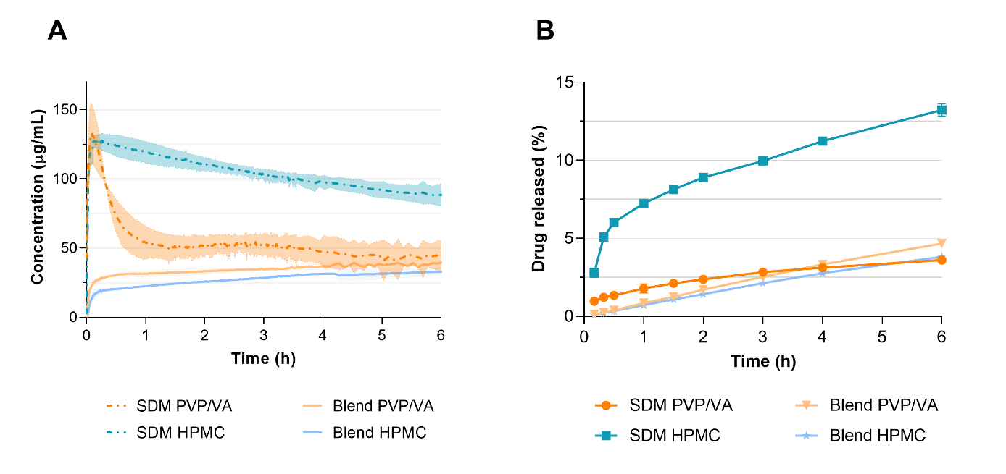
Figure 2 – Dissolution profile (A) and in vitro drug release profile (B) of piroxicam of powder formulations. Results are expressed as mean ± standard deviation (n=3). HPMC – hydroxypropyl methylcellulose; PVP/VA – polyvinylpyrrolidone/vinyl acetate; SDM – spray dried microparticles.
The lead formulation which showed the highest dissolution and drug release performance, the HPMC based SDM, was further evaluated regarding nasal deposition profile using the AINI.
For the nasal deposition studies, two method variables were studied namely administration angle from the horizontal plane and inhalation flow (Figure 3). The lower administration angle of 45º resulted in consistently lower vestibule deposition and higher turbinate deposition, in agreement with a study by Chen et al. [8] using other nasal devices. These results indicate that a 45º angle has better suitability for systemic drug delivery. Regarding the inhalation flow, a 15 L/min flow showed lower powder losses leading to higher mass balances (percentage of mass of drug recovered on AINI, FSI and capsule) (Figure 3), indicating better suitability of the analytical procedure. Accordingly, a 45º angle and 15 L/min inhalation flow should be considered for this device. The selected formulation was tested following these parameters presenting 55.3% of powder deposited on the turbinate area, evidencing SDM as an advantageous particle engineering strategy for nasal systemic delivery. A deposition of 4.8% on the pre-separator and FSI filter suggests low potential of the formulation to reach the gastrointestinal tract and lungs.
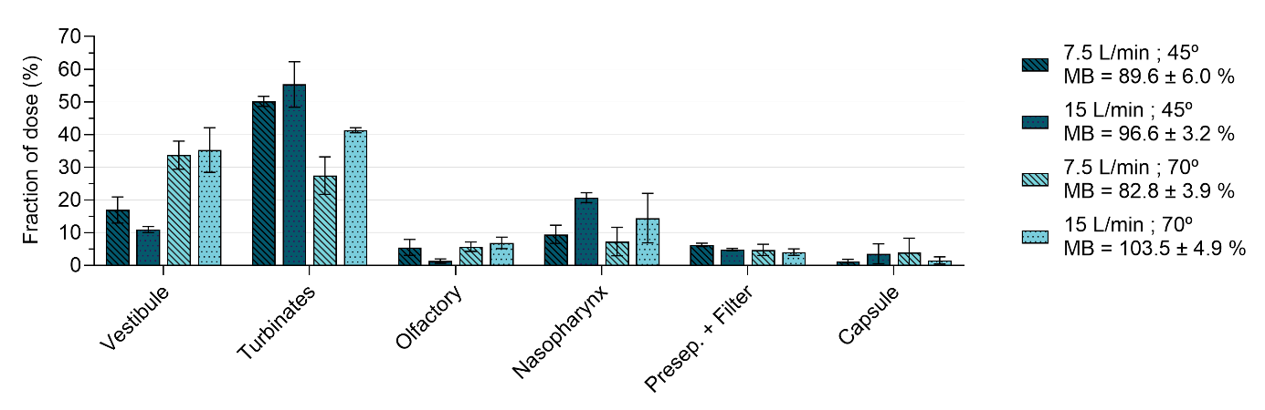
Figure 3 – Deposition profile and mass balance (MB) of SDM of HPMC under the experimental conditions tested. HPMC – hydroxypropyl methylcellulose; SDM – spray dried microparticles.

Conclusions
ASD for nasal delivery were successfully produced by spray drying using two different polymers at a 20% drug load. Amorphous microparticles within the nasal size range showed enhanced drug release properties compared with corresponding blends, where HPMC was able to sustain supersaturation for a longer period of time compared with PVP/VA polymer. The sustained supersaturation resulted in enhanced drug release profile for the HPMC based SDM.
Nasal deposition studies with the AINI were further conducted for the formulation with enhanced performance, namely the SDM of PXC in HPMC. The angle of actuation and inhalation flow rate were optimised, aiming at a high mass balance and turbinate deposition. With the Miat® device, a 45º actuation angle from horizontal plane and 15 L/min inhalation flow rate provided the optimal conditions. Using this methodology, the SDM exhibited high deposition on the turbinate area. Due to the superior drug release performance and high turbinate deposition, HPMC based SDM seem to be the lead candidate for further performance studies including mucoadhesion and permeation studies.
Overall, the results show spray drying as an advantageous technology for nasal targeted systemic delivery. Moreover, a combined performance evaluation using dissolution, drug release and nasal deposition methodologies was adequate to characterise and select lead formulation candidates.
____________________________________________________________________________________________________
[1] Tiozzo Fasiolo, L, Manniello, MD, Tratta, E, Buttini, F, Rossi, A, Sonvico, F, Bortolotti, F, Russo, P and Colombo, G. Opportunity and challenges of nasal powders: Drug formulation and delivery. European Journal of Pharmaceutical Sciences 2018; 113: 2–17.
[2] Henriques, P, Fortuna, A and Doktorovová, S. Spray dried powders for nasal delivery: Process and formulation considerations. European Journal of Pharmaceutics and Biopharmaceutics 2022; 176: 1–20.
[3] Fortuna, A, Alves, G, Serralheiro, A, Sousa, J and Falcão, A. Intranasal delivery of systemic-acting drugs: Small-molecules and biomacromolecules. European Journal of Pharmaceutics and Biopharmaceutics 2014; 88: 8–27.
[4] Murphy, B, Aisenstat, M, Ordoubadi, M, Tavernini, S, Duong, K, Zheng, J, Whittal, R, Sauvageau, D, Fox, C, Finlay, W, Vehring, R and Martin, A. Intranasal Powder Administration of a Spray-Dried Tuberculosis Vaccine Candidate Characterized using the Alberta Idealized Nasal Inlet. Respiratory Drug Delivery 2022; 1: 441–446.
[5] Jug, M, Hafner, A, Lovrić, J, Kregar, ML, Pepić, I, Vanić, Ž, Cetina-Čižmek, B and Filipović-Grčić, J. An overview of in vitro dissolution/release methods for novel mucosal drug delivery systems. J Pharm Biomed Anal 2018; 147: 350–366.
[6] Vig, B and Morgen, M. Formulation, Process Development, and Scale-Up: Spray-Drying Amorphous Solid Dispersions for Insoluble Drugs. in Developing Solid Oral Dosage Forms (Academic Press, 2017). 793–820 doi:10.1016/B978-0-12-802447-8.00030-3.
[7] Sun, DD and Lee, PI. Evolution of Supersaturation of Amorphous Pharmaceuticals: The Effect of Rate of Supersaturation Generation. Mol Pharm 2013; 10: 4330–4346.
[8] Chen, JZ, Finlay, WH and Martin, A. In Vitro Regional Deposition of Nasal Sprays in an Idealized Nasal Inlet: Comparison with In Vivo Gamma Scintigraphy. Pharm Res 2022; 39: 3021–3028.

