A Multi-Physics Theoretical and CFD Approach,
To Predict Low-GWP pMDI Spray Characteristics, Inside USP-IP Geometry

Hossain Chizari¹, Henk Versteeg², Weeratunge Malalasekera² & Barzin Gavtash¹

¹Kindeva Drug Delivery Limited, Derby Road, Loughborough, Leicestershire, LE11 5SF, UK

²Wolfson School of MEME, Loughborough University, Ashby Road, Loughborough, LE11 3TU, UK

Summary

This paper presents the development of a comprehensive mathematical model aimed at predicting pressurized metered-dose inhaler (pMDI) unwanted drug deposition, using low global warming potential (GWP) propellant. The model incorporates various factors such as the geometric dimensions of pMDI’s actuator/valve and the properties of the formulation such as propellant, excipient, and drug load. The model successfully predicts the drug deposition on the actuator and the USP-IP, and, hence, the delivered fraction to the NGI/ACI. These predictions are validated through laboratory testing.

Key Message

In this paper, we introduce a novel computational approach crucial for the pharmaceutical industry. By accurately predicting low-GWP pMDI deposition, our study offers practical solutions for drug delivery optimization. Pharmaceutical companies can now refine formulations and design inhalers more efficiently, reducing waste and enhancing therapeutic efficacy. Our findings illuminate specific industry challenges, paving the way for innovative inhalation therapies that improve patient outcomes while minimizing environmental impact. This research represents a significant step toward bridging theoretical understanding with practical industry applications.

Introduction

The prediction of pMDI unwanted oropharyngeal deposition is the mainstay problem for the respiratory drug community [1, 2]. It plays a crucial role in ensuring the efficacy, safety, and consistency of delivered dose to the lung [3]. Past research has focused on predicting the HFA134a/HFA227ea pMDI flow and droplet/drug particle trajectories in USP induction port and biological throat models using Reynolds-averaged Navier-Stokes (RANS) turbulence modelling [1, 4] and in some cases, Large-Eddy Simulation (LES) [5]. However, predicting drug deposition in pMDI applications presents several challenges. First and foremost, there is currently no comprehensive model available to predict the droplet size distribution as a function of time from first principles, specifically for low-GWP propellants such as HFA152a. Secondly, the dynamic nature of the pMDI aerosol plume makes it difficult to accurately capture the interactions between particles and the spray/airflow. Specific challenges are associated with the modelling of particle deposition in a turbulent flow field, as turbulent fluctuations can significantly influence the transport and deposition of drug particles [4, 6, 7].
The aim of this study is to enhance our understanding of low-GWP pMDI aerosol behaviour and optimize drug delivery systems. Building upon our previous model [8], we make three key advancements: (i) accurately estimating the aerosol droplet size distribution from first principles, refining our earlier predictions [9], (ii) employing the REFPROP database to precisely represent pMDI formulation properties, and (iii) meticulously modelling drug deposition within the computational fluid dynamics (CFD) framework using Large Eddy Simulation (LES). The model's accuracy is validated against experimental data from a USP induction port. These advancements not only contribute to our fundamental understanding of aerosol dynamics but also offer practical insights for designing more effective and environmentally friendly low-GWP pMDI systems, thereby addressing crucial challenges in pharmaceutical aerosol drug delivery.

Modelling Approach

The overall framework of our computational approach involves the utilization of finite volume CFD coupled with LES and Discrete Phase Model (DPM) within ANSYS-FLUENT commercial code. This approach allows us to represent the dynamic behaviour of the aerosol plume and its interaction with the flow field inside the mouthpiece region and USP induction port. To provide a clear understanding of the computational procedure, we present Figure 1 illustrating the grid of the CFD simulation. The computational mesh highlights important features such as uniformity and quality which are both important for a CFD calculation [5, 10].
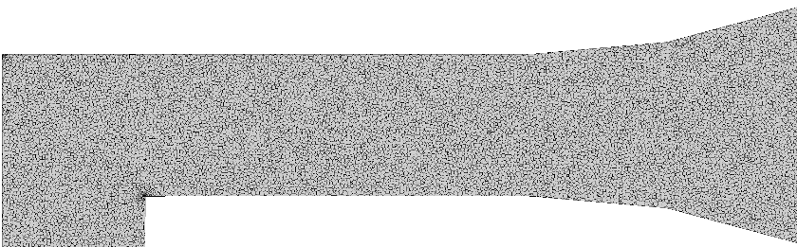 | 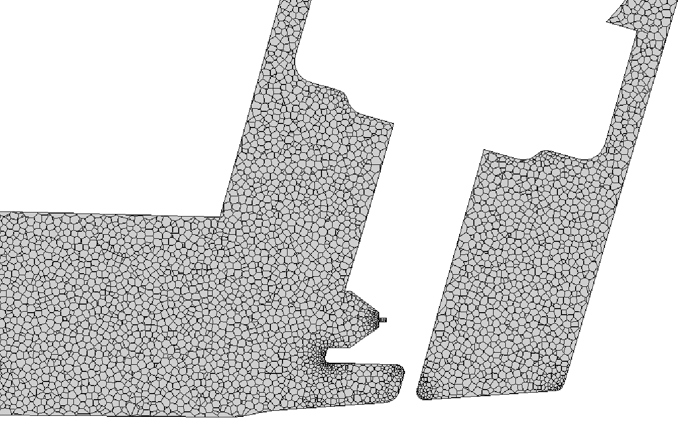
USP-IP typical element size: 200 µm | Actuator’s typical element size: 50 µm

Figure 1 – Cross-section of the grid topology in CFD calculations.
The spray source is defined within the Discrete Particle Method (DPM), which describes the temporal profile of mass, droplet size, and velocity of the aerosol source generated by the pMDI. More details of this model can be found in [11]. An example of the droplet size distribution for HFA134a and HFA152a generated by this model is illustrated in Figure 2. The main boundary conditions of the CFD simulation are shown in Table 1,
Boundary Condition Place | Property | Profile | Source
Spray Orifice (gas phase) | Mass Flow Rate | Transient | Mathematical Model
Spray Orifice (gas phase) | Pressure | Transient | Mathematical Model
Spray Orifice (droplets) | Velocity | Transient | CFD Domain
Spray Orifice (droplets) | Temperature | Transient | CFD Domain
Spray Orifice (droplets) | Size distribution | Transient | Mathematical Model
Air inlet | Mass Flow Rate | Steady | 30 lit/min
Table 1 - CFD boundary conditions.
The initial condition will be a steady-state solution of 30 l/min of airflow through the pMDI and USP induction port as in the standard test in USP 40 Chapter <601>. We used the steady-state solution for the k-ω turbulence model to generate initial conditions for the LES model with air only (without a pMDI aerosol source). The material properties of the HFA152a are linked with the REFPROP property database to ensure the accuracy of the model.

Results & Discussion

The aerosol source in the CFD model is evaluated using a new model that is described in detail in a companion paper [12]. The droplet size distribution is computed at each time step. Figure 2 shows a comparison between the predictions of this model and PDA data for an HFA134a aerosol at 5 mm from the spray orifice of the actuator. The good agreement achieved for HFA134a suggests that the instantaneous near-orifice droplet size distribution can be predicted with confidence for HFA152a. Note that the experimental data for HFA152a is not available for this paper.
pMDI Geometric Properties (HFA134a, HFA152a) |  |  | Droplet Size Distribution
Metering Chamber Volume | 50 mm³ | 50 mm³ | 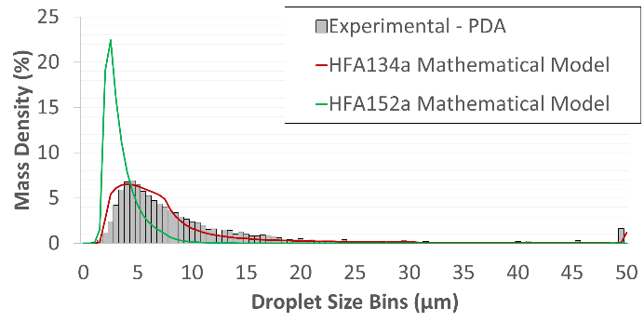
Valve Orifice Diameter | 0.63 mm | 0.63 mm
Expansion Chamber Volume | 15.5 mm³ | 40.0 mm³
Spray orifice Diameter | 0.3 mm | 0.3 mm
Figure 2 - Droplet cumulative mass density comparison between the PDA data at 5 mm in front of the spray orifice exit and the Mathematical Model for the whole course of the actuation.
Figure 3(a) shows the spatial distribution of droplets during the initial phase of the aerosol plume for HFA152a as it emerges from the spray orifice and flows through the mouthpiece region and the USP-IP. The colour scale indicates the droplet size. The smaller particles are found to follow the flow toward the exit of USP-IP. Larger droplets are more likely to hit the USP-IP walls. This illustrates the complex dispersion of therapeutic droplets, laying the foundation for subsequent deposition analysis. Figure 3(b) is focused on the main phase of the actuation event. Droplets continuously emerge through the spray orifice and leave the domain through the exit plane of the USP-IP. The spatial distribution of drug particles is fairly homogeneous and turbulent eddies bring smaller particles (green spectrum) near the rear surface of the USP-IP. Figure 3(c) shows the final actuation phase after formulation has run out and the aerosol source has stopped. Drug particles are seen to reach the end of the USP-IP (and would subsequently enter an impactor, which is not modelled in this study).

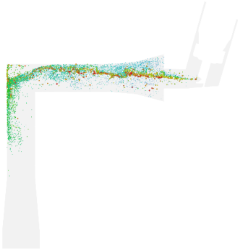  (a) | 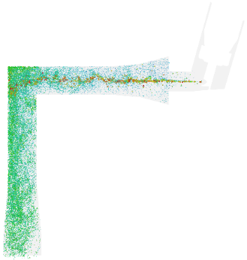  (b) | 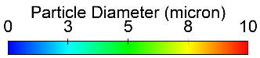  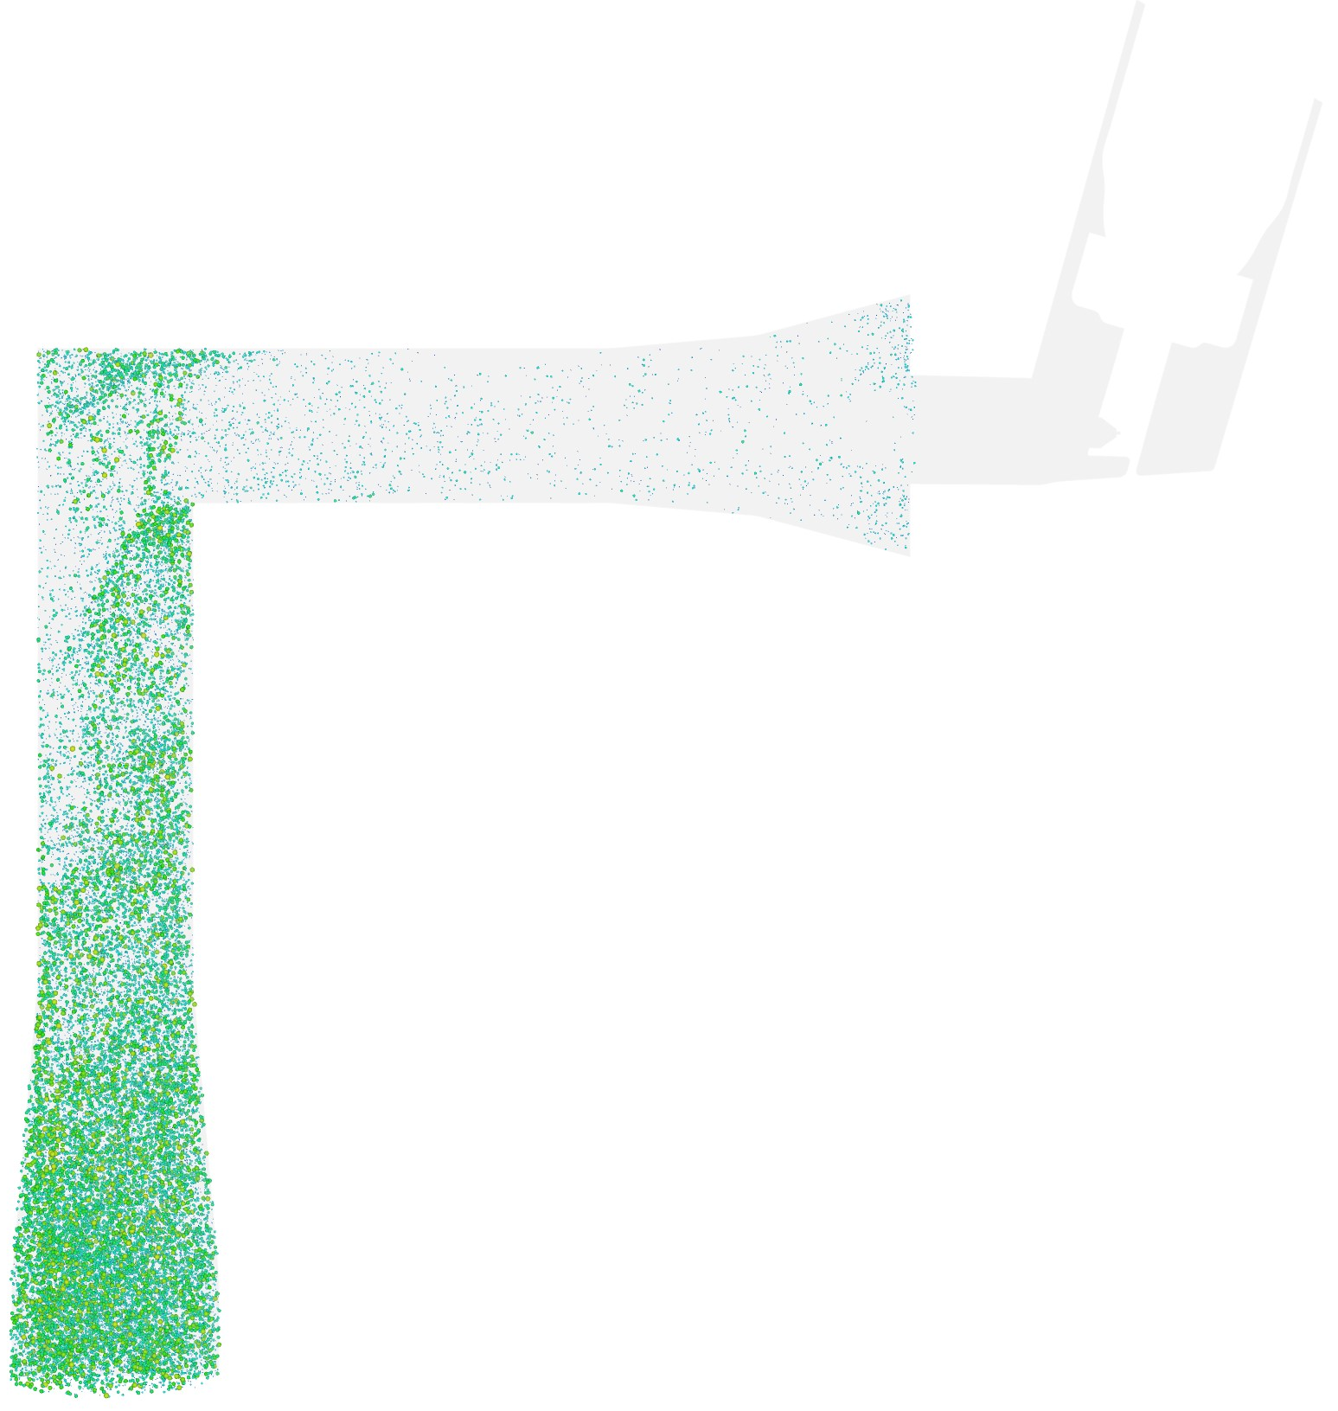  (c)
Figure 3 - Different phases of the aerosol for HFA152a within a USP throat. (a) Initial Phase [25ms].
(b) Main Phase [100ms]. (c) Final Phase [250ms].
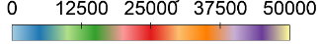
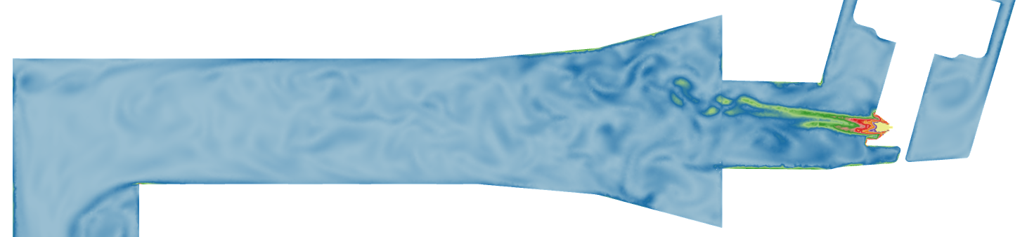
Figure 4 - Vorticity [1/s] for the Main Phase at 100ms.
Figure 4 illustrates the turbulence structure of the gas phase (mixture of HFA152 vapour and air) indicated by the field vorticity. The vorticity of the mixture near the orifice is very high due to the shear force between the vapor/droplet aerosol emerging from the spray orifice and the surrounding air. As we move away from the spray orifice, the vorticity reduces. Associated with this vorticity are vortices or turbulent eddies, which are responsible for the evaporation of the aerosol droplets and the randomness of the droplet trajectories, which affect droplet deposition.
 | HFA152a: Drug (99%:1% w/w%) Suspension |  | HFA152a: Ethanol (92%:8% w/w%) Solution
 | Experimental | Prediction | Experimental | Prediction
Ex-actuator USP deposition % | 33.66 | 34.7 | 30.74 | 30.00
Table 2 - Summary of deposition results comparing the model and experimental data.

Here we investigate two cases for spray deposition inside the USP-IP: (i) suspension formulation with approx.1% of Salbutamol drug mass in HFA152a, and (ii) solution Salbutamol in 8% ethanol, in HFA152. A comparison of the predicted USP-IP deposition and experimental measurements is given in Table 2. A good agreement is achieved in both suspension and solution cases. This is predominantly due to a realistic, time-dependent representation of the spray source, and secondly, the implementation of LES to resolve the flow turbulence structures. Our analysis of the CFD results shows that during the actuation event, deposition is higher compared with when the actuation stops where deposition decreases dramatically. This confirms that the main driver of the deposition is the jet momentum forcing the droplets to hit the USP-IP walls. Therefore, there seems to be a correlation between the jet momentum and the probability of droplet deposition.

Figure 5 shows the cumulative droplet-mass size distribution of the droplets exiting the USP-IP compared with their original size-mass distribution. The peak of the distribution substantially shifts towards the smaller droplet sizes indicating the significance of evaporation as the key secondary size reduction mechanism for HFA152a propellants. Figure 6 shows a 2-dimensional heat map of the deposited droplet’s location. The intensity of the green colour correlates with the location where deposition is higher. Our prediction suggests the horizontal section of the USP-IP, and more specifically, the initial contraction close to the mouthpiece collects a significant number of deposited droplets. the 90-degree bend also appears to be a main hotspot of deposition.

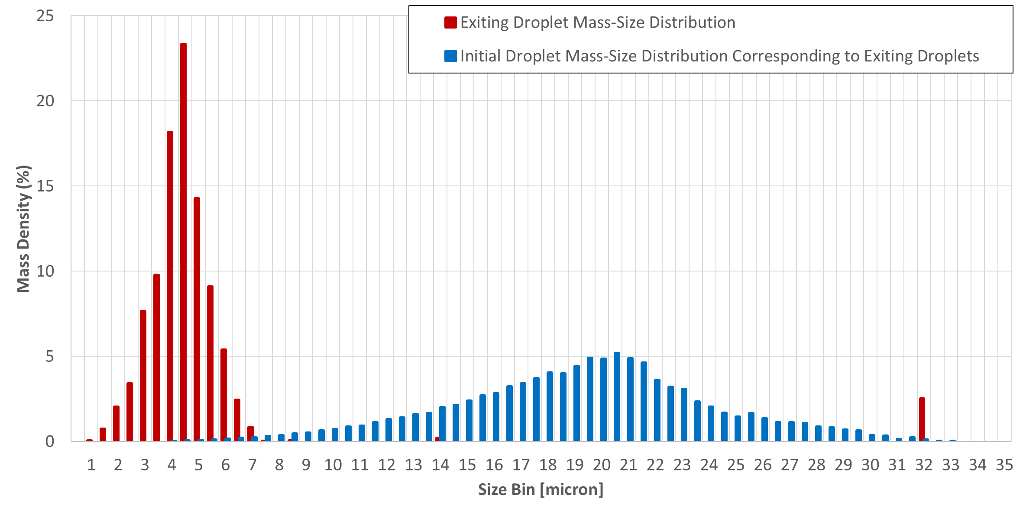 | 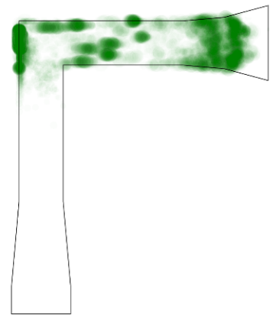
Figure 5 – Cumulative mass-size distribution of droplets existing the USP-IP, with their corresponding initial distribution | Figure 6 - Predicted cumulative deposition spatial distribution in USP-IP

Conclusion

In this paper we presented a comprehensive computational framework that combines a first principles and CFD approach consisting of LES and DPM to accurately predict drug deposition in the USP-IP. Our model incorporates a droplet size distribution model generated by a new aerodynamic atomization model, and a precise representation of the pMDI formulation properties using REFPROP. The results demonstrate the need for LES turbulence modelling to capture the dynamics of the aerosol plume and its effect on turbulence and subsequently the dispersion and deposition of drug particles. Validation of the model prediction against existing in-vitro HFA152a formulations has demonstrated the accuracy of our prediction. This capability has the potential to reduce the number of experimental iterations and eventually de-risk the product development stage, following digital engineering approaches that have been successfully adopted in various industries (e.g., aeronautics, and automotive). The insights gained from our model have significant benefits to the respiratory pharmaceutical industry's commitment to transitioning to low GWP propellants. These benefits include (but are not limited to):

- accurate prediction and control of low-GWP pMDI characteristics including unwanted deposition in complex geometries enabling pMDI drug delivery optimization.
- expedite and de-risk product development programs during the transition of high-GWP pMDIs to low-GWP pMDIs leading to reduced environmental impact.
- Improve the efficacy and safety of the low-GWP pMDI platform through digital engineering.

Moving forward, future research could focus on incorporating patient-specific geometries (anatomical throat) and breath profiles into the simulations to enhance the applicability of such models for improving patient-specific drug delivery. Additionally, the output of such a model can be used as an input to multi-compartmental pharmacokinetics (PK) models to predict the PK response. By advancing our understanding of mechanisms responsible for drug deposition, we can continually improve respiratory drug delivery systems and contribute to improved healthcare outcomes for patients with respiratory conditions.

Acknowledgement:

The authors gratefully acknowledge the financial support of Innovate UK in the form of funding for Knowledge Transfer Partnership KTP012178.

References

[1] | J. Xi, J. E. Yuan, M. Yang, X. Si, Y. Zhou and Y. Cheng, “Parametric study on mouth–throat geometrical factors on deposition of orally inhaled aerosols,” Journal of Aerosol Science, pp. 94-106, 2016.
[2] | W. DeHaan and W. Finlay, “In vitro monodisperse aerosol deposition in a mouth and throat with six different inhalation devices,” Journal of Aerosol Medicine, pp. 361-367, 2001.
[3] | P. R. Byron, M. Hindle, C. F. Lange, P. W. Longest, D. McRobbie, M. J. Oldham, B. a. T. C. G. Olsson, H. Wachtel and W. H. Finlay, “In Vivo–In Vitro Correlations: Predicting Pulmonary Drug Deposition from Pharmaceutical Aerosols,” Journal of Aerosol Medicine and Pulmonary Drug Delivery, pp. 59-69, 2010.
[4] | K. Stapleton, E. Guentsch, M. Hoskinson and W. Finlay, “On the suitability of k–e turbulence modeling for aerosol deposition in the mouth and throat: a comparison with experiment,” Journal of Aerosol Science, pp. 739-749, 2000.
[5] | F. Huang, Q. Zhu, X. Zhou, D. Gou, J. Yu, R. Li, Z. Tong and R. Yang, “Role of CFD based in silico modelling in establishing an in vitro-in vivo correlation of aerosol deposition in the respiratory tract,” Advanced Drug Delivery Reviews, pp. 369-385, 2021.
[6] | W. Finlay, The Mechanics of Inhaled Pharmaceutical Aerosols, San Diego: Academic Press, 2001.
[7] | W. Finlay and K. Stapleton, “The effect on regional lung deposition of coupled heat and mass transfer between hygroscopic droplets and their surrounding phase,” Journal of Aerosol Science, vol. 26, no. 4, pp. 655-671, 1995.
[8] | B. Gavtash, H. K. Versteeg, G. Hargrave, B. Myatt, D. Lewis, T. Church and G. Brambilla, “Multi-physics theoretical approach to predict pMDI spray characteristics,” in DDL, 2016.
[9] | H. Chizari, B. Gavtash, B. Myatt, W. Malalasekera and H. K. Versteeg, “Development of a Mathematical Model To Estimate Droplet Size Distribution of a Pressurized Metered Dose Inhaler in the Near-Orifice Region,” in DDL, 2022.
[10] | P. W. Longest and S. Vinchurkar, “Effects of mesh style and grid convergence on particle deposition in bifurcating airway models with comparisons to experimental data,” Medical Engineering & Physics, pp. 350-366, 2007.
[11] | H. Chizari, H. Versteeg, M. Malalasekera and B. Gavtash, “A Novel Mathematical To Predict The Particle Size Distribution Of pMDI Aerosols,” in DDL, 2023.

