Lactic Acid Bacteria Dry Powder Inhaler as Promising Tool for Pseudomonas aeruginosa Growth Inhibition in Pulmonary Dysbiosis

Stefania Glieca¹, Eride Quarta¹, Benedetta Bottari¹, Elena Bancalari¹, Erika Scaltriti², Martina Tambassi², Simona Bertoni¹, Lisa Flammini¹, Fabio Sonvico¹ & Francesca Buttini¹

¹Food and Drug Department, University of Parma, Parco Area delle Scienze 27/a, Parma, 43125, Italy

²Risk Analysis and Genomic Epidemiology Unit, Istituto Zooprofilattico Sperimentale della Lombardia e dell'Emilia-Romagna, Strada dei Mercati, 13/A, Parma, 43126, Italy

Summary
The aim of the project was the development and characterization of inhalation powders containing a probiotic (Lactiplantibacillus plantarum, Lacticaseibacillus rhamnosus or Lactobacillus acidophilus) for the interaction with the lung microbiota and for the containment of P. aeruginosa (PA) growth in patients with cystic fibrosis. By optimizing a spray drying process applying a design of experiment, it was possible to maintain the viability of the probiotics, which decreased by only one order of magnitude after the process in comparison with the bacterial viability in the stock suspension.
Probiotic powders showed a high respirability (FPF approximately 50%) suitable for lung deposition. Interestingly, Lpb. plantarum powder showed a bactericidal activity on the three different PA strains while the other two probiotic powder were bacteriostatic. The effect could be explained by the fact that the Lpb. plantarum is less impacted by the spray drying process, and for this reason it has a greater ability to adapt to the culture medium, to grow and acidify it up to a pH of 3.7.
The work represents a promising starting point for considering a probiotic dry powder inhaler as a tool to contain the growth of pathogenic lung microflora. This approach could be beneficial during the suspension of inhaled antibiotic therapy in the treatment regimen of cystic fibrosis.

Key Message

This work demonstrates how by optimizing a probiotic-based inhalation powder formulation it was possible to maintain the viability of Lactobacilli and their antimicrobial activity against Pseudomonas aeruginosa.

Introduction
Although for years the lung was considered sterile, recently the presence of a microbial population, constituting the pulmonary microbiota, has been demonstrated [1]. The healthy microbiota is characterised by a dynamism between the growth and colonisation of microorganisms and defence mechanisms by means of their elimination. In case of chronic respiratory diseases, such as cystic fibrosis (CF), pathogens overwhelm the defence mechanism of the lung and start colonising it, leading to dysbiosis [2]. This imbalance is also favoured by the prolonged use of antibiotics to eradicate chronic respiratory tract infections, making pathogens such as PA resistant [3].
For clinical purpose and to improve efficacy and success of the inhaled antimicrobic therapies, it could be valuable to restore a normal nasal and lung microbiome by administering probiotics directly to the lungs. Currently, it has been demonstrated that both intranasal and intra-tracheal administration of probiotics in a murine model of PA infection can have a prophylactic effect and reduce the fatal consequences of infection [4,5].
The aim of the project was the development and characterization of dry powders containing three different strains of lactic acid bacteria (LAB), namely Lactiplantibacillus (Lpb.) plantarum, Lacticaseibacillus (Lcb.) rhamnosus, or Lactobacillus (L.) acidophilus. A process of optimisation of the formulation was carried out to allow obtaining a powder which had both a high respirability and which allowed to keep the LAB viable after the process. Furthermore, their antimicrobial activity against three P. aeruginosa strains, representative of different degrees of virulence, was tested.

Experimental Methods

Frozen stocks cultures of L. acidophilus LA14 (ATCC SD5212), Lcb. rhamnosus GG (ATCC 53103) and Lpb. plantarum 4265 belonging to University of Parma Culture Collection were recovered in Man, Rogosa and Sharpe broth (MRS, Oxoid, Ltd., UK) by two overnight sub-culturing (2% v/v). The cultures were then washed with phosphate buffer saline (PBS, Oxoid, Ltd., UK) to remove the cultural medium. 100 mL of the bacterial suspension was spray-dried using a mini spray dryer B-290 (Buchi, CH) by adding lactose and leucine in a ratio of 70:30 (w/w). The powder manufacturing was optimized, using Lpb. plantarum as model, applying a central-composite Design of Experiments (DoE) with three critical factors investigated at two levels as reported in Table 1.

Table 1. Factors and range of values investigated for the optimization of the spray-dried powder manufacturing.
Factors | Range of Values
Excipients concentration (%w/v) | 0.75-1.00-1.25
Feed rate (mL/min) | 3.5-4.0-4.5
Inlet temperature (°C) | 125-135-145

The other process parameters were kept fixed: air flow rate of 600 L/h, aspiration of 35 m³/h, and nozzle of 0.7 mm. The critical quality attributes (CQAs) investigated were the viability (%) of the LAB and respirable fraction (%) of the powder. The microparticles morphology of the powder was investigated by scanning electron microscopy (SEM). The in vitro respirability, i.e. the respirable fraction (RF), of the powders was evaluated by a Fast Screening Impactor (FSI, Copley Scientific Ltd, UK) gravimetric analysis. In detail, a capsule of hydroxypropyl methylcellulose (HPMC) size 3 (Qualicaps Europe, ES) loaded with 40 mg of powder was aerosolized using a RS01 (Plastiape, IT) high resistance inhaler at 65 L/min.
The vitality of LAB before and after the powder production was investigated using the live/dead BacLight Bacterial Kit®. The viability of LAB was measured by the BacTrac 4300® Microbiological Analyzer system to obtain the kinetic parameters of Lag time, representing the time that cells require to adapt to medium and start growing and yEnd, index of the acidifying capacity.
The lead formulation composition among those investigated in the DoE in terms of LAB viability and respirability was chosen to prepare powders containing Lcb. rhamnosus or L. acidophilus.
The aerodynamic particle size distribution of the three powders was further investigated employing a Next Generation Impactor (NGI, Copley Scientific Ltd, UK) using the same parameters as above. Since the analysis was performed gravimetrically, the quantity in the induction port (IP) has not been quantified since this was not possible. In addition, for the Lpb. plantarum the deposition in each portion of the NGI was quantified by counting the colony forming unit (CFU). The powder was collected using Ringer's solution, bacteria were cultivated in agar plate and CFU were counted.
The aerodynamic parameters of emitted dose (ED), fine particle mass (FPM), fine particle fraction (FPF) and mass median aerodynamic diameter (MMAD), were calculated according to USP 44 <601> considering the amount of powder in the first type of experiment and the amount of CFU for the second.
The capacity of the LAB in the powders to inhibit the PA growth in vitro was evaluated by a liquid co-culture assay. In detail, it was evaluated the growth of three PA strains, with different virulence, in the presence of LAB powders suspended in PBS at a concentration of 10⁶ cells/mL.

Results
All eleven powders of the DoE were efficiently produced, with a yield exceeding 80% in all cases. The viability of the Lpb. plantarum was extremely variable between powders, ranging from 2.9 to 82%. Figure 1A shows a microscope image representative of an 80% bacteria vitality where live bacteria are indicated in green, while non-live bacteria are in red. On this CQA, the ANOVA analysis demonstrated a significant effect of both the concentration of the excipients (p= 0.0004) and the inlet temperature (p= 0.0321). In particular, as shown in 3D surface (Figure 1B), bacterial viability was higher with the highest concentration of excipients (i.e. 1.25 % w/v) and with the highest inlet temperature (i.e. 145°C). Although it is known that the high inlet temperature can negatively impact on viability, in our study the opposite has emerged. Here the viability depended on the combination of the two factors: highest temperature gave the better viability only with highest excipients concentration. This might be due to lower moisture content and water activity, which have been shown to be more effective in maintaining probiotic viability [6]. Moreover, the excipients were capable to form a protective matrix during particle formation.

Regarding the respirability, the highest RF values (66-68%) were obtained using a feed rate of 3.5 mL/min and an inlet temperature of 145°C. Indeed, by both reducing the feed rate and increasing the inlet temperature, the droplet is more efficiently dried, as it is exposed to the drying gas for a longer period, resulting in particles that are less cohesive, more easily dispersed and therefore respirable.
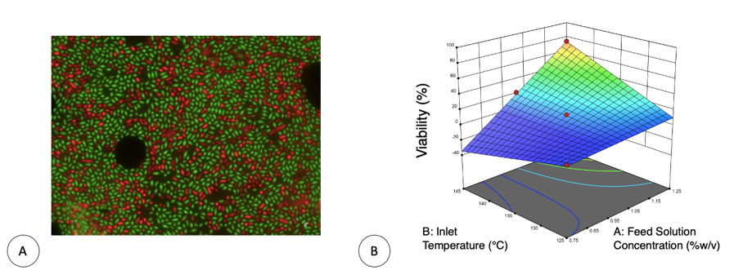
Figure 1. (A) Image of the Live-Dead fluorescence count of one Lpb. plantarum spray-dried powder of the DoE with a vitality of 80%. Live cells appear as green and dead cells appear as red. Magnification 100X. Each pixel corresponds to 0.1 μm and (B) 3D surface illustrating the effect of the inlet temperature (°C) and of excipients concentration (%w/v) on the Lpb. plantarum viability.
Considering the results of the DoE, the best performing formulation and parameters were used to obtain the Lcb. rhamnosus and L. acidophilus powders, i.e. 1.25% w/v of excipients, 3.5 mL/min of feed rate and 145°C of inlet temperature. Following the spray drying process, the viability of the LABs decreased only of 1 Log, obtaining powders with a concentration of probiotic in the range 10⁶-10⁸ CFU/mg.
From the aerodynamic performance, the ED for all the LAB powders was very high (>90%), the capsule was visually very clean after dispensing the 40 mg of powder (Table 2, Figure 2A). Aerodynamic deposition determined gravimetrically was, for all three powders, characterised by high deposition in the stages collecting particles < 5 µm. Lpb. plantarum and Lcb. rhamnosus had a similar deposition profile with FPM of about 19 mg leading to a FPF of 50% and MMAD of 3.1 µm. Even more respirable was L. acidophilus powder which, due to a higher amount of powder on the MOC, showed an FPM of 21 mg and a FPF of 56%.
Table 2. Gravimetrically evaluation of the aerodynamic performance of the three probiotics powders (loaded powder 40 mg) (n=3, mean ± std. deviation).
 | ED  (mg) | FPM  (mg) | FPF  (%) | MMAD  (µm)
Lpb. plantarum | 38.2±0.3 | 18.8±1.3 | 49.3±3.2 | 3.10±0.15
Lcb. rhamnosus | 38.3±0.4 | 19.3±1.0 | 50.3±3.4 | 3.08±0.12
L. acidophilus | 37.8±0.1 | 21.4±0.2 | 56.0±0.4 | 2.38±0.07

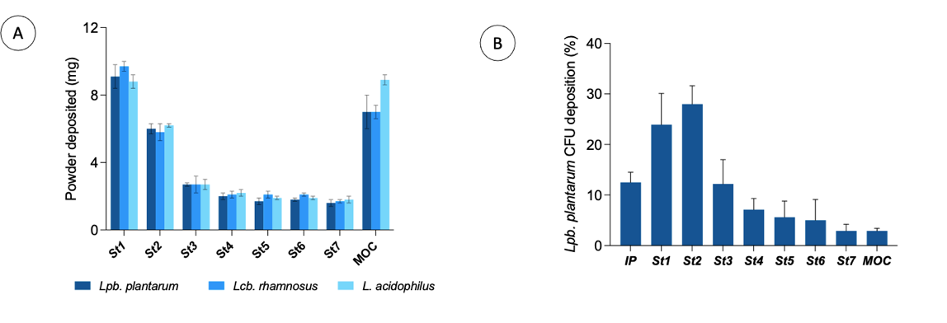
Figure 2. (A) Gravimetrically LAB powders deposition in the NGI (loaded powder in the inhaler 40 mg); (B) Lpb. plantarum CFU deposition (%) in the NGI. The CFU quantification was made by collecting the powder using Ringer's solution and doing the plate count after cultivation (n=3, mean ± std. deviation).

To date we have performed the CFU quantification in NGI of the Lpb. plantarum dry powder (Figure 2B). In detail, a content of CFU equal to 7.24 x 10⁸ were included in the 40 mg of loaded powder which represented a 51% w/w of the formulation. The recovery of the experiment was around 87%. Interestingly, the analysis revealed that the powder deposited in the last stages was mostly composed by excipients, while LAB mainly deposited in the stages which collect particles in the range 2-8 µm. This led to a LAB MMAD of 5.11 ± 0.62 µm and a FPF of 42.9 ± 5.1%. This is reasonable considering that LAB have an intrinsic length that can vary from 0.5 to 10 µm, and it is certainly not possible to reduce their intrinsic size during the formulation, as they would no longer be viable.
The microparticles of the Lpb. plantarum powder (Figure 3A) had a maximum size of 3-4 µm, with an irregular and corrugated shape, typical of spray-dried particles containing leucine.
Finally, it was demonstrated how Lpb. plantarum was the only LAB having a bactericidal effect against all PA strains tested (Figure 3B). On the other hand, Lcb. rhamnosus had a bacteriostatic effect while L. acidophilus significantly reduced the growth only of two bacterial strains. The ability of LAB to inhibit the growth of PA, when the antimicrobial activity was tested on the entire suspension of LAB, was attributed to their ability to lower the pH of the environment [7]. The analysis of the Lag time and yEnd for the three strains, revealed that L. acidophilus was the most affected by the treatment as it showed a long Lag time, low yEnd and highest pH (4.27 ± 0.04). Lcb. rhamnosus showed the fastest acidification, that means the shortest time to reach the final pH (3.75 ± 0.01). Finally, the lowest pH (3.71 ± 0.03) was reached by Lpb. plantarum, which is confirmed to be potentially the most promising strain in controlling the growth of other microorganisms.

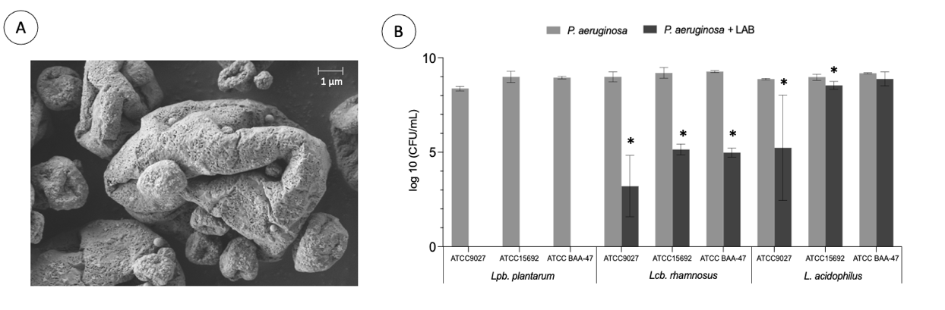
Figure 3. (A) SEM particle morphology of Lpb. Plantarum powder (B) antimicrobial activity of the three LAB spray-dried formulations on three different PA strains (n=3, mean ± std. deviation); *p < 0.05. vs PA in the absence of LAB.
Discussion and Conclusions
Lactobacilli have long been used as probiotics by oral administration, as they are safe microorganisms that confer a beneficial effect on the host and their therapeutic effect on chronic respiratory diseases has recently been demonstrated. The idea of this project was to obtain an inhalation powder containing probiotics so that they can interact directly with the respiratory epithelium, competing with pathogens, and promoting the restoration of the pulmonary microbiota. By optimizing the spray drying formulation, it was possible to obtain highly respirable powders maintaining the LAB viability. Among the three strains investigated, Lpb. plantarum was found to be the most resistant to the spray drying process, maintaining a higher powder viability and respirability and a bactericidal action against PA.
Overall, the work represents a promising starting point for the use of probiotic-based inhalation powders as a support treatment in the antibiotic therapy of CF.

References
[1] Wypych TP, Wickramasinghe LC, Marsland BJ. The influence of the microbiome on respiratory health. Nat Immunol 2019;20:1279–90. https://doi.org/10.1038/s41590-019-0451-9.
[2] Zhang D, Li S, Wang N, Tan HY, Zhang Z, Feng Y. The Cross-Talk Between Gut Microbiota and Lungs in Common Lung Diseases. Front Microbiol 2020;11:1–14. https://doi.org/10.3389/fmicb.2020.00301.
[3] Fainardi V, Neglia C, Muscarà M, Spaggiari C, Tornesello M, Grandinetti R, et al. Multidrug-Resistant Bacteria in Children and Adolescents with Cystic Fibrosis. Children 2022;9:1–7. https://doi.org/10.3390/children9091330.
[4] Fangous MS, Alexandre Y, Hymery N, Gouriou S, Arzur D, Blay G Le, et al. Lactobacilli intra-tracheal administration protects from Pseudomonas aeruginosa pulmonary infection in mice - a proof of concept. Benef Microbes 2019;10:893–900. https://doi.org/10.3920/BM2019.0069.
[5] Fangous MS, Gosset P, Galakhoff N, Gouriou S, Guilloux CA, Payan C, et al. Priming with intranasal lactobacilli prevents Pseudomonas aeruginosa acute pneumonia in mice. BMC Microbiol 2021;21:1–11. https://doi.org/10.1186/s12866-021-02254-7.
[6] Kakuda L, Jaramillo Y, Niño-Arias FC, Souza MF de, Conceição EC, Alves VF, et al. Process Development for the Spray-Drying of Probiotic Bacteria and Evaluation of the Product Quality. J Vis Exp 2023. https://doi.org/10.3791/65192.
[7] Chappell TC, Nair NU. Engineered lactobacilli display anti-biofilm and growth suppressing activities against Pseudomonas aeruginosa. NPJ Biofilms Microbiomes 2020;6. https://doi.org/10.1038/s41522-020-00156-6.

