Inhalable Nanomedicine for Treatment of Pulmonary Tuberculosis
Khaled H. Alzahabi¹, Theoni K. Georgiou², Hisham Al-Obaidi³, Brian D. Robertson⁴, Omar Usmani¹, Alexandra E. Porter² and Teresa D. Tetley¹
¹National Heart and Lung Institute, Imperial College London, London, UK.
²Department of Materials and London Centre for Nanotechnology, Imperial College London, London, UK.
³College of Pharmacy, University of Reading, Reading, UK.
⁴MRC Centre for Molecular Bacteriology and Infection, Imperial College London, London, UK.

Summary
Tuberculosis (TB) is currently treated using a cocktail of antituberculosis (anti-TB) drugs for between 6 and 24 months. The systemic side effects and lack of compliance can lead to multidrug resistant TB (MDR-TB). A faster, simpler more reliable therapy is urgently required to reduce both the drug dose and period of treatment, to improve patient compliance and reduce MDR-TB. To this end, we have constructed an inhalable anti-TB formulation to target Mycobacterium tuberculosis (M.tb) in the airways and in particular the deep lung. The aim was to assemble poly (lactic-co-glycolic acid) microparticles to carry silver nanoparticles (AgNPs) associated with rifampicin (RIF) in an aerosolised microparticle form to be delivered directly to the lungs by inhalation. The safety of the microparticles at the human alveolar respiratory gas-liquid interface was determined using transformed primary human alveolar epithelial cells with type 1 cell-like characteristics (TT1). The synthesised AgNPs were spherical, with a mean diameter of 15-18 nm. A concentration ≤10 μg/ml of AgNPs in serum free medium did not cause TT1 cell death. PLGA microparticles containing AgNPs and RIF were generated using solvent evaporation method and fully characterised for their size, charge and AgNP/RIF content. The microparticle constructs were spherical with diameter less than 5 µm (median 1.35 µm). RIF and AgNPs were successfully encapsulated within the PLGA microparticles with an encapsulation percentage of 79% and 53% respectively. The next step is to assess the safety of this delivery system against M.tb alone and against M.tb-infected models of TT1 epithelial cells and human lung macrophages.
Key Message
We have generated a microparticle drug delivery system for co-delivery of antibiotic rifampicin and silver nanoparticles by inhalation to improve the current TB treatment regimen, that is safe to human lung cells, will lower drug dose and reduce treatment times so reducing MDR-TB.

Introduction
Tuberculosis (TB) is an infectious bacterial disease that affects the lungs and other organs such as liver, spleen, and spine [1], causing severe symptoms of fever, fatigue, continuous cough and death, if not treated properly [2]. Every year, 10 million people globally contract active TB resulting in the death of approximately 1.5 million people [3]. Current treatment guidelines recommend oral administration of many first-line anti-TB drugs, such as rifampicin and isoniazid, for at least 6 months [4]. Lengthy treatment and associated side effects are the main reasons for patients’ non-compliance; combined with low bioavailability, short half-life and poor lung delivery of oral anti-TB drugs [5], the emergence of multidrug resistant-TB (MDR-TB) accounts for 19% of previously infected cases [6], illustrating that first-line anti-TB drugs won’t always control TB.
Hypothesis & Rationale: An aerosolised, inhalable microparticle pulmonary nanodrug delivery system containing anti-TB drugs and antibacterial agents such as silver nanoparticles will i) exhibit more effective antibacterial activity, ii) improve/reduce TB treatment regimens, iii) significantly decrease TB incidence and iv) minimize MDR-TB and associated mortality.
The aims of this study were: 1) To assemble poly (lactic-co-glycolic acid) (PLGA) microparticles to carry engineered antibacterial AgNPs associated with anti-TB drug; 2) To establish the safety of these structures at the human alveolar epithelial gas-liquid interface.

Methods:
Synthesis of silver nanoparticles: Silver nanoparticles were synthesised by a bath-reduction technique using sodium citrate and sodium borohydride as reducing agents [7]. The synthesised silver nanoparticles were characterised for their morphology and size using transmission electron microscopy (TEM); yield and purity were determined using Inductively Coupled Plasma (ICP). In order to determine the safety of the silver nanoparticles, putative toxicity/bioreactivity was assessed against an immortalised human alveolar epithelial type I-like (TT1) cell line (as a model for alveolar epithelial type I cells). Cell viability was measured using MTT assay (metabolic activity) and LDH assay (Cytotoxicity/necrosis). Proinflammatory IL6 and IL8 (CXCL-8) mediators were measured using enzyme-linked immunosorbent assays (ELISA). The silver nanoparticles were applied to the cells at concentration range 1 – 50 μg/ml for 24 hours.
Combining Ag NPs with rifampicin using PLGA carriers: An Oil/Water emulsion containing poly D,L-lactic-co-glycolic acid (PLGA), rifampicin and Ag NP was prepared by a solvent evaporation technique. An organic phase of Dichloromethane (DCM) containing PLGA, RIF and AgNPs was then added to the aqueous phase containing 1% Polyvinyl Alcohol (PVA) and homogenised for 30 min at 13000 rpm. The emulsion was left overnight to evaporate the DCM and the microparticles were washed, lyophilised and stored in the fridge. The prepared microparticles were characterised for their morphology and size, utilising scanning electron microscopy (SEM) with energy dispersive X ray spectroscopy(EDX), AgNPs content and availability using ICP and RIF content using a validated UV/Vis spectrophotometry.
Results and Discussion
Synthesis of silver nanoparticles: Citrate-capped AgNPs were successfully synthesised utilising the bath reduction process. The AgNPs were spherical in shape (Figure 1. A) with an average diameter of 16.5 nm and a narrow size distribution with a standard deviation of 4.6 nm (Figure1. B).
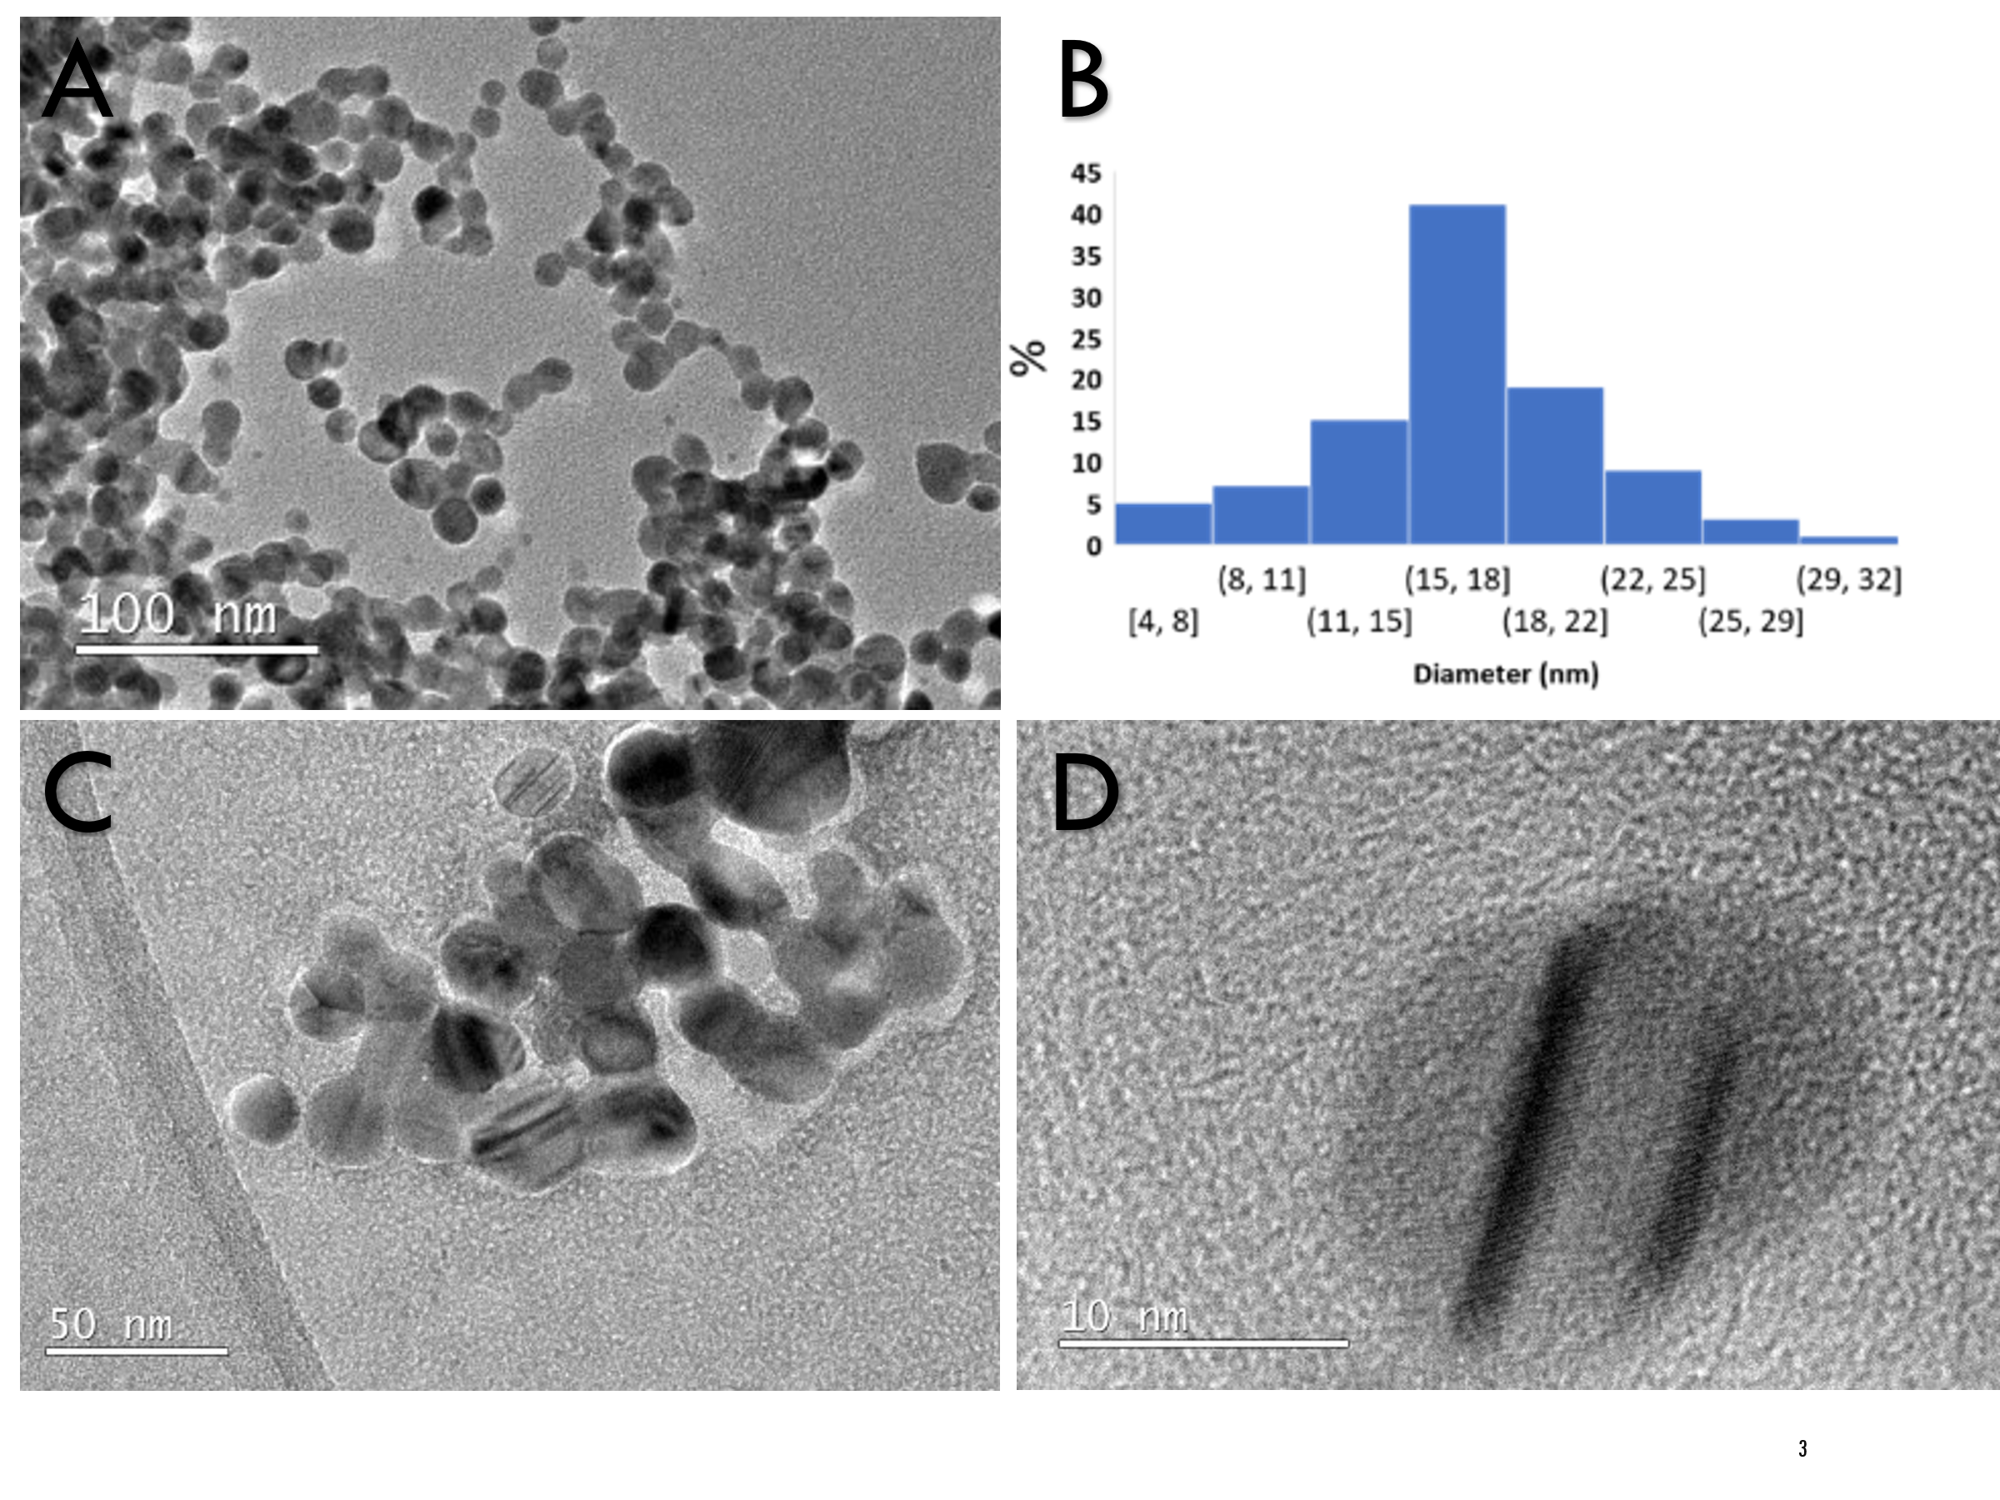
Figure 1- images of synthesised AgNPs at different magnifications at 200kV; A) scale bar of 100 nm, B) the size distribution of AgNPs constructed from image (A) using ImageJ software where 200 particles were counted. C) AgNPs before adding DPPC stained with 1% Uracil acetate (UA), D) one silver nanoparticle showing the fringes
40 % of the synthesised AgNPs showed a size between 15 – 18 nm. Staining AgNPs with 5% UA, which was used as a stain to observe the surfactant layer around the silver did not change the appearance of the AgNPs (Figure 1.C); agglomeration could be caused by drying of the AgNPs suspension after dispersion onto the lacy TEM grid. The viability, cytotoxicity and mediator release of TT1 cells exposed to between 1 and 10 ug/ml were not different to those of unexposed control. At concentrations of 25 and 50 μg/ml of AgNPs showed marked loss of viability (15% and 20% respectively) and a significant increase of IL6 and IL8 (25% and 100% for 25 μg/ml and 40% and 230% for 50 μg/ml) levels respectively.

Figure 2 - MTT viability results, LDH cytotoxicity, IL6 and IL8 cytokine levels of TT1 cells treated with AgNPs. (CTR-) represents the non-treated control cells while (CTR+) represents cells treated with 20 ug/ml ZnO used as a positive control. Significance is denoted as a p-value: p ≤ 0.05; * p ≤ 0.01 **, p ≤ 0.001****; p ≤ 0.0001 **** with using 3 biological replicates and 6 technical replicates.

Combining Ag NPs with RIF using PLGA carriers:
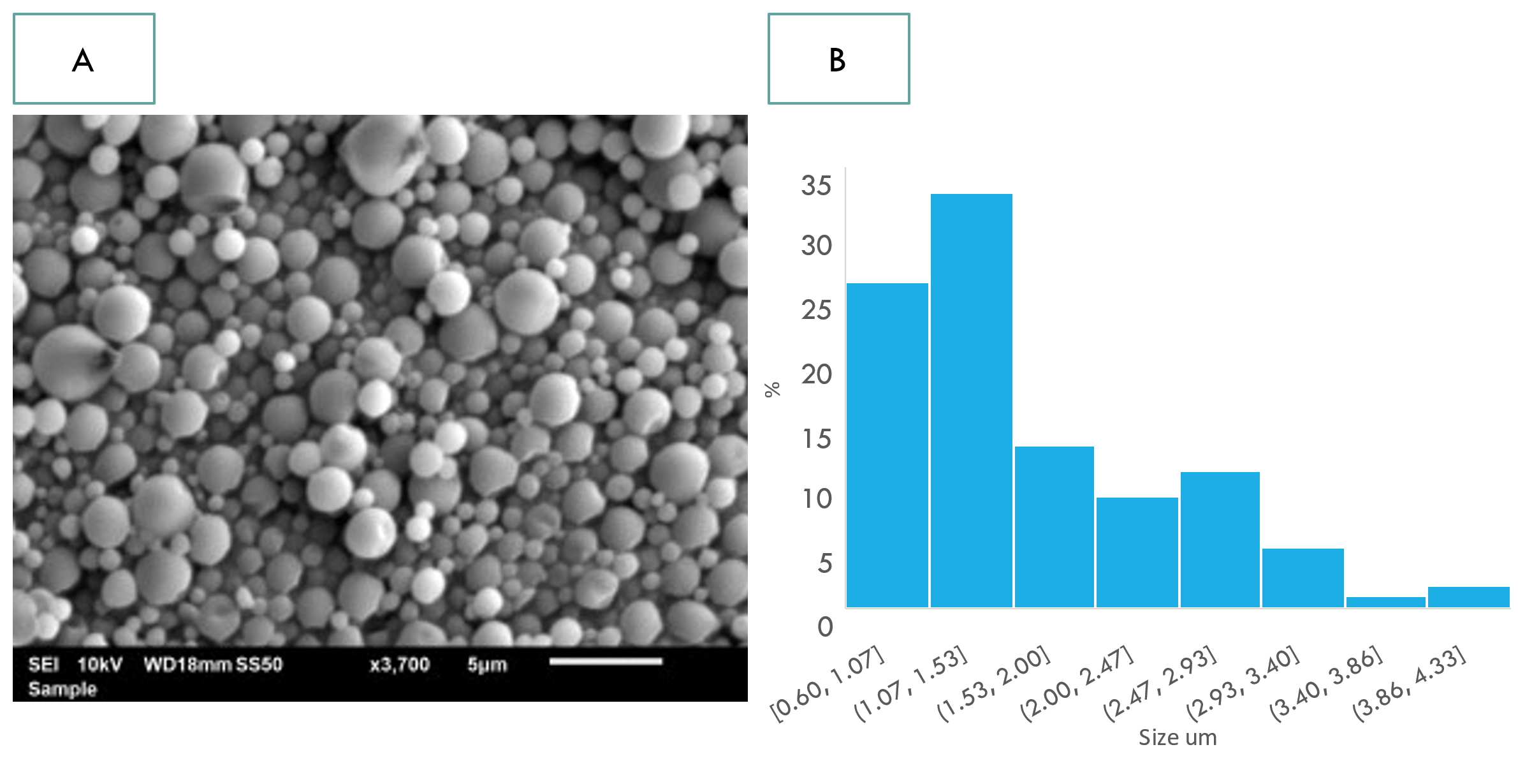
The prepared PLGA microparticles were spherical in shape (Figure 3.A). 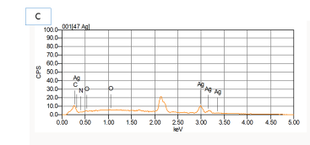
Figure 3 Characterisation of PLGA microparticles containing RIF and AgNPs. A) SEM image of the microparticles with a scale bar of 5 μm. B) the size distribution of microparticles constructed from image (A) using ImageJ software where 200 microparticles were analysed. C) EDX analysis of image (A).

All microparticles showed a size less than 5 μm (Figure 3.B). EDX spectrum of PLGA microparticles showed peaks of silver, carbon, nitrogen and oxygen (Figure 3.C) confirming the presence of silver within the PLGA microparticles. A validated UV/Vis spectroscopy method was used to quantify the amount of RIF within the PLGA microparticles along with ICP to quantify AgNPs. Linear correlation between the concentration and the light extinction (R²=0.9992) which confirmed the sensitivity of the validated method in estimating RIF concentrations in the sample. UV/Vis and ICP showed a high encapsulation percentage of RIF and AgNPs within the PLGA at a rate of 79% and 58%, respectively.
Conclusion:
The engineered AgNPs were uniform with a narrow size distribution and were safe when used at realistic levels of below 10 μg/ml. AgNPs were successfully combined with RIF within a PLGA carrier. Further studies are required to assess the safety of the formulation using human lung alveolar epithelial and macrophage cells, while in vitro efficacy of the prepared microparticles against M.tb alone and using a combination of different human lung cells infected with M.tb is underway.

References
1. Gaba, S., et al., Tuberculosis Presenting as Hepatic and Splenic Microabscesses. Cureus, 2020. 12(5): p. e8247.
2. Alzahabi, K.H., et al., Approaches to treating tuberculosis by encapsulating metal ions and anti-mycobacterial drugs utilizing nano- and microparticle technologies. Emerg Top Life Sci, 2020. 4(6): p. 581-600.
3. Organisation, W.H., Global Tuberculosis Report 2021. 2021.
4. (NHS), T.N.H.S. Tuberculosis - Treatment 2022; Available from: https://www.nhs.uk/conditions/tuberculosis-tb/treatment/.
5. Vinnard, C., et al., Markers of gut dysfunction do not explain low rifampicin bioavailability in HIV-associated TB. Journal of Antimicrobial Chemotherapy JAC, 2017. 72(7): p. 2020-2027.
6. (WHO), W.H.O. Tuberculosis: Multidrug-resistant tuberculosis (MDR-TB). 2022; Available from: https://www.who.int/news-room/questions-and-answers/item/tuberculosis-multidrug-resistant-tuberculosis-(mdr-tb).
7. Leo, B.F., et al., The stability of silver nanoparticles in a model of pulmonary surfactant. Environ Sci Technol, 2013. 47(19): p. 11232-40.
8. LeClair, D.A., et al., Optimization of Spray Drying Conditions for Yield, Particle Size and Biological Activity of Thermally Stable Viral Vectors. Pharm Res, 2016. 33(11): p. 2763-76.

