Gallium siderophores for the treatment of Aspergillus fumigatus lung infections

B. Grassiri^{1,2}, M.E. Piatek^{3,4}, L. More O’Ferrall^{3,5}, J.A. Sake², G. Batoni⁶, C. Ehrhardt², D.M. Griffith^{3,5}, K. Kavanagh^{3,4}, A.M. Piras¹, A.M. Healy^{2,3}

¹University of Pisa, Department of Pharmacy, 56126 Pisa, Italy

²School of Pharmacy and Pharmaceutical Sciences, Trinity College Dublin, Dublin 2, Ireland

³SSPC, The Science Foundation Ireland Research Centre for Pharmaceuticals, Ireland

⁴Department of Biology, Maynooth University, Maynooth, Ireland
⁵Department of Chemistry, Royal College of Surgeons in Ireland, Dublin 2, Ireland

⁶Department of Translational Research and New Technologies in Medicine and Surgery, University of Pisa, 56126 Pisa, Italy

Summary
Fungal lung infections are a serious threat, especially for immunocompromised patients. The metal gallium can disrupt iron metabolism in bacteria. Indeed, gallium salts have been reported to be valuable tools for the treatment of P. aeruginosa infections in cystic fibrosis patients. Recently the antifungal effect of gallium nitrate has been demonstrated against Aspergillus fumigatus. The aim of this project was to assess inhaled formulations of gallium salts or siderophore complexes that can be efficiently delivered to the lungs and act on the fungal infection. The synthesis of gallium maltolate (GaM), gallium citrate (GaC) and three novel siderophore Ga complexes (GaS1, GaS2 and GaS3) was undertaken. Microbiological testing of all synthesised compounds was carried out to evaluate their toxicity on A. fumigatus and a cytotoxicity screening on NCI-H441 was performed to evaluate the safety of the compounds with respect to inhaled administration. None of the tested compounds were toxic to NCI-H441 cells at any of the concentrations and time points tested. The siderophore complexes were more effective against A. fumigatus compared to the other salts. GaS1 showed fungicidal properties at 0.5 mg/mL and was selected as the lead compound.
DPI formulations of GaS1 were prepared by spray-drying with L-leucine and in vitro deposition characteristics of prepared powders indicated good potential for efficient pulmonary delivery. Ultimately, the anti-fungal activity of a formulated inhalable product will be tested on an in vitro infection lung model.

Key Message
The novel gallium-siderophore complex, GaS1, was shown to be selectively toxic against A. fumigatus, and non-toxic to NCl-H441 cells. An inhaled formulation that efficiently delivers the siderophore-gallium complex to the lungs could be a promising adjuvant for the treatment of A. fumigatus infected patients.

Introduction
The lack of available drugs for the treatment of fungal infections, along with the emergence of drug-resistant strains, results in millions of deaths each year [1]. Fatal disseminated mycoses caused by filamentous fungi are becoming an increasing problem in the ever-expanding population of immunocompromised patients susceptible to opportunistic pathogens. The ubiquitous environmental mould Aspergillus fumigatus is a frequent cause of different types of human diseases, especially for patients with impaired immunity [1]. An unconventional approach to fight microbial infection is to exploit nutritional vulnerabilities of microorganism metabolism. The metal gallium can disrupt iron metabolism in bacteria. Various Ga³⁺ related agents, e.g. gallium nitrate (GaN), gallium maltolate (GaM), gallium chloride, and gallium citrate (GaC), have shown bacterial growth inhibitory effects on P. aeruginosa [2], B. cepacia [3] and S. aureus [4]. Especially for P. aeruginosa, GaN was effective against laboratory P. aeruginosa strain PA01, cystic fibrosis isolates and multi-drug resistances isolates [2] and was able to effectively eradicate biofilm in vitro and in vivo [2, 5]. The highly efficient heme consumption system of bacteria was fully blocked in vitro and in vivo by gallium protoporphyrin, which also prevented extrapulmonary dissemination and patient death [6]. Despite its known antibacterial and antitumoral activity, there are few reports of the antifungal effect of gallium [7, 8]. [⁶⁸Gallium]-radiolabelled siderophores have been widely described in the literature as a valuable instrument for diagnosing A. fumigatus infection [9], whereas the potential therapeutic antifungal properties of gallium itself are still little studied. Bastos et al. demonstrated the fungistatic effect of GaN against azole-sensitive and -resistant A. fumigatus strains and also a synergistic effect with caspofungin [7]. In a recent study two new siderophore analogues chelating gallium ions were prepared and tested against A. fumigatus and A. niger, and both displayed good in vitro anti-fungal activity, comparable to amphotericin B [10].
The aim of this work was to develop an innovative gallium-based therapy which can be efficiently delivered to the lungs as an aerosol.

Experimental Methods

Materials: Sabouraud dextrose agar and Sabouraud dextrose medium (Oxoid -Thermo Fisher, Ireland); Tween-20 (VWR Chemicals, Ireland); A. fumigatus spores 26933 and NCI-H441 cells were acquired from ATCC (USA); PBS, RPMI-1640 medium, FBS, sodium pyruvate, trypsin-EDTA, alamarBlue reagent, anhydrous citric acid, ethanol, hydrogen peroxide solution and potassium hydroxide were acquired from Sigma-Aldrich (Ireland); gallium nitrate was purchased from Thermo Fisher (Ireland).

Methods
Synthesis of gallium compounds: Five water soluble gallium salts/complexes were synthesised from gallium nitrate (GaN) as the starting material. Gallium maltolate (GaM) (neutral), gallium citrate (GaC) (charged) [11], and the novel siderophores, GaS1, GaS2 and GaS3 (charged complexes), were synthesised. Elemental analysis (EA), IR, MS, 1H NMR, 13C NMR and X-ray crystallography were used for the physicochemical characterisation of gallium compounds
Gallium compound fungal toxicity evaluation: A. fumigatus was grown on Sabouraud dextrose agar at 37°C. PBS (10 mL) containing 0.01% Tween-20 was used to harvest conidia. Conidia were pelleted and washed twice in sterile PBS and counted. Gallium compounds were serially diluted in 96-well plates (Corning) containing Sabouraud dextrose media to final concentrations of 4-500 μg/mL. A. fumigatus conidia suspensions were added to all wells to obtain a final concentration of 5 × 10⁵ conidia/mL. Plates were incubated at 37°C for 24 h and 48 h in a static incubator. Growth was measured in a plate reader (Bio-Tek Synergy HT) at 600 nm.
Agar diffusion test: Aliquots (100 μL) of A. fumigatus spore suspensions in PBS were spread over Sabouraud dextrose agar at a final concentration of 1 × 10⁵ spores/mL. A hole with an 8 mm diameter was punched out of the agar and 50 μL of GaS1, GaS2 and stock solutions or control (deionised water only) were introduced into the wells. Agar plates were incubated at 37°C and the diameter of the zones of inhibition were measured after 24 h. The test was run in triplicate for every compound at every test concentration.
Fungicidal/fungistatic assay: A. fumigatus (5 × 10⁵ spores/mL) was incubated in Sabouraud dextrose broth supplemented with GaS 1, 2 and 3 (0.050 and 0.500 mg/mL) for 0–24 h at 37°C in an orbital shaker at 200 rpm. Aliquots (100 μL) were removed every 2 h for 8 h and at the 24 h time point and spread on Sabouraud dextrose agar plates. The plates were incubated at 37°C for 24 h, at which time the level of growth was photometrically assessed.
Cytotoxicity evaluation: NCI-H441 cells were grown in RPMI-1640 medium further supplemented with 5% FBS and 1% sodium pyruvate at 37°C and 5% CO₂. For cytotoxicity assessment, NCI-H441 cells were seeded in 96-well plates at 1.65 × 10⁴ cells/well for 6 days until confluency was reached. For 4 h cytotoxicity assessment, cells were serum starved 24 h before the experiment. On day 6 the medium was replaced with serum free medium containing gallium compound solutions (concentration range 0.005–5 mg/mL) to evaluate their cytotoxicity. After 4 h or 24 h of incubation, media was removed and cells were washed twice with Krebs-Ringer buffer. One hundred microlitres of alamarBlue reagent (1:10 in KRB) was added to each well and cells were incubated at 37°C for 3 h. Measurement of fluorescence at 544 nm (excitation) and 590 nm (emission) was made using an automated plate reader (FLUOstar Optima, BMG Labtech, Offenburg, Germany). Values were normalised to the negative control and expressed as cell viability (percent of control).
Preparation of spray-dried GaS1/L-leucine powder: Composite systems containing different L-leucine (LL) and GaS1 weight ratios (0:100; 20:80, 30:70 % w/w, LL:GaS1) were spray dried as a 0.5% (w/v) solution in water using a Büchi B-290 Mini Spray dryer operating in the open mode.
In vitro aerosol deposition studies using the Next Generation Impactor (NGI): An NGI (Copley Scientific Limited, UK) was used with a low resistance RS01 (Plastiape, Osnago, Italy) capsule-based device and operated according to European Pharmacopoeial conditions [12]. A no. 3 HPMC capsule was loaded with 20 ± 1 mg of powder for each formulation tested and the amount of powder deposited on each NGI stage was determined spectrophotometrically by UV detection (samples were read at 285 nm and normalized at 450 nm). Each formulation was spray dried in duplicate and each duplicate sample tested on the NGI. The mass median aerodynamic diameter (MMAD), fine particle fraction less than 5 μm (FPF) and geometric standard deviation (GSD) were determined using CITDAS V3.00 Copley Inhaler Testing Data Analysis Software (Copley Scientific Limited, UK).

Results
Five gallium compounds were synthesised, starting from GaN, and characterised via a range of physicochemical characterisation techniques showing differences in chemical structural characteristics. GaN, GaM, GaC, GaS1, GaS2 and GaS3 were evaluated for both antifungal activity and cytotoxicity. In the microbiological screening on A. fumigatus, GaM did not show any toxic effect at any of the concentrations tested at both time points analysed. GaN and GaC were toxic to A. fumigatus when used at a concentration of 500 μg/mL after 48 h incubations (Fig. 1). In contrast, all three Ga-siderophore complexes were shown to be toxic to A. fumigatus in a concentration range of 31–500 μg/mL at both 24 h and 48 h time points (Fig. 1). Notably, the 96-well plates containing the Ga-siderophores were incubated over a week and no growth was detected in wells containing 31–500 μg/mL gallium complexes over the 7-day period. In the agar inhibition study, only GaS1 and GaS2 at a concentration of 0.5 mg/mL showed a well-defined and clear zone of inhibition of 2±0.1 cm diameter, whereas GaN, GaM and GaC were comparable to the negative control. The agar plate containing 0.5 mg/mL of GaS3 showed a zone in which the growth of A. fumigatus was reduced, but not enough to accurately determine the diameter of a completely clear zone of inhibition. The fungistatic/fungicidal test confirmed these results, classifying GaS1 and GaS2 0.5 mg/mL solutions as fungicidal while GaS1 0.05 mg/mL, GaS2 0.05 mg/mL, and GaS3 0.05–0.5 mg/mL were fungistatic.
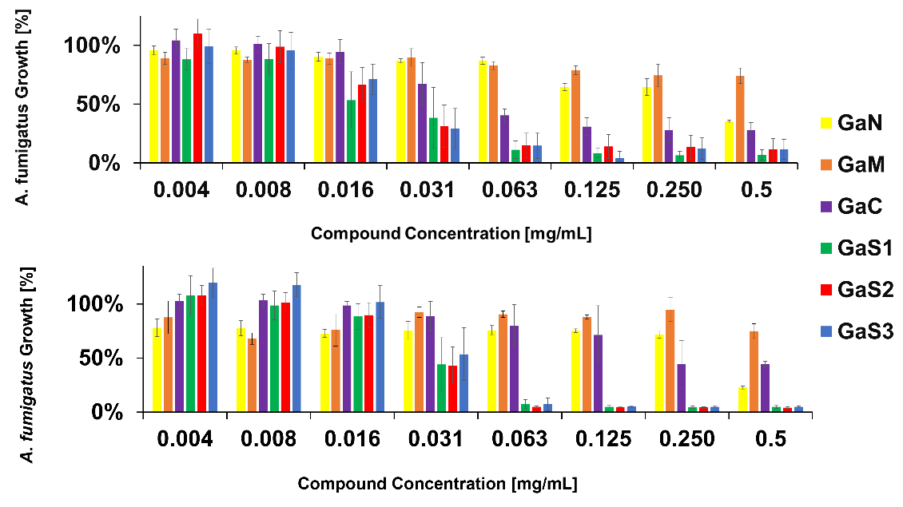
B
A
Figure 1: Gallium compound toxicity evaluation on A. Fumigatus after [A] 24 h and [B] 48 h incubation.
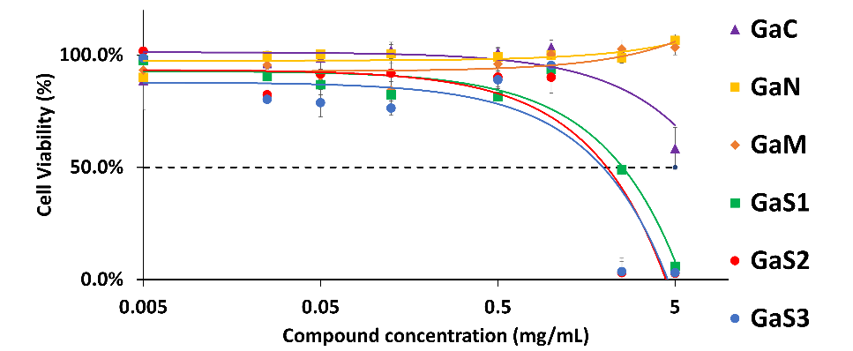
Figure 2: Gallium compounds toxicity to NCI-H441 distal lung epithelial cells after 24 h incubation.
All the compounds tested exhibited high cell viability after 4 h at all tested concentrations (Cell Viability of 100% for all the compounds at all concentrations tested). After 24 h incubation with NCl-H441 cells, high cell viability was registered in the range 0.005–1 mg/mL for all the compounds (Fig. 2). The low cell viability observed at 2.5 and 5 mg/mL after 24 h incubation of the Ga-siderophores (Fig. 2) could be due to the siderophores’ ability to interact with metals, such as calcium, that are present in the cell culture medium. This interaction may have led to cells becoming detached and then being washed away as dead cells. This effect is not expected to be relevant in physiological conditions, where these materials are much more abundant.
All spray-dried composites were obtained in good yield and showed favourable deposition profiles (Table 1). A trend of increased yield and better deposition with increasing concentration of LL in the formulation was observed.
Table 1: Preliminary results summary of spray-drying yield and deposition properties of NGI-tested powders.
LL:GaS1 | Yield (%) | MMAD (µm) | GSD | FPF < 5 µm (%)
0:100 | 69.20; 72.80 | 3.68; 3.18 | 1.69; 1.55 | 57.11; 66.32
20:80 | 72.00; 75.20 | 2.52; 3.31 | 1.31; 2.21 | 72.01; 81.23
30:70 | 75.20; 82.00 | 2.02; 3.21 | 2.33; 1.56 | 83.23; 78.20

Discussion
Currently, the few available drugs used to treat severe fungal infections show disadvantages such as high toxicity, limited capability to inhibit multiple fungal cell targets, rapid development of drug resistance when used in single therapy, as well as short half-life [7]. The efficacy of three salts (i.e. GaN, GaM and GaC) on bacterial strains [2-4], has been previously described. Indeed, there is a phase 1/2a clinical trial (NCT03669614) ongoing investigating the safety and pharmacokinetics of GaC administered via inhalation in healthy adults and P. aeruginosa infected cystic fibrosis subjects. All three newly synthesised compounds - GaS1, GaS2 and GaS3 - showed a consistently higher efficacy against A. fumigatus than GaM, GaN and GaC and the same level of cytotoxicity in NCl-H441 cells in the range 0.005-0.5 mg/mL. After toxicity screening, GaS1 was selected as the lead compound, as it showed the most pronounced activity against A. fumigatus. DPI formulations comprised of GaS1 and L-leucine were prepared by spray-drying, and show suitable characteristics for effective pulmonary delivery, with FPFs <5 μm between 57 and 83% and median mass aerodynamic diameters of approximately 3 μm.
Conclusions
GaS1 is a newly synthesised novel gallium-siderophore complex, selectively toxic against A. fumigatus, and non-toxic to NCl-H441 cells. Siderophore-gallium based DPI formulations were shown to have good potential for efficient delivery to the lungs and may represent a promising adjuvant therapy for the treatment of A. fumigatus infected patients.
Acknowledgments
This work was supported by Science Foundation Ireland, co-funded under the European Regional Development Fund under grant number 12/RC/2275_P2. This work is also supported by Erasmus+2022 and ILO-2 2020.
_____________________
[1] C. Thornton, Breaking the mould – novel diagnostic and therapeutic strategies for invasive pulmonary aspergillosis in the immune deficient patient, Expert Rev. Clin. Immunol. 10 (2014) 10.
[2] Y. Kaneko, M. Thoendel, O. Olakanmi, B.E. Britigan, P.K. Singh, The transition metal gallium disrupts Pseudomonas aeruginosa iron metabolism and has antimicrobial and antibiofilm activity, J Clin Invest 117(4) (2007) 877-88.
[3] E. Peeters, H.J. Nelis, T. Coenye, Resistance of planktonic and biofilm-grown Burkholderia cepacia complex isolates to the transition metal gallium, J Antimicrob Chemother 61(5) (2008) 1062-5.
[4] D. Baldoni, A. Steinhuber, W. Zimmerli, A. Trampuz, In vitro activity of gallium maltolate against Staphylococci in logarithmic, stationary, and biofilm growth phases: comparison of conventional and calorimetric susceptibility testing methods, Antimicrob Agents Chemother 54(1) (2010) 157-63.
[5] C. Bonchi, E. Frangipani, F. Imperi, P. Visca, Pyoverdine and proteases affect the response of Pseudomonas aeruginosa to gallium in human serum, Antimicrob Agents Chemother 59(9) (2015) 5641-6.
[6] L. de Leseleuc, G. Harris, R. KuoLee, H.H. Xu, W. Chen, Serum resistance, gallium nitrate tolerance and extrapulmonary dissemination are linked to heme consumption in a bacteremic strain of Acinetobacter baumannii, Int J Med Microbiol 304(3-4) (2014) 360-9.
[7] R.W. Bastos, L. Rossato, C. Valero, K. Lagrou, A.L. Colombo, G.H. Goldman, Potential of Gallium as an Antifungal Agent, Front Cell Infect Microbiol 9 (2019) 414.
[8] A. Evans, K.A. Kavanagh, Evaluation of metal-based antimicrobial compounds for the treatment of bacterial pathogens, J Med Microbiol 70(5) (2021).
[9] J. Pfister, R. Bata, I. Hubmann, A.A. Hormann, F. Gsaller, H. Haas, C. Decristoforo, Siderophore Scaffold as Carrier for Antifungal Peptides in Therapy of Aspergillus fumigatus Infections, J Fungi (Basel) 6(4) (2020).
[10] Y. Li, Z. Li, Cyclopeptide Derivatives from the Sponge-Derived Fungus Acremonium persicinum F10, Mar Drugs 19(10) (2021).
[11] M. Piatek, D.M. Griffith, K. Kavanagh, Quantitative proteomic reveals gallium maltolate induces an iron-limited stress response and reduced quorum-sensing in Pseudomonas aeruginosa, J Biol Inorg Chem 25(8) (2020) 1153-1165.
[12] European Pharmacopoeia, Preparations for inhalation: aerodynamic assessment of fine particles, European Pharmacopoeia (2014) 276-286.

