Personalised Airway and Lung Management (PALM): tuning the particle size on-demand for effective aerosol delivery

Tuncay Alan¹, Jason Brenker¹, Hoai Nguyen An Le¹, Abanoub Shenoda¹, Jackson Gum¹, Juhura G. Al-mazi², Sonia Pal¹, Hui Xin Ong², Daniela Traini²

¹Monash University, Department of Mechanical and Aerospace Engineering, Melbourne VIC, 3800 Australia

²Woolcock Institute of Medical Research, 431 Glebe Point Road Glebe NSW 2037,Australia

Summary
We present a new aerosol delivery platform: Personalised Airway and Lung Management (PALM), which can atomise liquids on-demand and generate aerosol particles with controlled diameters (WO2020019030A1). The devices comprises of microfabricated, hydrophilic channels placed on top of a piezoelectric substrate. Upon actuation, a controlled volume of fluid can be drawn into the device through a rapid capillary driven flow. Consequent high frequency vibration of the fluid/air interface results in a mist of micrometer-diameter droplets to be ejected. The devices are breath actuated and very importantly, the droplet size can be tuned on-demand by modifying the actuation parameters, allowing personalised therapy. The aerosol generation chip, piezoelectric driving element, associated driving electronics and sensing components are integrated into a small form factor device, which comfortably fits into the palm of a hand.
Key Message
The breath actuated portable device can continuously draw liquids from a wide variety of external reservoirs via acoustically enhanced capillary filling. This minimises the dead volume and ensures consistent operation without requiring external pumping. The mean diameter of the generated droplets can be tuned on-demand by dialling the actuation parameters.

Introduction

Drug deposition in the respiratory tract is greatly influenced by the size and distribution of the aerosol particles/droplets, and the patient’s breathing pattern. Particles with aerodynamic diameters, d<5 μm have the highest likelihood to reach the terminal bronchioles, while larger particles (d>5 μm) tend to get trapped in the upper airways. Moreover, considering the variability in patients’ airway geometries, lung capacities and disease states, it could be inferred that the optimum particle size to target specific regions of the lung will vary from patient to patient [1]. Hence, a personalised approach that is capable of tuning the droplet size is necessary to increase therapeutic effectiveness, which is not possible with any commercially available devices.

Ultrasonic actuation offers a significant potential to enable personalised therapy and has attracted a significant attention [2-3]. For instance, widely used mesh nebulisers employ a vibrating perforated plate in contact with the fluid to generate a mist of droplets using portable devices. However, mesh nebulisers cannot tune the aerosol particle diameter on-demand. The particle diameter is fixed for each drug/device pair and drug formulations need to be associated with specific mesh designs. The particle tuneability can be addressed using surface acoustic wave (SAW) technology. However, they result in a larger spread in particle diameters, can provide relatively low doses and require a well-defined fluid volume and shape which need to be maintained throughout operation.

To address these unmet needs, we have developed Personalised Airway and Lung Management (PALM) [4,5], a breath actuated ultrasonic inhaler which uses disposable chips to tune the aerosol size distribution on-demand. At the heart of the device is a patented microfluidic technology which is integrated with piezoelectric driving elements, associated driving electronics and various sensors and enclosed in a handheld device designed to improve adherence and user experience.

Methods

The microfluidic component consist of a series of linear channels with widths smaller than 20 μm formed in a silicon substrate through Deep Reactive Ion Etcing (DRIE). The interiors of the channels are rendered hydrophilic while the exterior substrate is kept hydrophobic through a modified coating process. The chips are then attached to a lead zirconate titanate (PZT) transducer which is driven by a signal generation and amplification circuit, activated by a small form factor microcontroller. Upon actuation, a controlled volume of fluid is drawn into the channel through a rapid capillary driven flow. The high frequency vibration of the fluid/air interface results in a highly uniform mist of micrometer diameter droplets to be ejected at very high flow rates, as shown in Figure 1a&b.
Throughout the aerosolisation, the channels bound the liquid to be aerosolised to a well defined rectangular region. The ejected volume of fluid is continuously replenished through capillary flow. The actuation of the device is 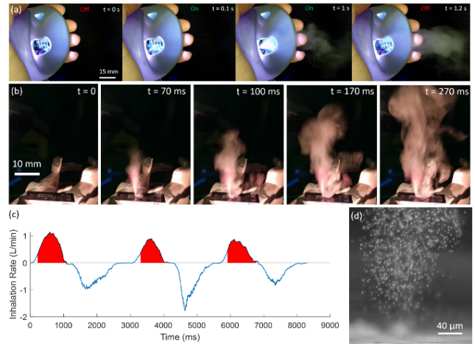 Figure 1: (a) Example of an ejection of a mist of droplets during a 1.1 s pulse of the PALM. (b) Typical aerosol formation demonstrating a volumetric flow rate of around 0.27 ml/min-1 which is comparable to current portable nebulisers on the market. (c) Example of measured breathing cycle with device actuation indicated in red. (d) Snapshot of droplets as they leave the microfluidic chip, from a high speed video recorded at 30,000 fps

triggered by the measured airflow rate through the device (Figure 1c). We demonstrate droplets with a narrow size distribution (Figure 1d), ejected at a total volumetric flow rate of 0.27 mL/min, which is comparable to current portable nebulizers on the market. The flowrate can be further scaled up by increasing the channel density.

Results and Discussion
To assess the performance of the PALM device, a solution of salbutamol sulphate (5 mg/2.5 mL) in saline was aerosolised using a conventional pMDI, a mesh nebulizer (Philips Innospire Go), and compared to our PALM device. The aerosol output was evaluated using a Next Generation Impactor (NGI) for aerodynamic particle sizing with a connected USP throat induction port. For each device, 1 mL of the formulation was loaded into the inhaler and continuous aerosol generation was performed at 15 L/min until all solution was aerosolized. Each device was tested in triplicate.
As shown in Table 1, the PALM device shows a higher fine particle fraction (FPF) and lower mean diameter when compared to a mesh nebuliser and a pMDI. Furthermore, the droplet size can be dialled by modifying the actuation parameters (Figure 2), paving way to on-demand personalised therapy.

Table 1: Comparison of key aerosol metrics for PALM device and commercially available mesh nebuliser, and pressurised metered dose inhaler.
Device | Fine Particle Fraction (FPF) | Mass Mean Aerodynamic Diameter (MMAD) µm | Geometric Standard Deviation (GSD)
PALM | 70.86 % ± 9.11 | 3.05 µm ± 0.31 | 1.75 ± 0.04
Philips Innospire Go | 64.4 % 12.2 | 3.99 µm ± 0.73 | 1.82 ± 0.02
pMDI | 52.0 % ± 2.9 | 4.3 μm ± 0.19 | 1.75 ± 0.04

There are several key advantages of the PALM technology; i) the hydrophilic channels can draw the fluid from an arbitrary reservoir to the active region of the chip through capillary action. This enables fluids to be drawn directly from drug filled capsules. ii) The fluid interface is constrained to the top of the channels ensuring a very well-defined,
stable interface from which aerosolisation occurs. iii) By defining the geometry and the position of these channels, multiple active regions can be created, which allows further scaling of the droplet delivery rate by simply increasing the density of channels on the chip.
Unlike in other ultrasonic approaches, PALM limits the degrees of freedom of the interface, and, hence allows the capillary waves to be easily controlled by tuning the frequency and the amplitude of vibration. To determine the effects of actuation parameters on the mean droplet size, device output was characterised through laser diffraction (Malvern, Spraytec) at increasing actuation frequencies. As shown in Figure 2, increasing frequency results in a drop in the mean droplet diameter while improving the spread in the measured droplet sizes.
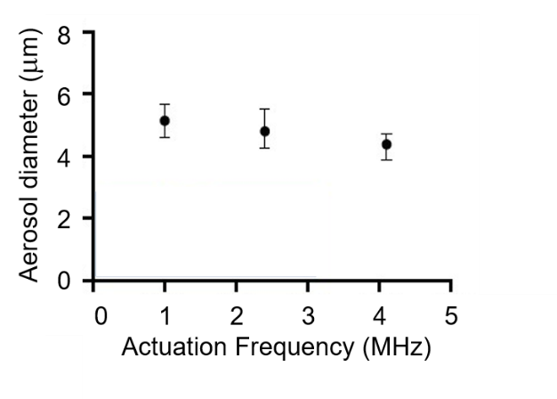
Figure 2. Dependence of droplet diameter and its size distribution on the actuation frequency for fixed channel geometry and vibration amplitude
Conclusions
PALM combines a patented aerosol generation technique with a user friendly design to improve adherence and the patient experience. The breath actuated, hand-held device is able to generate an improved fine particle fraction compared with commercially available approaches. Very importantly, the droplet size and distribution can be tuned on-demand by simply tuning the actuation parameters offering significant advantages for personalised drug delviery.
Acknowledgements
This study was supported by a NHMRC Development Grant 2000120. This work was performed in part at the Melbourne Centre for Nanofabrication (MCN) in the Victorian Node of the Australian National Fabrication Facility (ANFF). DT is funded by a Fellowship from the National Health and Medical Research Council (NHMRC) of Australia (APP1173363).
References
[1]. Usmani OS, Biddiscombe MF, Nightgale JA, Underwood SR, Barnes PJ: Effects of bronchodilator particle size in asthmatic patients using monodisperse aerosols. J Appl Physiol 2003, 95(5): 2106-2112.
[2]. Witte C, Nazarzadeh E, Pritchard J, Reboud J, Cooper JM, Surface Acoustic Wave Nebulisation for Targeted Inhalation Drug Delivery to Central and Peripheral Airways, Drug Delivery to the Lungs, 32 (2021)
[3] Pritchard J, Nebulisers: Time to reinvent the wheel, ONdrugDelivery, 92,10-15 (2018).
[4] Brenker J, Alan T, Traini D, “Personalised Aerosol Loading and Management (PALM): a Hand-Held Device for Aerosol Drug Delivery”. ONdrugDelivery, 131 (2022), pp 44–48.
[5] Brenker J, G. Al-mazi J, Le NHA, Pal S, Ong HX, Traini D, Alan T, Microfluidic Aerosol Generation: Development of a Next Generation Hand-Held Device for Aerosol Drug Delivery, Respiratory Drug Delivery (2022).

