Design and Exploration of Modified Cyclone Separator for Improved Yield of Spray-Dried Cubosomal Powder using Design of Experiment

Akash Deep & Vikas Rana

Department of Pharmaceutical Sciences and Drug Research, Punjabi University, Patiala (Punjab), India

Summary
This research work aimed to study effect of cyclone design or dimensions on cyclone separator performance in bench-top spray-dryer for the production of spray-dried cubosomal powder. The different cyclone separators were designed by modifying five geometrical parameters, i.e., length of cyclone body (L_{b}), length of cyclone cone (L_{c}), Height (H) and Width (W) of inlet section, and gas/air exit diameter (D_{e}) of standard cyclone separator. Further, the designed cyclones were evaluated using Lapple's equations, i.e., number of effective turns (N_{e}), inlet velocity of air (V_{i}), pressure drop (∆P) and cut-point diameter (d_{pc}). The modified cyclone (type XVII) with highest N_{e}, V_{i}, ∆P and lowest d_{pc} was selected for preparation of powder in comparison to standard cyclone (type I). Further, the Design of experiment was employed to evaluate the effect of formulation, process parameter and cyclone design (type I and XVII) on device removal efficiency (DRE), aerosolization efficiency (AE), fine particle fraction (FPF) and yield of cubosomal powder. Experimental results indicated that modified cyclone has significantly improved the yield of powder with insignificantly increasing the ∆P. The optimized spray-dried powder possesses sufficient geometrical standard diameter (d_{G}) (3.9 ± 0.25 µm) & aerodynamic diameter (d_{A}) (2.04 ± 0.15 µm) to deliver formulation to deeper lung tissues. It was found that modified cyclone was advantageous over standard one in increasing 1.8 folds yield with DRE, AE and FPF of 94.2%, 52.2%, and 63.8% respectively. Overall, this improvement in powder yield with desirable aerosolization properties will be beneficial in early-stage research and development involving bench-top spray-dryer.
Key Message
The modified cyclone has greatly improved the recovery of smaller inhalable particles. Thus, it could be envisaged that the application of developed cyclone could be extended to the recovery of any particulate delivery system in the size range of 1-5 µm, which was not effectively possible earlier with Lab-scale spray-dryer.
Introduction
Lung cancer is now identified as an extremely deadly disease with a minimal survival rate worldwide. Approximately, 85% of lung cancer patients have NSCLC as large cell, epidermoid, adenocarcinoma, bronchoalveolar, and squamous cell cancer [1, 2]. As an epidermal growth factor receptor (EGFR) kinase inhibitor, erlotinib (ERL) has strong potential in lung cancer therapy. Other than the poor aqueous solubility issue of ERL (BSC class II), which limits its oral bioavailability, the oral administration of the drug has two more major drawbacks. The first is the dose-related toxicities, and the second one is the inconvenience for cancer patients who have gastrointestinal tract (GIT) disorders along with cancer [3]. To overcome the above challenges, various solubility enhancement techniques have been utilized for pharmaceuticals [4-6]. Among them, Spray drying is the technique of choice for particle design with various drug delivery characteristics, irrespective of the route of administration [7, 8]. This drying process facilitates the designing of a novel stable cubosomal delivery system by modulating the size of particles, morphology, surface area, and crystallinity, which helps to improve stability of cubosomes. A surprising drawback about laboratory spray dryers is their low product yield because the active ingredients are expensive and available in very small amounts. The objective of the present investigation was to study the effect of cyclone separator design (standard and modified), formulation parameters (GMO: P407, PEG200, stirring temperature, stirring speed, stirring time, mannitol: leucine), and process parameters (inlet temperature, outlet temperature, aspirator flow rate) on the aerosolization properties and yield of ERL-loaded spray-dried cubosomal powder using Taguchi design and Signal to Noise ratio.
Methods
Generally, the efficacy of collecting the fine powder particles (1-5 µm) from the standard cyclone (type I) of lab-scale mini spray-dryer (Technosearch Instruments, Thane) was approximately 15-20% (FIGURE 1). To design the modified cyclone separator for the enhanced collection of respirable cubosomal powder, Classical cyclone design (CCD) and Texas cyclone design (TCD) processes were adopted to calculate the number of effective turns (N_{e}), inlet air velocity (V_{i}), pressure drop (∆P) and cut point diameter (d_{pc}) [9, 10]. To attain quality target product profile (QTPP) targets, various critical quality attributes (CQAs) were identified according to the ICH Q8 guidelines, including device removal efficiency (DRE), aerosolization efficiency (AE), fine particle fraction (FPF), and yield, that alter the quality of inhalable spray-dried cubosomal powder. After defining the QTPP and Ishikawa diagram (FIGURE 2A) [11], the risk assessment study was carried out for determining the critical material and process parameters that affect the quality of the inhalable spray-dried cubosomal powder and spray drying process [12, 13]. After risk assessment, a Taguchi L12 OA design (10 factors with 1 dummy at 2 levels) was utilized to study the effect of various formulation parameters, process parameters and cyclone design on percentage yield, device removal efficiency (DRE), aerosolization efficiency (AE), fine particle fraction (FPF), drug content uniformity, and particle size. The aqueous ethanolic solution (70%) containing Glyceryl monooleate (GMO), Poloxamer (P407), Mannitol and leucine with total solid content vary from 1.0- 1.1% w/v with constant ERL concentration (5.2% w/w) was spray dried with bench top spray dryer using standard and modified cyclone separator. The collected data from different trials were evaluated by analysis of variance (ANOVA) and signal to noise (S/N) ratio determined using Minitab software Version 19.2.0, USA. Further characterizations of the optimized cubosomal powder for change in solid-state properties and surface characteristics include particle size, SEM, and TEM. The Twin stage impinger were used to evaluate the aerosolization properties, i.e., mass median aerodynamic diameter (MMAD), device removal efficiency (DRE), aerosolization efficiency (AE), and FPF (fine particle fraction) of cubosomal powder obtained from both the cyclones [14, 15].
Results
Based on Lapple models, all the five main geometrical parameters were modified to fabricate, a new cyclone separator (type XVII) for enhanced recovery of inhalable spray-dried cubosomal powder with an expected average particle size of 1-5 µm (FIGURE 1). By altering the inlet airflow patterns using a modified cyclone, system modifications were made to favor decreased airflow resistance (increased ∆P), which in turn expected to improve the recovery of cubosomal powder. Apart from equipment configuration, particles can be further engineered by controlling a variety of formulation and process parameters. The Taguchi design was able to screen the most effective parameters that affect the aerosolization properties of inhalable spray-dried cubosomal powder based on the percent contribution of each active factor (FIGURE 2B). The Signal to Noise ratio was able to show the impact of critical material attributes (CMA), i.e., GMO: P407, PEG200, and critical process parameters (CPP), i.e., inlet temperature and cyclone design at both levels on critical quality attributes (CQA), i.e., % DRE, AE, FPF, yield of cubosomal powder. The highest delta value of cyclone design in both DRE and yield showed that cyclone design was considered to be the most important parameter that would majorly affect the spray drying yield with maximum device removal efficiency (FIGURE 3). The optimized ERL-loaded spray-dried cubosomal powder obtained using modified cyclone separator (type XVII) showed suitable aerodynamic properties with an acceptable MMAD of 3.1 µm and FPF of 72.2%. The SEM analysis and TEM analysis confirmed the spherical structure of solid powder particles and later one confirmed the cubic structure of cubosomes in the cubosomal dispersion formed after suitable reconstitution with water, respectively (FIGURE 4).
Conclusion
It was found that the selection of appropriate cyclone separator designs and configurations allows the preparation of ERL-loaded inhalable spray-dried cubosomal powder, which showed improved yield with desirable aerosolization properties. Material attributes and process parameters involved in the fabrication of ERL-loaded cubosomal powder were optimized to achieve desirable properties of DPI for good lung-regional expression. Advanced cyclone design (type XVII) has greatly improved the recovery of smaller diameter particles (<3µm), by increasing airflow pattern inside cyclone that would help to increase the centrifugal force on particles, thereby decreased cut point diameter of particles with insignificantly increasing the pressure drop (∆P). Thus, it could be envisaged that the application of developed cyclone separator (type XVII) could be extended to the recovery of any particulate delivery system in the size range of 1-5 µm, which was not effectively possible earlier.
Acknowledgement
The author would like to acknowledge the financial assistance provided by UGC-RGNF, India (Award no. F1-17.1/2014-15/RGNF-2014-15-SC-PUN-84255).
Figure 1 - Schematic diagram of laboratory co-current Spray dryer (TechnoSearch instruments) displaying operative principle of spray drying process along with illustrative design of cyclone separator.

Figure 2 - (A) Ishikawa diagram enclosed the various material components and process parameters that affect the quality of inhalable spray-dried cubosomal powder (B) Percent contribution of each active factor based on Taguchi design.
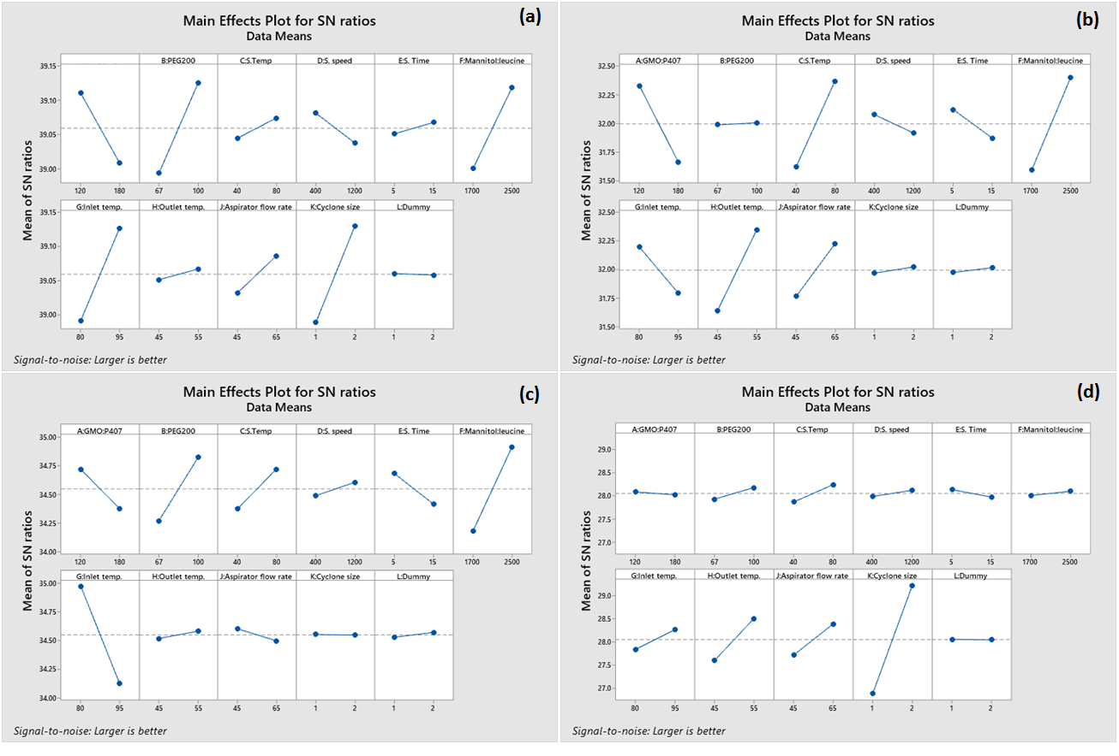
Figure 3 - Main eﬀects plot for Mean Signal-to-Noise ratio of a) Device removal efficiency, b) Aerosolization efficiency, c) Fine particle fraction, and d) Yield.

Figure 4 - (A) SEM image of spray-dried cubosomal powder particles, (B) TEM image, and (C) Particle size analysis of cubosomes formed after reconstitution of powder in water.
References
[1] Singh A, Bhatia S, Rana V: Inhalable Nanostructures for Lung Cancer Treatment: Progress and Challenges, Current Nanomedicine (Formerly: Recent Patents on Nanomedicine) 2019; 9:4-29.
[2] Ahmad J, Akhter S, Rizwanullah M, Amin S, Rahman M, Ahmad MZ, Rizvi MA, Kamal MA, Ahmad FJ: Nanotechnology-based inhalation treatments for lung cancer: state of the art, Nanotechnology, science and applications 2015; 8:55.
[3] Kim J, Ramasamy T, Choi JY, Kim ST, Youn YS, Choi H-G, Yong CS, Kim JO: PEGylated polypeptide lipid nanocapsules to enhance the anticancer efficacy of erlotinib in non-small cell lung cancer, Colloids and Surfaces B: Biointerfaces 2017; 150:393-401.
[4] Erdoğar N, Akkın S, Varan G, Bilensoy E: Erlotinib complexation with randomly methylated β-cyclodextrin improves drug solubility, intestinal permeability, and therapeutic efficacy in non-small cell lung cancer, Pharmaceutical Development and Technology 2021; 26:797-806.
[5] Dora CP, Kushwah V, Katiyar SS, Kumar P, Pillay V, Suresh S, Jain S: Improved oral bioavailability and therapeutic efficacy of erlotinib through molecular complexation with phospholipid, International Journal of Pharmaceutics 2017; 534:1-13.
[6] Patel K, Doddapaneni R, Patki M, Sekar V, Bagde A, Singh M: Erlotinib-valproic acid liquisolid formulation: evaluating oral bioavailability and cytotoxicity in erlotinib-resistant non-small cell lung cancer cells, AAPS PharmSciTech 2019; 20:1-11.
[7] Dellamary LA, Tarara TE, Smith DJ, Woelk CH, Adractas A, Costello ML, Gill H, Weers JG: Hollow porous particles in metered dose inhalers, Pharmaceutical research 2000; 17:168-174.
[8] Al-Khattawi A, Koner J, Rue P, Kirby D, Perrie Y, Rajabi-Siahboomi A, Mohammed AR: A pragmatic approach for engineering porous mannitol and mechanistic evaluation of particle performance, European Journal of Pharmaceutics and Biopharmaceutics 2015; 94:1-10.
[9] Taiwo MI, Namadi MA, Mokwa B: Design and analysis of cyclone dust separator, Am J Eng Res 2016; 5:130-134.
[10] Bashir K: Design and fabrication of cyclone separator, China University of Petroleum 2015.
[11] Soni G, Yadav KS, Gupta M: QbD based approach for formulation development of spray dried microparticles of erlotinib hydrochloride for sustained release, Journal of Drug Delivery Science and Technology 2020; 57:101684.
[12] Aven T: Improving risk characterisations in practical situations by highlighting knowledge aspects, with applications to risk matrices, Reliability Engineering & System Safety 2017; 167:42-48.
[13] Benjasirimongkol P, Piriyaprasarth S, Moribe K, Sriamornsak P: Use of risk assessment and Plackett–Burman design for developing resveratrol spray-dried emulsions: a quality-by-design approach, AAPS PharmSciTech 2019; 20:1-10.
[14] Kadota K, Tanaka M, Nishiyama H, Tse JY, Uchiyama H, Shirakawa Y, Tozuka Y: An effective approach to modify the inhalable betamethasone powders based on morphology and surface control using a biosurfactant, Powder Technology 2020; 376:517-526.
[15] Miyazaki Y, Aruga N, Kadota K, Tozuka Y, Takeuchi H: Improved respirable fraction of budesonide powder for dry powder inhaler formulations produced by advanced supercritical CO2 processing and use of a novel additive, International Journal of Pharmaceutics 2017; 528:118-126.

