Investigation of Design Features on the Performance of 3D-Printed Dry Powder Inhalers.
Part 2: swirl pipe design

Yuqing Ye^{1,2}, Ziyi Fan¹, Ying Ma^{1,2} & Jesse Zhu*¹

¹Western University, 1151 Richmond Street, London, N6A 3K7, Canada

²Suzhou Inhal Pharma Co., Ltd., 502-Bldf A SIP, 108 Yuxi Road, Suzhou, 215125, China

*Corresponding author: Dr. Jesse Zhu; E-mail address: jzhu@uwo.ca

Summary
Inhaled therapy has undergone a rapid expansion in dry powder inhalers (DPIs) in the past fifty years to treat pulmonary diseases. Despite their popularity, the development of DPIs has been constricted by low and inconsistent pulmonary drug delivery efficiency as well as significant drug loss in the mouth-throat region. Inhaler design has been a crucial player in powder dispersion and aerosolization. To improve the inhaler performance, swirl pipe designs with different diameters (3, 6, 9 mm) were introduced and incorporated into the mouthpiece of a capsule-based inhaler, and then evaluated by experimental analysis and numerical analysis using a carrier-based formulation. The results illustrate that the swirl pipe design can promote drug-carrier separation by introducing strong turbulent flow. Such “promotion” is much more prominent in the narrower swirl pipe (3 mm). However, the API retention in the device is remarkably high, up to 40%, which is likely due to the sudden configuration transition and particle-wall impaction as well. Therefore, the aerosolization performance of the inhaler with the swirl pipe design is compromised with undesirable results. Summarily, the swirl pipe design has the capability of increasing drug-carrier separation but generates high drug retention in the device. Further modifications to the swirl pipe design will be made to improve its aerosolization performance.
Key Message
Swirl pipe design can decrease drug deposition in the pre-separator (mouth-throat region) by promoting separation between API and carrier particles yet produce undesirably high drug retention in the inhaler with narrower swirl pipe and therefore a compromised aerosolization performance, which is likely due to the rapid configuration transition and high particle-wall impaction.

Introduction
Dry powder inhalers (DPIs) have proven to be an effective and convenient way to deliver medications in respirable size (1-5 µm) to the lungs in the treatment of respiratory and even systemic diseases [1]. An increasing popularity is received by DPIs because of ease of use, formulation stability, fewer environmental issues, and less coordination required for inhalation and actuation [2]. Currently, most commercial DPI products produce low fine particle fraction (FPF) with a large fraction of medications depositing in the mouth-throat region, especially for the carrier-based DPI formulations.
To improve FPF and decrease oropharynx deposition, numerous studies have been carried out, including particle engineering, inhaler design, and formulation optimization. The inhaler is an indispensable component in the medication-device DPI system, which is responsible for generating drug aerosol by a built-in dispersion mechanism. It is believed that turbulence in the DPI flow fields can encourage the deagglomeration of API fines or the de-attachment of APIs from the carrier [3]. For example, the grid structure is an effective design that can introduce strong turbulence as well as high velocity to improve dispersion by collision and/or shear stress [4].
Swirl pipe design is also capable of generating turbulent flow, which was first introduced into the DPI, Turbuhaler®, to break up “soft pellets” and promote de-agglomeration and dispersion, consequently improving the FPF to up to 50% [5]. Other efforts have also been made to study the swirl pipe design. For example, Lee et al. designed a spiral-shaped mouthpiece mounted to a blister-based multidose DPI, showing strong swirl motion of air streams and enhanced FPF [6].
Despite the efforts to improve the detachment of API fines from the coarse carrier, limitations also exist. The recently published study by Lee et al. used the spiral design as an extended mouthpiece, which may be inconvenient for patients to use. More importantly, the feasibility and performance of the swirl pipe design in a capsule-based inhaler have not been investigated yet. Therefore, in this study, the spiral pipe design with different configurations is introduced into a capsule-based inhaler to study its influence on the API-carrier separation and overall aerosolization performance.

Methods and materials
Indacaterol Maleate (IM) dry powder mixture (Batch NO.: BVY12) and a capsule-based inhaler, Breezhaler®, from Novartis Pharma (Switzerland), were used as the dispersion formulation and the model inhaler (Figure 1d), respectively. Chromatography-grade methanol and orthophosphoric acid purchased from Fisher Scientific, Canada, were used as the mobile phase components. The mixture of Brij35 from Alfa Aesar, Canada, and analytical-grade glycerol from Fisher Scientific, Canada, was used for cup coating.
The swirl pipe design was incorporated into the Breezhaler®, and changes were made to the inner diameter, thus generating three spiral channels with an inner diameter of 3 mm, 6 mm, and 9 mm, as can be seen in Figure 1.
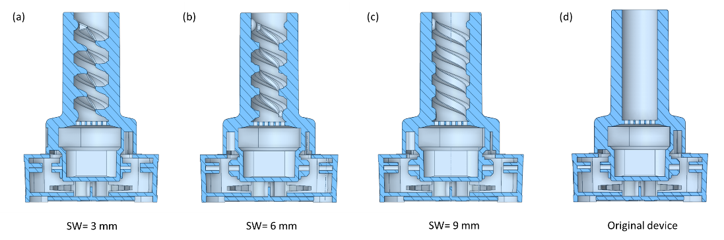
Figure 1 Illustration of 3D models of the inhalers with different swirl pipe designs
Aerosolization performance of the inhalers was evaluated using a Next Generation Impactor (NGI, Copley, Nottinghamshire, UK). The NGI was attached with a critical flow controller TPK 2000 (Copley Scientific Ltd, Nottingham, UK) to control the inhalation time duration and an HCP5 vacuum pump (Copley Scientific Ltd, Nottingham, UK) to draw air into the NGI system. Inhalers were actuated at a volumetric flow rate of 60 L/min for a total of 4 s with 13 capsules dispersed for each aerodynamic test. The NGI stages were coated with a mixture of ethanoic Brij35-glycerol to prevent particle re-entrainment [7]. After aerosol generation, the capsules and all the NGI stages were extracted with the methanol-water mixture (60:40), followed by IM content analysis by High-Performance Liquid Analysis (HPLC). Using the resulting aerodynamic particle size distribution data, fine particle fraction (FPF), emitted dose, un-detached drug fraction in pre-separator (PS), and mass retention of IM in the device were calculated. The FPF is defined as the mass percentage of IM with an aerodynamic diameter of 1-5 µm as of the loaded dose. The emitted dose is the emitting mass fraction of IM from the inhaler as of the loaded dose. The un-detached drug fraction is the mass fraction of IM in the pre-separator as of the loaded dose. The mass retention of IM in the device is the percentage of IM retained in the inhaler as of the loaded dose. Statistical analysis was performed using one-way ANOVA analysis at a p-value of 0.05.
Computational Fluid Dynamics (CFD) analysis was performed by using ANSYS Fluent (ANSYS Inc., USA). Turbulent flow inside the fluid domain was modelled using the standard generalized k-ε equations (two equations), which could predict the velocity, shear stress, and turbulent intensity for transit and turbulent flow [3], [8]. The unistructural poly-hexacore meshing was used since it has proven to generate high-quality meshes compared with polyhedrons [9]. The number of generated meshes was within the range of 350,000-700,000, which was sufficient to achieve mesh independence. As inhalers were evaluated at a steady volumetric flow rate of 60 L/min, the equivalent mass outflow of 0.001205 kg/s for mouthpiece outlet and zero-gauge pressure for inlets were adopted as boundary conditions, as reported in [10]. The absolute convergence criterion for simulations was set as 1×10⁻⁵. The system was solved by a segregated algorithm named SIMPLE in ANSYS, and double precision was employed in all the calculations for simulations.

Results
The inhalers with different swirl pipe diameters were evaluated by aerodynamic analysis and computational analysis.
Aerosolization performance
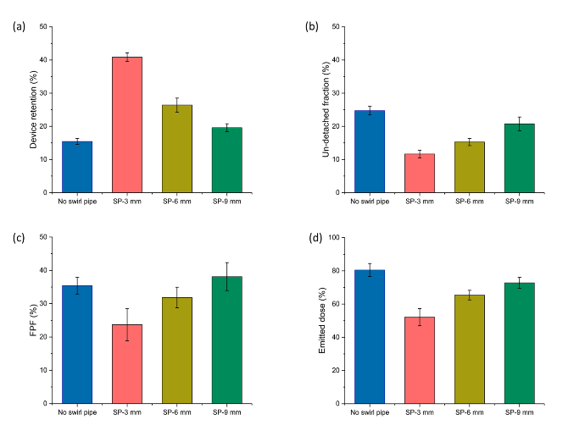
Swirl pipe design affects inhaler performance, including drug retention in the device, un-detached drug fraction in pre-separator (PS), fine particle fraction (FPF), and emitted dose, shown in Figure 2. Drug retention in the inhalers with the swirl pipe (SW) design is increased when compared with original inhaler without swirl pipe (15.4%±0.9%). Particularly, the mass retention is remarkably high for the narrow spiral channel (3 mm), approximately 40.9%±1.3%, as can be seen in Figure 2a. Increasing the pipe diameter to 9 mm, the retention is significantly decreased to 19.6%±1.2% (p<0.05).
The drug deposition in the pre-separator (PS) can be reduced by the swirl pipe design. Compared with the original inhaler with a 24.7%±1.3% value in PS, a great decrease to 11.7%±1.2% for the inhaler with a 3 mm-wide swirl pipe is observed in Figure 2b (p<0.05), which shows a significantly improved separation between the API and the carrier. When the swirl pipe diameter increased to 9 mm, such “separation” is not as significant as expected. The results illustrate that the swirled mouthpiece could promote detachment of the API from the carrier. Narrower swirl pipes greatly contribute to the detachment of APIs from the carrier, which may lead to an improvement in aerosolization performance.
Figure 2 The aerosolization performance including (a) drug retention in the device, (b) un-detached drug fraction in pre-separator, (c) fine particle fraction, and (d) emitted dose
Despite the remarkably increased de-attachment between API and carrier by the narrow swirl pipe (3 mm), the FPF and emitted dose show undesirable results, 23.7%±4.8% and 52.1%±5.2%, respectively. As the inner diameter of the swirling pipe increased from 3 mm to 9 mm, a significant increase in FPF and emitted dose to 38.1%±4.2% and 72.8%±3.3% are observed in Figure 2c and Figure 2d (p<0.05). In comparison with the original inhaler, the 9-mm swirl pipe shows little difference in FPF (p>0.05) and significant difference in emitted dose (p<0.05).
Overall, the swirl pipe design could promote de-attachment of the API from the carrier. Narrow swirl pipe shows better separation but lower aerosolization performance in terms of FPF and emitted dose, which may result from too much drug retention in the device.
Computational analysis
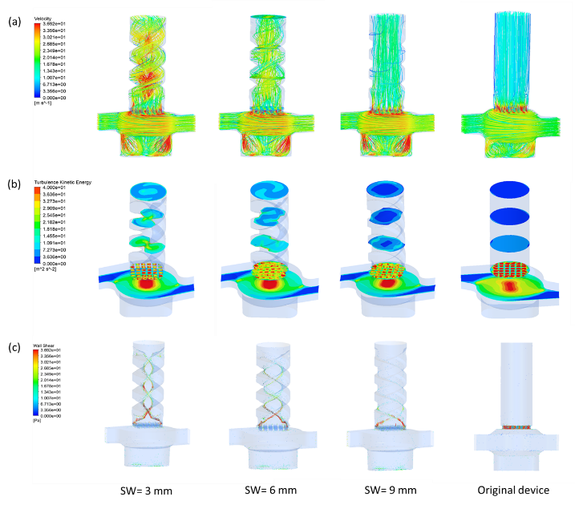
The influence of swirl pipe (SW) designs on the velocity, turbulent kinetic energy (TKE), and wall shear in the inhaler is shown in Figure 3. The introduction of swirl pipe generated spiral flow fields and spiral flow patterns (Figure 3a). The narrower spiral pipe produced more swirled flow with higher velocity in the mouthpiece when compared with straight air trajectories with relatively small velocity in the original inhaler.
In addition to the swirled airstreams, the intensive turbulent flow was also introduced by the swirl pipe design. Particularly, the narrow swirl pipe (3 mm) led to a relatively high TKE level. The area-averaged TKE on five specific planes are shown in Figure 3b to present an overview of turbulent differences along the mouthpiece forward to the exit. Highest TKE is observed at the grid for the inhalers with or without swirl pipe, which is consistent with the previous work in [4]. It is also noticeable that the turbulence intensity decreases along the mouthpiece from the grid to the exit, while the turbulence in the circular chamber shows insignificant differences between the inhalers (p>0.05), which illustrates that the swirl pipe design mainly affects the mouthpiece regions. Furthermore, the turbulent level and wall shear in the spiral pipes are greatly elevated in comparison with the original inhaler. When the diameter of the swirl pipe is decreased, an apparent increase in TKE and wall shear is observed in Figure 3b and Figure 3c, particularly in the early entry of the swirl pipe.
Figure 3 Contour maps of (a) airflow trajectories, (b) turbulent kinetic energy profiles in the inhalers with different swirl pipe designs

Discussion
The swirl pipe design could decrease drug impaction in pre-separator (PS) by promoting API-carrier separation. Particularly, the narrower swirl pipe (3 mm) is capable of significantly decreasing the un-detached drug in PS to as low as 12%, which could be ascribed to the increased turbulent intensity and wall shear in the mouthpiece region.
Despite the improved separation, a remarkably high fraction of drug particles retains in the device, especially for the narrow swirl pipe (3 mm). A possible reason lies in the sudden geometric transition for the flow from a large circular cross-session (11.2 mm) to a narrow spiral channel (3 mm), which causes the impaction of particles on the entry of the mouthpiece wall. Additionally, a strong particle-wall collision could be introduced by the tangential shear stress and velocity, causing drug deposition in the mouthpiece. Moreover, the API-carrier mixture used in the study is also a possible contributor to the high drug retention. In the narrower spiral channel, a high velocity is generated (Figure 3b) in the flow fields where the large carrier particles with APIs attached have great momentum and tend to impact on the pipe wall. Therefore, affected by the “improved separation” and “high drug retention”, the overall aerosolization performance of the inhaler with a 3-mm wide swirl pipe is not as satisfactory as expected.
When looking at the inhaler with a large diameter of the swirl pipe (9 mm), the API-carrier separation is moderately decreased while device retention is much reduced than that of 3-mm swirl pipe due to the relatively smooth transition as well as a much smaller velocity and wall shear in the flow field. Overall, the FPF of the inhaler (9 mm) is greatly improved in comparison with the narrow swirl pipe yet shows insignificant changes with the original inhaler in FPF. In future work, the swirl pipe design should be further modified to improve the dispersion and aerosolization performance.

Conclusions
The swirl pipe design with different diameters (3, 6, 9 mm) were investigated by experimental and computational tests. The results show that the swirl pipe could promote API-carrier separation by introducing intensive turbulent flow, which is particularly prominent in the inhaler with narrower spiral mouthpiece (3 mm). Despite the benefits, high mass percentage of drug particles retained in the device, leading to compromised aerosolization performance. Future work will be placed on the modifications of the swirl pipe design to further improve its dispersion and aerosolization.

References
[1] H.-G. Lee, D.-W. Kim, and C.-W. Park, “Dry powder inhaler for pulmonary drug delivery: human respiratory system, approved products and therapeutic equivalence guideline,” Journal of Pharmaceutical Investigation, vol. 48, no. 6, pp. 603–616, Nov. 2018, doi: 10.1007/s40005-017-0359-z.
[2] M. L. Levy, W. Carroll, J. L. Izquierdo Alonso, C. Keller, F. Lavorini, and L. Lehtimäki, “Understanding Dry Powder Inhalers: Key Technical and Patient Preference Attributes,” Adv Ther, vol. 36, no. 10, pp. 2547–2557, Oct. 2019, doi: 10.1007/s12325-019-01066-6.
[3] T. Suwandecha, W. Wongpoowarak, K. Maliwan, and T. Srichana, “Effect of turbulent kinetic energy on dry powder inhaler performance,” Powder Technology, vol. 267, pp. 381–391, Nov. 2014, doi: 10.1016/j.powtec.2014.07.044.
[4] K. Elserfy, A. Kourmatzis, H.-K. Chan, R. Walenga, and S. Cheng, “Effect of an upstream grid on the fluidization of pharmaceutical carrier powders,” International Journal of Pharmaceutics, vol. 578, p. 119079, Mar. 2020, doi: 10.1016/j.ijpharm.2020.119079.
[5] Sz. Kugler, A. Nagy, A. Kerekes, M. Veres, I. Rigó, and A. Czitrovszky, “Determination of emitted particle characteristics and upper airway deposition of Symbicort® Turbuhaler® dry powder inhaler,” Journal of Drug Delivery Science and Technology, vol. 54, p. 101229, Dec. 2019, doi: 10.1016/j.jddst.2019.101229.
[6] H.-J. Lee et al., “Spiral mouthpiece design in a dry powder inhaler to improve aerosolization,” International Journal of Pharmaceutics, vol. 553, no. 1–2, pp. 149–156, Dec. 2018, doi: 10.1016/j.ijpharm.2018.10.036.
[7] D. Daniher et al., “Protective effects of aerosolized pulmonary surfactant powder in a model of ventilator-induced lung injury,” International Journal of Pharmaceutics, vol. 583, p. 119359, Jun. 2020, doi: 10.1016/j.ijpharm.2020.119359.
[8] M. Ilie, E. A. Matida, and W. H. Finlay, “Asymmetrical Aerosol Deposition in an Idealized Mouth with a DPI Mouthpiece Inlet,” Aerosol Science and Technology, vol. 42, no. 1, pp. 10–17, Jan. 2008, doi: 10.1080/02786820701777440.
[9] Y. H. Kim, D. D. Li, S. Park, D. S. Yi, G. H. Yeoh, and A. Abbas, “Computational investigation of particle penetration and deposition pattern in a realistic respiratory tract model from different types of dry powder inhalers,” International Journal of Pharmaceutics, p. 121293, Nov. 2021, doi: 10.1016/j.ijpharm.2021.121293.
[10] Y. H. Kim, D. D. Li, G. H. Yeoh, and A. Abbas, “Optimization of swirler type dry powder inhaler device design – Numerical investigation on the effect of dimple shape, inlet configuration and mouthpiece constriction,” Journal of Aerosol Science, vol. 159, p. 105893, Jan. 2022, doi: 10.1016/j.jaerosci.2021.105893.
[11] Guozhen Li, P. Hall, N. J. Miles, and T. Wu, “Optimization of a four-lobed swirl pipe for Clean-In-Place procedures,” 2015, doi: 10.13140/RG.2.1.4838.0004.

