Improved in vitro-in vivo correlation (IVIVC) in freeze-dried particle deposition patterns of antigen-containing liposomes

Matteo Aroffu^{1,2}, Fátima García-Villén², Maria Letizia Manca¹, Maria Manconi¹ & José Luis Pedraz²

¹ Department of Scienze della Vita e dell’Ambiente, University of Cagliari, via Ospedale 72, 09124, Cagliari, Italy

² Laboratory of Pharmaceutics, School of Pharmacy, University of the Basque Country (UPV/EHU), paseo de la Universidad 7, 01006, Vitoria-Gasteiz, Spain

Summary
Several infective diseases develop due to air-borne pathogens. Therefore, being able to counteract them already at the entry site may make it possible to avoid their spread. Lung vaccination offers the possibility to reach local immunisation along with systemic immunisation. Moreover, it allows to meet patients’ needs for a painless, self-administration.
Consequently, freeze-dried liposomal nanovaccines carrying ovalbumin as antigen model have been specifically designed to be administered by the lungs. A commercial device characterized by low resistance, the Aerolizer®, was chosen as dry powder inhaler (DPI). However, when it comes from inhalant dry powders, the choice of the device is not the only relevant element in terms of lung delivery. Patient's state of health must be considered too. Therefore, we assessed powders’ behaviour simulating healthy, asthmatic and COPD patients’ inhalation profiles by means of a breathing simulator coupled to the next generation impactor (NGI). Moreover, in order to get a better in vitro-in vivo correlation (IVIVC), we combined them with the adult Alberta idealised throat (AIT).
Finally, considering that the mucus lining the respiratory mucosa is the main obstacle in antigen transport, we analysed the penetration of vesicular nanovaccines through an artificial mucus model either in presence of the patented mucolytic BromAc® or not.
Key Message
This study evaluates the inhalation performances of a pulmonary vaccine designed as a dry powder in healthy, asthmatic and COPD profiles, highlighting how specific diseases can influence lungs deposition parameters, especially in terms of fine particle dose (FPD) thus affecting therapeutic outcome.

Introduction
Inhalation has been used as effective route of administration of therapeutical products against air-borne pathogens since the 20th century due to its own advantages [1]. However, one of the main challenges to be faced in vaccines’ delivery remains the instability related to the sensitiveness of antigens to various conditions, such as aerosolizing [2] and metabolic active environments [3]. An already validated strategy to improve stability is the encapsulation into liposomes [4], biocompatible, colloidal systems that can be easily turned into powders achieving even further stability. Several strategies can be adopted to tune the size of the resulting particles. The most used include freeze-drying, spray freeze-drying and spray drying, among others. The resulting powders are then usually delivered to the lungs by using dry powder inhalers (DPIs). If from one hand particles ranging 1-5 μm are required for a deposition in the deep lungs thus allowing systemic actions, on the other hand bigger particles can deposit in the mucosal-associated lymphoid tissue (MALT), located in the tonsils, allowing a local, adaptive immune response [5]. Unfortunately, DPIs themselves are not the only element on which particle size is dependent. The inhalation pattern of the patient must be considered when it comes from lung deposition as it may adversely affect the therapeutic outcome [6]. For this reason, the assessment of powders’ behaviour under different health conditions is nowadays required. Finally, another crucial element that can complicate targeting is the mucus lining the respiratory mucosa, which is why a strategy to facilitate mucus penetration should be always considered [7].
With that in mind, the objectives of this study were: 1) formulate a suitable powder for lung delivery; 2) evaluate how patient's state of health can affect powders’ lung deposition and, consequently, the effectiveness of the therapeutic approach; 3) enhance mucus penetration.
Experimental methods and materials
Liposomal nanovaccines loading ovalbumin (Sigma-Aldrich, Italy) as antigen model were prepared by direct sonication using a Branson Sonifier 250 (USA). Briefly, 14 mg of either DPPC or S PC-3, 1 mg of cholesterol, 10 mg of ovalbumin were dispersed in 3 ml of distilled water and pulse sonicated (duty-cycle 70%, output control 5) three times for 1.5 minutes, allowing the samples to cool down between each cycle in order to avoid overheating phenomena.
To improve stability, all the colloidal formulations were subsequently freeze-dried in a Lyobeta freeze-dryer (Telstar, Spain) in presence of Inulin (Fagron, Spain) as cryoprotectant (1:3 lipid to cryoprotectant ratio). Only the formulations with a final size to initial size ratio (Sf/Si) < 1.3, that is an index of the effectiveness of the process[8], were further characterized.
Size (DM), polydispersity index (PI) and zeta potential (ZP) were determined by means of photon correlation spectroscopy method by using a Zetasizer Ultra (Malvern, UK), both before and after freeze-drying. The encapsulation efficiency (EE%) was instead determined indirectly through centrifugal filtration (2000 rpm, 1 h) using centrifugal separators Vivaspin 500 (Sartorius, Germany) with appropriate cut-off (100 kDa), once again before and after freeze-drying.
The effective formation of nanoliposomes, their shape and lamellarity were assessed by cryo-transmission electron microscopy (cryo-TEM) with a TECNAI G2 20 TWIN (FEI) microscope as well as their integrity after freeze-drying and subsequent rehydration. In contrast, cryoprotectant-coated nanoliposomes were identified by scanning electron microscopy (SEM) using a tabletop TM4000 microscope (Hitachi High-Tech, Japan) operating at 5 kV voltage and x1000 magnification.
To perform the in vitro aerodynamic performance studies, the commercial device Aerolyzer® (Novartis, Switzerland) was selected as dry powder inhaler (DPI). Immediately before each experiment, the liposomal freeze-dried powders were diluted 1:10 with Respitose® SV003 and homogenized per 10 seconds with a CapMix™ Capsule Mixing Device (3M, UK). Subsequently, 5 size 3 hydroxypropyl methylcellulose Quali-V®-I capsules (Qualicaps, Spain) were manually filled with 14 mg of diluted powder, yielding a final ovalbumin quantity of 200 μg/capsule. Each capsule was then shaken for 5 more seconds before the use.
To investigate lung deposition and have a better in vitro-in vivo correlation, further studies were undertaken by pairing the Next Generation Impactor (NGI) (Copley, UK) with both the adult Alberta Idealised Throat (AIT) and the BRS 3000 breath simulator (Copley, UK). Moreover, healthy, asthmatic and COPD patient inhalation patterns were shaped accordingly to some equations previously developed [9] and uploaded to the BRS 3000 breath simulator in order to study powders’ behaviour in the three aforementioned types of patients.
Lastly, a mucus penetration study was carried out using a previously developed artificial mucus model on Transwell® (6.5 mm well, 5.0 μm pore) [10]. Vesicles were tested in the absence or presence of the patented mucolytic agent BromAc®, at a Bromelain concentration of 100 μg/ml.
Results
Liposomal nanovaccines loading ovalbumin were successfully developed and freeze-dried, having narrow size distribution both before and after freeze-drying (Figure 1).
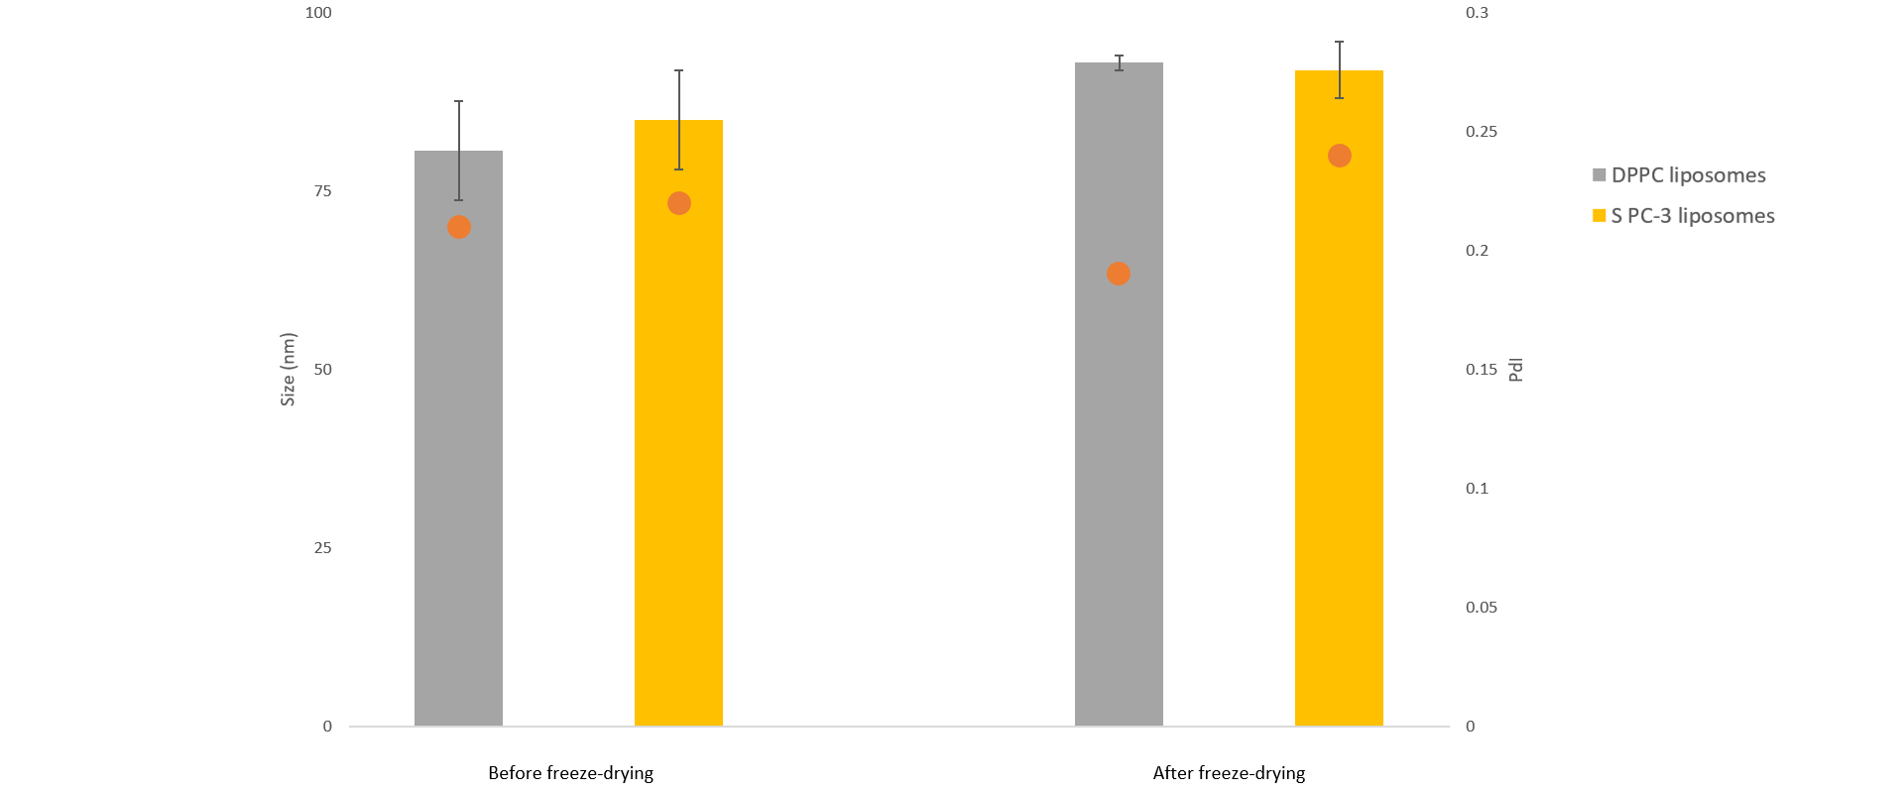
Figure 1 – Size (nm) and polydispersity index (PdI) of DPPC liposomes (grey bars) and S PC-3 liposomes (yellow bars) before (left) and after (right) freeze-drying.
The effective formation of both liposomes and cryoprotectant-coated liposomes as well as liposomes integrity after freeze-drying was confirmed by microscopy, as shown in Figure 2. Overall, spherical, unilamellar liposomes were detected as well as spherical particles with a diameter of less than 5 microns.
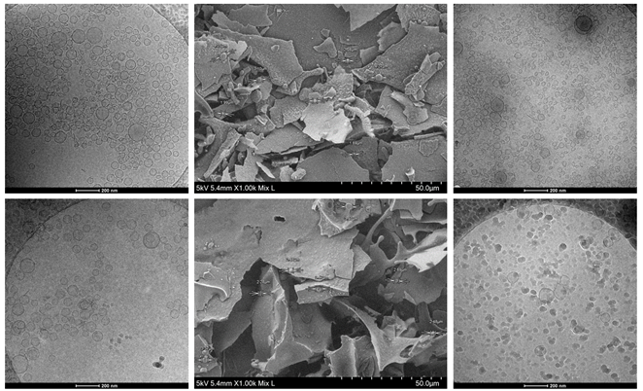
A
B
C
D
E
F
Figure 2 – Cryo-TEM images of DPPC liposomes and S PC-3 liposomes before freeze-drying (A and D, respectively), after freeze-drying as powders (B and E, respectively) and after freeze-drying and rehydration (C and F, respectively).
NGI tests on simulated healthy, asthmatic and COPD patient highlighted different lung deposition behaviours for the diluted powder, especially in terms of FPD. Table 1 shows these differences in the three different conditions. Higher values of FPD were detected for healthy patients probably due to the higher inspiratory volumes.
Table 1 – Fine particle dose (FPD) delivered by DPPC liposomes and S PC-3 liposomes in healthy (left), asthmatic (centre) and COPD (right) patients.
 | Healthy patients | Asthmatic patients | COPD patients
 | FPD (μg) | FPD (μg) | FPD (μg)
DPPC liposomes | 72.01±0.31 | 54.41±3.78 | 56.21±0.62
S PC-3 liposomes | 70.48±3.42 | 55.29±0.19 | 59.33±2.84
The mucus penetration study compared vesicles either with or without BromAc®, as shown in Figure 3. The addition of BromAc® allow the vesicles to reach levels of mucus penetration at 2 h comparable to the ones reached by the vesicles without it at 24 h, demonstrating the importance of the mucolytic agent in this type of therapy.
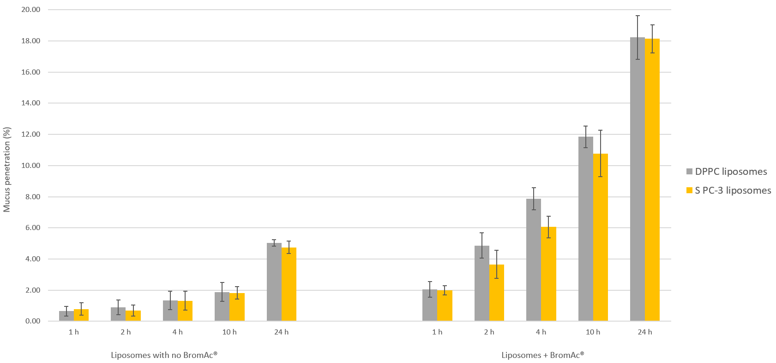
Figure 3 – Mucus penetration (%) of DPPC liposomes (grey bars) and S PC-3 liposomes (yellow bars) in absence (on the left) and in presence (on the right) of the mucolytic agent BromAc®.
Discussion
Aiming at improving antigen stability, ovalbumin was at first encapsulated into liposomal nanovesicles and then freeze-dried. Both the dimensional and morphological analysis confirmed the successful encapsulation of the antigen and therefore the suitability of the resulting dry powder. Considering that the pulmonary administration is a convenient site to deliver therapeutic or prophylactic agents due to the possibility of exerting local and systemic effects with an easy, painless and self-administration, a dry powder inhaler (DPI) was chosen to deliver the dry powder to the lungs. Specifically, the Aerolizer was chosen as a commercial device characterized by low resistance and ease of use. However, lung deposition with DPIs is strictly related to the flow generated by the patients. Therefore, three different inhalation profiles were investigated to understand how the differences in the inhalation patterns can influence the effectiveness of the therapy. In pulmonary delivery, the effective dose that actually reaches the lungs and it is therapeutically available is called fine particle dose (FPD). This study pointed out how the lung deposition parameters, and in particular the fine particle dose (FPD), were modified according to the different inhalation profile patterns, suggesting the need of a customized therapeutic approach. In any case, while therapy can be influenced by the patient's state, the presence of mucus can hinder the targeting process and thus the initiation of the therapeutic activity. For this reason, an analysis was conducted on artificial mucus, which demonstrated the increased ability of vesicles to cross mucus in the presence of BromAc® and thus paved the way for a combination therapy with a mucolytic agent.
Conclusion
Even if the pulmonary administration route offers several advantages, a lot of variables can affect the therapeutic outcome. Being able to predict with good correlation in vitro-in vivo the pulmonary deposition plays nowadays a key role because it could help in designing a proper therapy in advance. In addition, combining pulmonary delivery with a mucolytic agent can help in speeding up targeting and onset of therapeutic action.
Although these preliminary results are promising, future studies are needed to investigate vesicles interaction with immune cells.

References
[1] J.L. Rau, The inhalation of drugs: Advantages and problems, Respir. Care. 50 (2005) 367–382.
[2] E. Bodier-Montagutelli, A. Mayor, L. Vecellio, R. Respaud, N. Heuzé-Vourc’h, Designing inhaled protein therapeutics for topical lung delivery: what are the next steps?, Expert Opin. Drug Deliv. 15 (2018) 729–736. https://doi.org/10.1080/17425247.2018.1503251.
[3] G. Candiano, M. Bruschi, N. Pedemonte, L. Musante, R. Ravazzolo, S. Liberatori, L. Bini, L.J.V. Galietta, O. Zegarra-Moran, Proteomic analysis of the airway surface liquid: Modulation by proinflammatory cytokines, Am. J. Physiol. - Lung Cell. Mol. Physiol. 292 (2007) 185–198. https://doi.org/10.1152/ajplung.00085.2006.
[4] C.S. Haworth, D. Bilton, J.D. Chalmers, A.M. Davis, J. Froehlich, I. Gonda, B. Thompson, A. Wanner, A.E. O’Donnell, Inhaled liposomal ciprofloxacin in patients with non-cystic fibrosis bronchiectasis and chronic lung infection with Pseudomonas aeruginosa (ORBIT-3 and ORBIT-4): two phase 3, randomised controlled trials, Lancet Respir. Med. 7 (2019) 213–226. https://doi.org/10.1016/S2213-2600(18)30427-2.
[5] T. Sécher, A. Mayor, N. Heuzé-Vourc’h, Inhalation of Immuno-Therapeutics/-Prophylactics to Fight Respiratory Tract Infections: An Appropriate Drug at the Right Place!, Front. Immunol. 10 (2019) 1–6. https://doi.org/10.3389/fimmu.2019.02760.
[6] J.K.F. Jakobsson, H.L. Aaltonen, H. Nicklasson, A. Gudmundsson, J. Rissler, P. Wollmer, J. Löndahl, Altered deposition of inhaled nanoparticles in subjects with chronic obstructive pulmonary disease, BMC Pulm. Med. 18 (2018) 1–11. https://doi.org/10.1186/s12890-018-0697-2.
[7] P. Muralidharan, E. Mallory, M. Malapit, H. Don, H.M. Mansour, Inhalable PEGylated phospholipid nanocarriers and PEGylated therapeutics for respiratory delivery as aerosolized colloidal dispersions and dry powder inhalers, Pharmaceutics. 6 (2014) 333–353. https://doi.org/10.3390/pharmaceutics6020333.
[8] P. V. Date, A. Samad, P. V. Devarajan, Freeze thaw: A simple approach for prediction of optimal cryoprotectant for freeze drying, AAPS PharmSciTech. 11 (2010) 304–313. https://doi.org/10.1208/s12249-010-9382-3.
[9] R.R. Delvadia, X. Wei, P.W. Longest, J. Venitz, P.R. Byron, In Vitro Tests for Aerosol Deposition. IV: Simulating Variations in Human Breath Profiles for Realistic DPI Testing, J. Aerosol Med. Pulm. Drug Deliv. 29 (2016) 196–206. https://doi.org/10.1089/jamp.2015.1215.
[10] J. Zhao, L. Qin, R. Song, J. Su, Y. Yuan, X. Zhang, S. Mao, Elucidating inhaled liposome surface charge on its interaction with biological barriers in the lung, Eur. J. Pharm. Biopharm. 172 (2022) 101–111. https://doi.org/10.1016/j.ejpb.2022.01.009.

