Effects of saline nebulisation on SARS-CoV2 spreading and exhaled bio-aerosol particles in hospitalised COVID-19 patients

Francesca Buttini¹, Leonardo Gori², Fabio Morecchiato², Andrea Bartolini², Gian Maria Rossolini,² Alessandro Bartoloni², Jessica Mencarini², Ruggero Bettini¹ and Federico Lavorini²

¹Food and Drug Department, University of Parma, Parco Area delle Scienze 27A, Parma, 43124, Italy

²Department of Experimental Medicine, University of Florence, Largo Brambilla 3, Florence, 50134, Italy

Summary
Nebulised therapy is the mainstay for treating obstructive airway diseases, but there is heightened particular concern about the potential risk for SARS-CoV2 transmission during nebulisation in COVID-19 patients. In 10 patients (6 females, mean age 63±4 yr) hospitalised for COVID-19 we investigated the effects of 0.9% saline nebulisation on SARS-CoV2 spreading. In 5 out of the 10 patients we also ascertained whether saline nebulisation changed the number of exhaled particles. Air samples were collected by using suction pumps equipped with 0.45µ PTFE filters and positioned around the patient's bed. Exhaled particles were quantified by using an optical particle counter. At baseline (i.e. before nebulisation) SARS-CoV2 was detected more in the pumps close to the patient than in those far away. In the pumps close to the patient, detection of SARS-CoV2 was similar after saline nebulisation compared to baseline. In the pumps far from the patient saline nebulisation slightly but not significantly increased SARS-CoV2 detection compared to baseline. Overall, no significant changes in the SARS-CoV2 detection was observed after saline nebulisation. At baseline, we found a large variability among patients in the exhaled particles emission, with 2 patients showing higher emission of particles than the remaining patients. Saline nebulisation induced a marked decrease in exhaled particles in the 2 patients who displayed high emission at baseline, whereas no changes was observed in the remaining. Of note, the patients who displayed high emission at baseline showed a reduction in the number of pumps positive for SARS-CoV2 after saline nebulisation. This pilot study shows that saline nebulisation does not significantly change SARS-CoV2 spreading. Thus, there is no compelling reason to alter aerosol delivery devices for patients with established nebuliser-based regimens.
Key Message
Saline nebulisation does not change SARS-CoV2 spreading.

Introduction
The severe acute respiratory syndrome coronavirus 2 (SARS-CoV2), which causes COronaVirus Disease 2019 (COVID-19), has resulted in a worldwide pandemic and currently represents a major public health [1]. The SARS-CoV2 virus is transmitted between people through respiratory droplets, bio-aerosols and contact routes [2]. An increased risk of SARS-CoV2 transmission has been associated with aerosol generating procedures, including nebulised treatment [3]. Despite the lack of any robust evidence, there is currently a heightened concern regarding the potential risk of transmission of SARS-CoV2 from patients with COVID-19 undergoing nebulised treatment [4]. While some guidelines [5,6] have advised against the use of nebuliser treatment unless absolutely necessary, others [7] have recommended the continued use of nebulised treatment when applicable. Aerosols generated by a nebuliser is derived from a medication solution and is not a bioaerosol - potentially infectious - as that generated during cough or sneeze [8]. However, nebulisers could generate fugitive emissions during the drug administration, which are added to patient expiration potentially infectious [9]. Moreover, aerosol delivery devices, including nebulisers, could be theoretically considered as fomites, and, therefore, required strict hygiene rules before, during and after use. Interestingly, it has been reported that, in healthy volunteers, nebulisation of isotonic saline reduced the number of exhaled bio-aerosol particles expired by 72% for up to 6 hours due to modifications of the surface tension and viscous forces acting on lung-lining fluid [10]. Whether nebulisation of isotonic saline aerosols may reduce exhaled particle also in patients affected by viral infection, including SARS-CoV2, is unknown.
Hence, this study aimed at investigating the effects of 0.9% saline nebulisation on SARS-Cov2 spreading in patients with COVID-19. We hypothesise that saline nebulisation may transiently reduce the number of exhaled bio-aerosol droplets with no significant diffusion of virus in the environmental caused by the nebulisation.

Methods
This is a single centre, cross-sectional explorative study on adult patients of both genders admitted to the Careggi University Hospital (Florence, Italy) for COVID-19. We excluded patients requiring ventilation or high (FiO₂ >40%) level of supplemental oxygen. Air samples of the hospital patient's room environmental were collected according to the ISPE guidelines [11] by using five suction XR5000 pumps (SKC Inc., Eighty-Four, PA) positioned around the patient's bed at different heights and distances (Figure 1) and containing a 0.45 µ PTFE filter. At baseline pumps run at 3 L/min for 3 hours to allow control (i.e. before saline nebulisation) air samples collection. During the air-sampling period, patients were free to talks and/or cough. After sampling, the airborne viral load captured within each pump filter were detected and quantified using a real-time polymerase chain reaction assay (RT-qPCR). After sampling of control air, each patient was asked to breathe normally for 3-5 min through a mouthpiece connected to an optical particle counter (Climet, Ultimate 100, Redlansa, CA) to measure the number of expired particles. Subsequently, patients were administered 0.9% saline delivered by means of a PARI LC Plus Jet nebuliser (PARI, Starnberg, Germany) connected to a compressed air source at 18 psi. Air sampling was collected during and 3 hours after nebulisation with the same procedure as described above. In addition, measurement of exhaled particles was repeated 15, and 60 min after nebulisation. Comparison between the number of samples positive for SARS-CoV2 before and after nebulisation was performed by means of the Fisher’s exact test. Differences between exhaled particles before and after nebulisation were qualitatively assessed. A P<0.05 value was taken as significant
Figure 1. Positioning, heights and distances of the five suction pumps from the patient’s hospital bed.
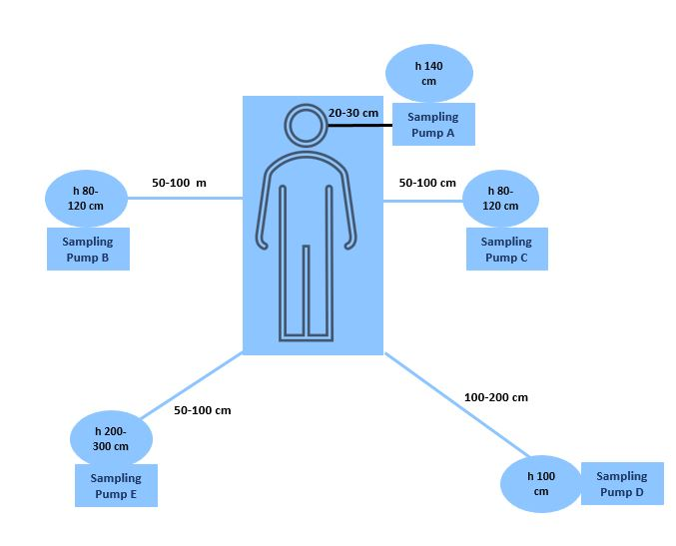
Results
We enrolled 14 patients (6 females, mean age 63±4 yr) with a RT-qPCR positive for SARS-COV2 and viral loads in nasal swab ranging from 2.10² to 9.10⁵ copies/ml. 10 out of the 14 patients completed the pre (50 samples) and post (50 samples) nebulisation runs, whereas the remaining patients dropped out due to worsening of the disease. In these 10 patients, we detected SARS-CoV2 in all the 5 selected sites before and after nebulisation (Figure 2 right panel). At baseline, SARS-CoV2 was detected more in the pumps positioned closely to the patient (pumps A-C) than in those far away (pumps D and E), where SARS-CoV2 was found in only 10% of these pumps (Figure 2 right panel). In the pumps positioned close to the patient, detection of SARS-CoV2 was similar or lower after saline nebulisation compared to baseline (Figure 2, right panel). In the pumps far from the patient saline nebulisation slightly but not significantly increased SARS-CoV2 detection compared to baseline (Figure 2, right panel). Overall, no significant changes in the SARS-CoV2 detection was observed after saline nebulisation (Figure 2 left panel). In a subgroup (n=5) of patients, we measured the number of exhaled particles before and after nebulisation. At baseline, we found a large variability among patients in the exhaled particles emission, with 2 patients (#3, and #4) showing higher emission of exhaled particles than the remaining patients (Figure 3). Saline nebulisation induced a marked decrease in exhaled particles in the 2 patients who displayed high emission at baseline, whereas no changes was observed in the remaining. Of note, patients #3 and #4 showed a reduction in the number of pumps positive for SARS-CoV2 after saline nebulisation.

Figure 2. Left panel: Overall results of SARS-CoV2 detection before and after saline nebulisation in ten patients with COVID-19. Red bars, percentage of patients with presence of SARS-CoV2; green bars, percentage of patients with absence of SARS-CoV2. Right panels, results of SARS-CoV2 detection before and after saline nebulisation according with the different five sampling sites. P was always >0.5 (Fisher’s exact test)
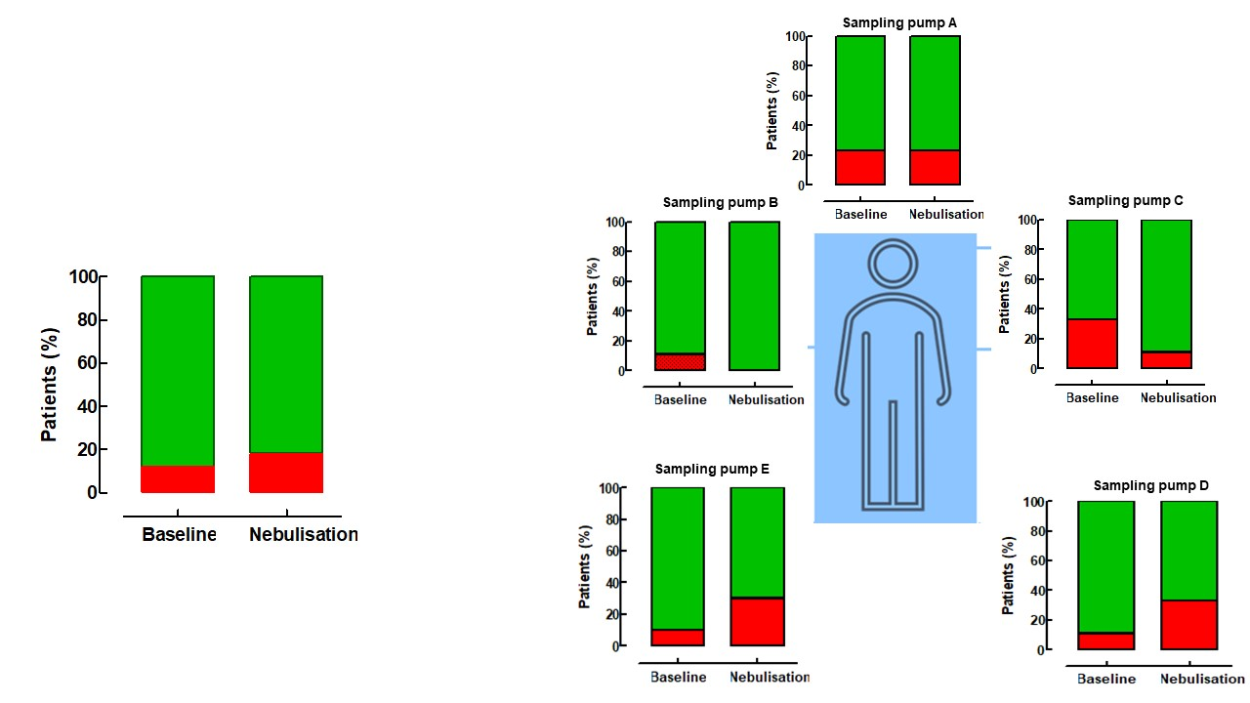

Figure 3. Left panel: absolute number of exhaled particles before and after saline nebulisation obtained in five COVID-19 patients. Right panel: presence or absence of SARS-CoV2 in the sampling pumps of these five patients.
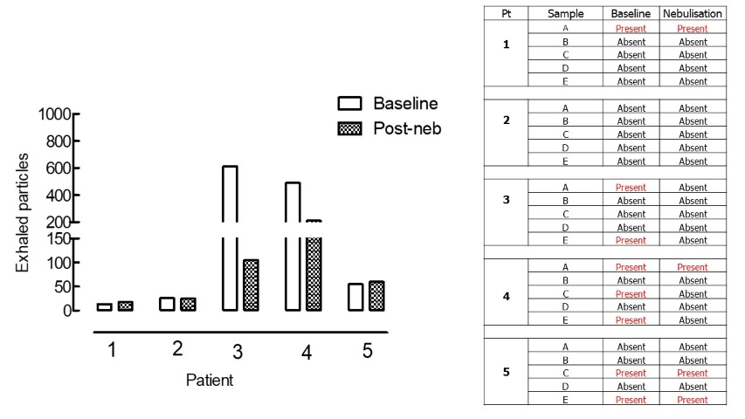
Discussion and conclusion
In this pilot study, we found that SARS-Cov2 was detected in only 12% of the samples independently of the sampling areas. In addition, SARS-Cov2 detection differs substantially among the different sampling areas, with more virus detected in the pumps positioned close to the patient. Overall, saline nebulisation does not change SARS-Cov2 spreading. Interestingly, patients who emitted large number of exhaled particles showed a reduction in the virus detection in the sampling areas. These results, albeit preliminary, suggest that there is no compelling reason to alter aerosol delivery devices for patients with established nebuliser-based regimens

References
- WHO. Coronavirus disease (COVID-19) technical guidance: Infection prevention and control. Geneva: World Health Organization. 2020. https://www.who.int/emergencies/diseases/novel-coronavirus-2019/technical-gui dance/infection-prevention-and-control. Accessed March 16, 2020
- Leung NHL, Chu DKW, Shiu EYC, Chan KH, McDevitt JJ, Hau BJP, Yen HL, Li Y, Ip DKM, Peiris JSM, Seto WH, Leung GM, Milton DK, Cowling BJ. Respiratory virus shedding in exhaled breath and efficacy of face masks. Nat Med. 2020;26:676-680
- Lavorini F, Usmani OS, Dhand R. Aerosol delivery systems for treating obstructive airway diseases during the SARS-Cov2 pandemic. Internal and Emergency Med 2021;16:2035-2039
- Amirav I Aerosol treatments during COVID19 pandemic: a personal journey. J Aer Med Pulm Drug Deliv 2020: 33:1–24.
- Global Initiative for Asthma, GINA Report, Global Strategy for Asthma Management and Prevention, 2020. https:// ginasthma.
- Australian National Asthma Council, Managing asthma during the COVID-19 (SARS-CoV-2) pandemic, Available at: COVID-19, https:// www. Asthma handbook. org.
- National Institute for Health and Care Excellence, COVID-19 rapid guideline: severe asthma (NICE guideline [NG166]) 2020.https://www.nice.or g.uk/guidance/ng166.
- Dhand R, Li J Jie Li Coughs and Sneezes: Their Role in Transmission of Respiratory Viral Infections, Including SARS-CoV-2. Am J Respir Crit Care Med. 2020 1;202:651-659.
- Harding H, Broom B, Broom J (2020) Aerosol generating procedures and infective risk to healthcare workers: SARS-CoV-2 the limits of evidence. J Hosp Infect 105:717–725
- Edwards DA, Man JC, Brand P, Katstra JP, Sommerer K, Stone HA, Nardell E, Scheuch G. Inhaling to mitigate exhaled bioaerosols. P Natl Acad Sci Usa 2004; 101, 17383–88.
- Good Practice Guide: assessing Particulate Containment 2nd edition. At: Ispe.org/publications/guidance-documents/assessing-particulate-containment-performance.

