Characterising Protein DPI Formulations: How and why does the dissolution behaviour change?

Friederike Roth, Regina Scherließ

Department of Pharmaceutics and Biopharmaceutics, Kiel University, Grasweg 9a, Kiel, 24118, Germany

Summary
Treating lung diseases with high molecular protein drugs is still limited by their inability to penetrate well through the pulmonary tissue. Local pulmonary application facilitates treatment with these protein drugs. Furthermore, it would broaden the application possibilities of smaller proteins and peptides that are able to penetrate through the epithelium. The application via the lung is a suitable alternative to the commonly used parental application. To ensure the stability of the sensitive protein drugs during storage an inhalable dry powder formulation is a good option. The most suitable production method for protein DPI formulations is spray drying. This, however, comes with various stress factors for the protein and can thereby change the properties of the protein. This study focuses on observed changes in the dissolution behaviour. It aims to characterise these changes and to find a structural explanation. We used ovalbumin as a model protein and compared the commercial lyophilisate with ovalbumin spray-dried with two different spray-drying nozzles: the two-fluid nozzle and the ultrasonic nozzle. As a characterising method, we choose the Franz cell dissolution measurements. The obtained dissolution profiles show differences in dissolution velocity. Although a morphological explanation seems obvious, experimental observations indicate further changes. Further experiments to characterise these changes are ongoing It was not possible to find a structural explanation for these dissolution changes with the used methods. Neither XRPD measurements nor fluorescence emission spectra assay showed structural changes after spray drying. The search for a method to identify the structural explanation for the observed changes continues.
Key Message
Dry powder formulations for inhalation seem to be promising for protein drugs. Nevertheless, the production method can influence proteins not only in their biological effect, but also in physical characteristics such as dissolution profile. Our research aims to investigate the resulting structural changes. We were able to characterise the dissolution behaviour changes after spray drying; the search for a structural explanation, however, continues.

Introduction
Developing inhalable protein formulations broadens the usability of protein drugs. In general, the systemic as well as the local application are possible via the lung. Proteins with a higher molecular weight, however, cannot penetrate through the pulmonary epithelium easily, which limits their possibilities for treating lung diseases [1]. After injection of larger proteins, the concentration in the blood is often multiple times higher than the concentration in the lung [1]. This comes with the need for high dosages and can lead to systemic side effects [1]. A pulmonary application would therefore lower the needed dose and the possibility of systemic side effects. Low molecular weight proteins that can penetrate through the pulmonary epithelium are suitable for local and systemic application via the lung. A well-known example of the latter would be Insulin for inhalation [2].
Proteins in general are complicated molecules and can undergo structural changes easily [3]. In liquid formulation, their storage stability can be low [1]. Therefore, this research focuses on more stable dry powder formulations.
Spray drying is a common method to produce inhalable dry powder formulations. This production method allows engineering particles with characteristics matching the requirements for inhalation. These particles should be round with a narrow size distribution in the range of the necessary aerodynamic diameter of 1-5 µm [4]. Production only requires a liquid for atomisation. Therefore, the formulation can be simple and contain high concentrations of active ingredients, which is convenient for the development of a protein drug product. The process, however, can change the chemical and physical properties of sensitive drugs, like proteins. The changes can be caused by various occurring stress factors like thermal and dehydration stress, shear forces or air-liquid interface stress [3]. These can interfere with the drug´s biological effect.
Our research aims to distinguish the impact the different stress factors during spray drying have on proteins. Therefore, it compared different spray drying systems, different spray drying nozzles, the different stages of spray drying and chosen model proteins. In the end, it aims to identify protein stabilising conditions or excipients to ensure the structural integrity and the activity of inhalable protein drugs.
This study investigates the changes in dissolution behaviour. Those changes were observed during the performance of earlier studies and caught our attention. This part of the research now aims to find a method to characterise the dissolution behaviour of spray-dried protein formulations and to identify structural changes possibly influencing this behaviour. It also compares the impact of different process conditions on the dissolution behaviour.

Experimental methods
Model Protein: We used ovalbumin in form of a lyophilised powder (Merck KGaA, Darmstadt, Germany) as a model protein in the Franz cell dissolution measurements. Unlike some other examined proteins, like chymotrypsin, ovalbumin as lyophilisate showed no visible changes such as gel formation or visible aggregation during a slow dissolution process. Furthermore, it has a high aqueous solubility of 40 mg/mL [5].
Mini Spray Dryer: For spray drying, we used the Mini Spray Dryer B-290 (Büchi Labortechnik AG, Switzerland) with two different nozzles. The two-fluid nozzle atomises the protein solution via gas flow, which exposes the protein to high shear forces and air-liquid interface stress. Depending on the spray feed concentration, it typically leads to particle sizes of the dry product of 2-25 µm [6]. The ultrasonic nozzle uses ultrasound for atomisation. The process leads typically, depending on the spray feed concentration, to a particle size of the dry product of 10-60 µm [6]. The used solutions contained an ovalbumin concentration of 4.0 mg/mL in Milli-Q water. An inlet temperature of 150°C heated the airflow in which the droplets then dried in the drying chamber. Due to technical differences, the resulting outlet temperature was 80-90°C for the two-fluid nozzle and 50-60 °C for the ultrasonic nozzle. The drying process additionally exposes the protein to thermal and dehydration stress. Last, a cyclone collects the dry particles.
Fluorescence Emission Spectra Assay: We used the fluorescence emission spectra assay as a method to detect changes in protein structure tertiary structure or the formation of aggregates. The plate reader Tecan Spark (Tecan Trading AG, Männedorf, Switzerland) recorded the emission spectrum from 400 to 600 nm of the extrinsic fluorescence of a saturated solution in water (about 0.015 mg/mL) of the fluorescent dye anilinonaphthalene-8-sulfonic acid (ANS) using an excitation wavelength of 375 nm. ANS, being almost insoluble and therefore non-fluorescent in water, interacts with the hydrophobic parts of a protein, which increases the solubility of ANS. An increase in the hydrophobicity of the protein caused by changes in the tertiary structure or protein aggregation can therefore lead to a blue shift and an increase in the emission intensity [7]. Before analysis, the spray-dried protein was redissolved to a concentration of 4.0 mg/mL. In addition, a sample of the native ovalbumin as positive control and of the denatured (100°C for 3 h) ovalbumin as negative control were analysed at a concentration of 4.0 mg/mL. The measurement was performed in triplicates.
XRPD measurement: The diffractograms of one sample of the lyophilisate and one sample of the protein spray-dried with the two-fluid nozzle was compared using a Mythen 1K-detector Stadi-Ps (STOE & CIE GmbH, Darmstadt, Germany) with the following parameters: Mo-Ka1-radiance, 2-35° 2 Theta, 60sec/step.
Franz cell dissolution measurement: To detect changes in the dissolution velocity we chose the Franz cell dissolution method. The Franz cell consists of a donor compartment that is separated from the receptor medium by a moistened membrane. Therefore, the sample does not have direct contact with the medium. This allows a slow dissolution, making the detection of dissolution behaviour changes simpler. A thermal jacket heats the receptor compartment. We chose a temperature of 37 °C +/- 0.5°C, 7.9 mL Milli-Q water as receptor medium, a cellulose acetate membrane (0.45 µm) and a sample mass of 50 mg +/- 5 mg. 0.2 mL sample was taken every 6 min from the acceptor compartment for 90 min and immediately replaced with 0.2 mL of Milli-Q water.
Protein concentration: The protein concentration was determined using the NanoDrop One (Thermo Fisher Scientific, Waltham, Massachusetts). The used protein analysation profile measures concentration at 280 nm and takes a baseline at 340 nm. This excludes interference caused by possible protein aggregation.
The dissolution profiles were then compared using the similarity factor f₂ where R_{t} is the dissolution value of the reference batch at time t and T_{t} is the dissolution value of the test batch at time t. Values over 50 show equivalence of the dissolution profiles whereas values under 50 show differences.

f = 50 * log {[1+ (1/n)$\sum_{t=1}{n}$ ( R_{t} – T_{t} )² ] ^{-0,5}*100}
Results
The fluorescence emission spectra assay showed no change in fluorescence emission of ovalbumin after spray drying with either nozzle compared to the native protein. For the denatured samples, however, a blue shift and an increase of the fluorescence intensity maximum occurred (Figure 1).
The XRPD spectra showed no changes after spray drying. Both samples before and after spray drying seem to be mostly amorphous (Figure 2).

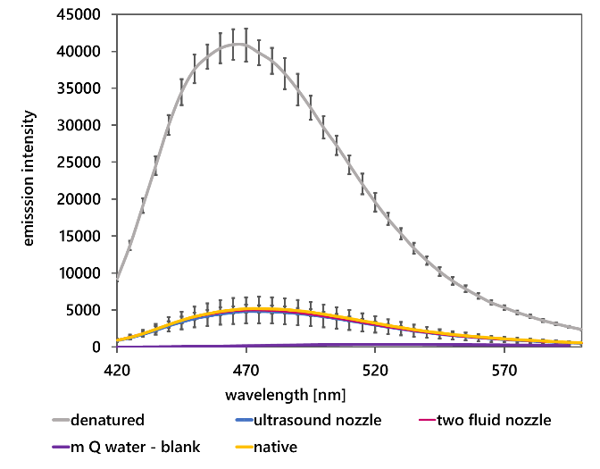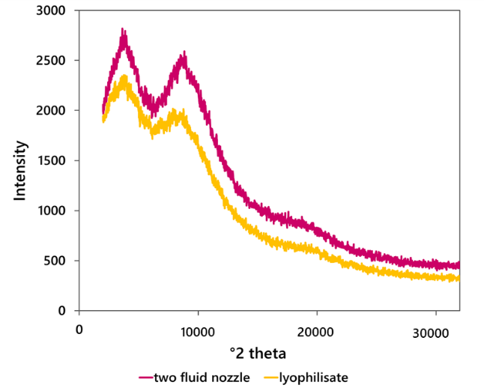

Figure 1: Fluorescence emission spectra with the fluorescence dye ANS of ovalbumin in the native and the denatured state compared with the spray-dried ovalbumin. Mean curve of three spray dried products, error bars= sd
Figure 2: XRPD spectra of ovalbumin (lyophilisate and sample spray-dried with the two-fluid nozzle), n=1

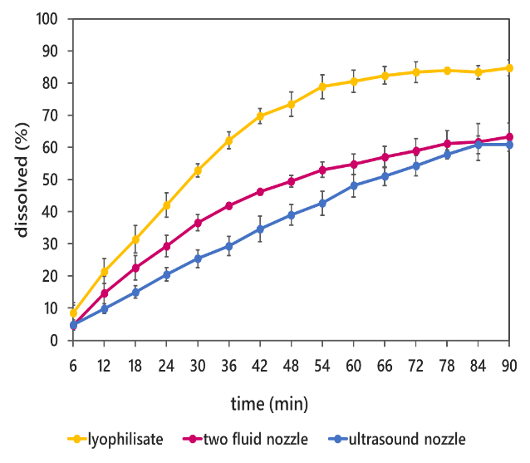
The Franz cell measurements showed different behaviours for the compared samples. The lyophilisate sample was visually fully dissolved after 90 min while undissolved residues remained in the spray-dried samples. In addition, the dissolution profiles showed differences. The lyophilisate showed a dissolution of 84.70% after 90 min while the extent for the two spray-dried samples was lower (63.24% for the two-fluid nozzle product and 60.80% for the ultrasound nozzle product). This trend also occurred for all other time points, where the dissolution of the lyophilisate was always higher than the dissolution for both spray-dried samples (Figure 3).
Furthermore, the ultrasound nozzle sample had a lower percentage dissolved for all time points (except the first), although the difference was not as prominent as the difference to the lyophilisate. The similarity factor value for comparison of the dissolution profile with the lyophilisate as reference was lower than 50 for both products (two-fluid nozzle 34.7 and ultrasound nozzle 28.3) indicating no similarity. The spray-dried samples do not show significant differences between each other (f₂ = 55.3).

Figure 3: Franz cell measurements dissolution profiles of ovalbumin, comparison of lyophilisate and spray dried samples.
Mean curve of three spray dried products, error bars= sd

Discussion
The fluorescence emission spectra assay did not detect a change in the tertiary structure or protein aggregation after spray drying of the protein. Furthermore, the XRPD spectra showed no long-range structural changes. However, a change in dissolution behaviour had been obvious in handling the spray dried products. Franz cell measurements revealed different dissolution profiles of the lyophilisate and the spray-dried protein samples. For the observed changes in dissolution velocity, an obvious explanation would be changes in particle morphology and particle size changes during the spray drying process. The extreme differences in dissolution after 90 min and further visual observation of the dissolution behaviour before and after spray drying, however, indicate a more complex situation and a possibly transient influence on the solubility. In the native state, most proteins fold so that hydrophilic amino acids face the outside and the hydrophobic amino acids face the hydrophobic core [3]. This can change if the protein is exposed to stress factors such as interface stress and often leads to an increase in hydrophobicity. Consequently, a change in solubility is likely, which in practice may result in aggregation. Experiments in characterising these changes are still ongoing.
Conclusion
The study shows the importance of evaluating different aspects of protein stability. The three applied analytical methods showed different results for the model protein ovalbumin after spray drying with different nozzles. While the fluorescence spectra assay showed no changes in tertiary structure nor a formation of aggregates and the XRPD showed no changes in the long-range structure, dissolution behaviour was altered as partly confirmed by Franz cell measurements. This may indicate a structural change in the protein. The search for a method to precisely characterise and predict these changes is ongoing.

REFERENCES
[1] Matthews, A.A.; Ee, P.L.R.; Ge, R. Developing inhaled protein therapeutics for lung diseases. Mol Biomed, 2020, 1, 1705.
[2] Cipolla, D. Will pulmonary drug delivery for a systemic application ever fulfill its rich promise? Expert opinion on drug delivery, 2016, 13, 1337–1340.
[3] Manning, M.C.; Chou, D.K.; Murphy, B.M.; Payne, R.W.; Katayama, D.S. Stability of protein pharmaceuticals: An update. Pharmaceutical research vol 27, 2010, 4, 544–575.
[4] Sunday A. Shoyele. Drug Delivery Systems: Chapter 7 Engineering Protein Particles for Pulmonary Drug Delivery p. 149; Humana Press, 2008.
[5] Sigma Aldrich. Technical data sheet: Product specifications ovalbumin.
[6] Büchi Labortechnik AG. Product brochure Mini Spray Dryer B-290 HP.
[7] Robert A. Poole, Andrea Hawe, Wim Jiskoot, Kevin Braeckmans. Fluorescence spectroscopy to characterize protein aggregates and particles. In: Hanns-Christian Mahler, Wim Jiskoot: Analysis of aggregates and particles in protein Pharmaceuticals; pp. 201–227.

