Using PreciseInhale® for Controlled Volunteer Exposures with Aerosols Extracted from Clinical Inhalers

Per Gerde^{1,2}, Carl-Olof Sjöberg¹ Helen Bäckroos¹ & Helena Litorp^{3,4}

¹Inhalation Sciences AB, Hälsovägen 7, Novum, 141 57 Huddinge, Sweden

²IMM, Karolinska Institutet, Nobels väg 13, 171 77 Stockholm, Sweden

³CTC Clinical Trial Consultants, Dag Hammarskjölds väg 10B, 752 37 Uppsala, Sweden

⁴ Department of Global Public Health, Karolinska Institutet, 171 77 Stockholm, Sweden

Summary
The PreciseInhale® (PI) platform was used to extract clinical inhaler doses from the pressurized metered dose inhaler (pMDI) Evohaler Seretide forte, Fluticasone Propionate (FP) 250 µg, Salmeterol Xinafoate (SMX) 25 µg and then expose human volunteers by visually prompting controlled administration from the clinical exposure module of PI. Through 4 study arms the following two comparisons were made: I) The direct inhalation of one dose from the clinical inhaler, according to the label instructions, was compared to the same dose aspirated into the PI and inhaled by the volunteers, following prompted instructions. II) Six subdivided fractions of one dose from the Evohaler was inhaled and targeted to the peripheral lung and the central airways respectively, using the bolus breath hold method provided by the PI. Results show that, compared to direct inhalation from the inhaler, instead extracting the clinical inhaler dose into the PI and then controlling the exposure from the PI both increase the lung deposited dose of drug and the dosing precision. The peripheral lung bolus of FP had a 98% deposition upon inhalation compared to 58% deposition of the central airway bolus. FP had similar pharmacokinetics in both regions, whereas SMX had a significantly higher Cmax following exposure of the peripheral lung.
Key Message
By administering clinical inhalers via PreciseInhale® an improved precision during whole lung exposures was achieved and inhaler aerosol boli could be targeted to different lung regions, which may improve in silico models describing the link between the elusive site-of-entry dosimetry in lungs and the measurable pharmacokinetics of the systemic circulation.

Introduction
Clinical inhalers for dry powder aerosols have a built-in conflict between on the one hand the flow rate requirements to generate an optimal particle size distribution and a high emitted amount of drug during actuation and aspiration, and on the other hand, to provide an optimal flow rate for the subsequent exposure of the patient’s lungs. In general, higher flow rates are required for optimal inhaler actuation than for providing airway target exposures in high yields [1]. As opposed to the often suboptimal use of inhalers by patients [2], the clinical module of the PreciseInhale exposure platform (PI) relies on a two-step strategy for ideally utilizing inhaler aerosols where 1) batches of aerosol are first generated into a 300 mL holding chamber and then 2) extracted from the holding chamber for exposure at desired flow rates and inhaled volumes. Both flow rates as well as inhaled air volumes and aerosol exposure volumes can be independently set and optimized for maximum efficiency. Both dry powder inhalers and pressurized Metered Dose Inhalers (pMDI) can be used with the PI, where the latter relies on a pneumatic mechanism to synchronize inhaler actuation with aspiration of aerosol into the holding chamber. Separating the inhaler actuation/aspiration from drug inhalation could accomplish two improvements in drug administration; I) minimize throat deposition during exposures, making the coal block procedure unnecessary, and II) provide regional targeting using the bolus breath hold method [3]. Both these possibilities will permit two improvements in the use of blood concentration in the systemic circulation as a surrogate or proxy for the local dose of an inhaled drug in the lungs [4]. Firstly, minimizing throat deposition will limit the contribution from gastrointestinal absorption to the systemic pharmacokinetic concentrations following an inhalation exposure, and secondly, during the exposures controlled by the PI, major respiratory tract regions can be selectively targeted with the bolus-breath hold method to control the region of deposition more independent of the deposition driven by aerosol particle size distribution.
The study had two major objectives; I) to compare one dose, inhaled directly form the Evohaler by the volunteers, with the same dose first actuated and aspirated by the PreciseInhale then inhaled by volunteers using the same inhalation maneuver, and II) to compare one dose actuated and aspirated by the PI, and inhaled as either peripheral lung boli or central airway boli, using the bolus breath hold method.

Experimental Methods
For the current exposures the PI system was used with the inhaler actuation/aspiration system for pMDI. Single doses of fluticasone propionate (FP) 250 µg and salmeterol xinafoate (SMX) 25 µg was actuated and aspirated from the Evohaler Seretide Forte (1) into the 300 mL holding chamber of the PI system at a flow rate of 30 L/min for 630 ms, giving an optimal placement of the aerosol puff in the holding chamber (Fig 1A). Immediately after actuation and aspiration, the aerosol was ready for a flow- and volume prompted inhalation maneuver by healthy volunteers (Fig 2A). Twelve healthy volunteers were recruited as research subjects for the study. The desired breathing pattern was prompted to the research subject through a graphical interface, where a constant flow rate inhalation and a similar flow rate exhalation was separated by an adjustable breath hold period (Fig 2B). Also, the fulfilment of desired inhaled- and exhaled volumes are indicated on the screen, plus progress of the breath-hold period.

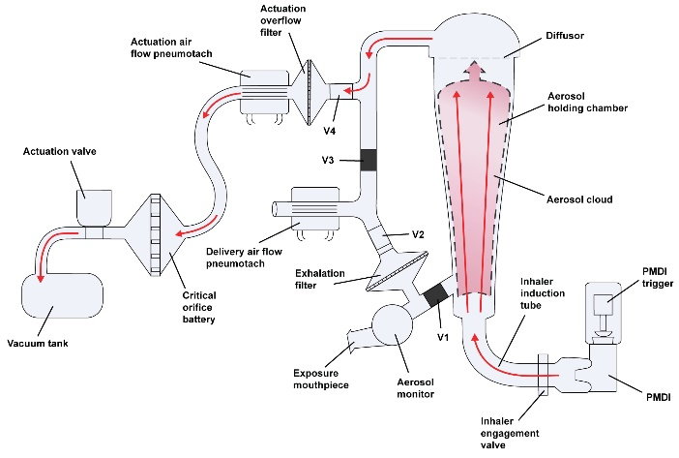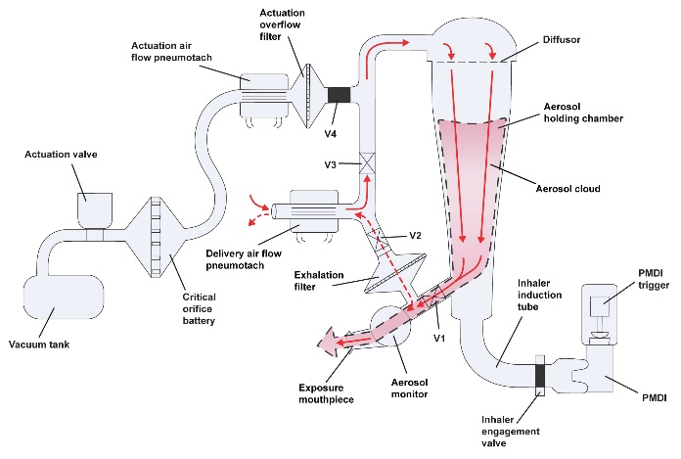
A) B)
Figure 1A. Flow sketch of the PI during the inhaler actuation and aspiration for clinical exposures. The approximate distribution of aerosol at the end of actuation is indicated. 1B. Flow sketch where inhalation exposures are shown in solid red lines together with the flow direction of aerosol during whole lung exposures. For exhalation- and bypass inhalation exposures, where airflow passes the exhalation filter, the flow path is shown with a dashed red line.
Both the inhaler aspiration flow rate and exposure maneuver flow rate were monitored by the computer software, together with the inhaled- and exhaled aerosol concentration at the mouthpiece as measured by a Casella Microdust Pro forward scatter instrument. The study was divided into four arms for pairwise comparison. All 12 subjects participated in each of the four study arms with a wash out time of at least a week between study arms:
Arm 1: Direct inhalation. One dose from the inhaler was inhaled according to the label instruction. One deep breath with synchronized actuation of the inhaler at approximately 30 L/min was followed by a 10 s breath hold period.
Arm 2: Whole lung. Actuation and aspiration of one dose from the inhaler into the PI, followed a prompted ideal inhalation maneuver from the PI of the 300 mL aerosol volume in the beginning of a 1.5 L inhaled volume at 30 L/min, followed by a 10 s breath hold then followed by a 1.8 L exhalation volume at 30 L/min through a PARI filter pad.
Arm 3: Peripheral lung. Actuation and aspiration of one dose from the inhaler into the PI, followed by the prompted inhalation of a 1 L air volume at 15 L/min with a 70 mL aerosol bolus intercalated at 500 to 570 mL followed by a 7 s breath hold and an exhalation of a 1.3 L volume at 15 L/min through a PARI filter pad. The exposure procedure was repeated 6 times in each volunteer with fresh aerosol to achieve a cumulative peripheral lung bolus exposure similar to the whole dose exposures of Arm 1 and 2.
Arm 4: Central airways. Actuation and aspiration of one dose from the inhaler into the PI, followed by the prompted inhalation of a 1 L air volume at 15 L/min with a 70 mL aerosol bolus intercalated at 850 to 920 mL followed by a 7 s breathhold and exhalation of a 1.3 L volume at 15 L/min through a PARI filter pad. The exposure procedure was repeated 6 times in each volunteer to achieve the central airway bolus exposure.

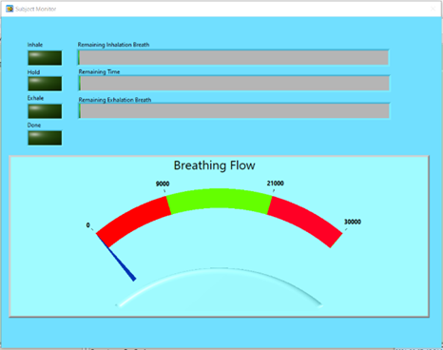
A B
Figure 2A. The PI prompting screen for clinical exposures. 2B. A schematic of the resulting flow- and exposure pattern during the regional targeting procedures of Arm 3 and 4. The approximate placement in the breath of aerosol boli for respectively peripheral lung and central airway targeting are indicated.

Deposition in study Arms 2-4 was determined from calculated inhaled amounts minus the amount measured on the exhalation filters. Drug deposition in filters was quantitated following dissolution in methanol and analysis using HPLC.
After each exposure procedure, blood was repeatedly sampled from an arm vein collected at 16 time points in each treatment period: pre-dose, 2, 4, 6, 15, 30, 45 minutes, 1, 1.5, 2, 2.5, 3, 4, 7, 12, and 24 hours after treatment. Blood plasma samples were analyzed for both FP and SMX using LC/MS/MS (Pharm-Analyt, Baden, Austria).
Study arm 1 was compared with study arm 2 to evaluate the efficiency of exposure and the precision of dosing when exposing volunteers via PI, compared to direct exposure from the inhaler. Study arm 3 was compared to study arm 4 to investigate the effect on the systemic pharmacokinetic response by placing aerosol boli of similar particle size distribution in the two major regions of the lungs at a deeper and shallower penetration depth in the lungs, respectively.

Results
By using PI for clinical exposures, the breathing pattern during the procedures can be tightly prompted and controlled for improved dosing precision and regional targeting. In case of the regional targeting exposures no direct measurement was made of bolus placement during breath hold with for example imaging. The regional selectivity of the exposures was instead inferred from aerosol concentration measurement versus depth of penetration in the lungs and from deposition fractions of aerosol, based on measured amounts on exhalation filters. There was a clear link between the measured exhaled fraction of drugs of the PI exposures and the three different exposure procedures of Arms 2, 3 and 4. The mean fraction of FP deposited in the three arms came out respectively as 0.993, 0.976, and 0.577 (Table 1).
For whole lung exposures, the AUC24 for SMX and FP was respectively a factor of 1.89 and 2.55 times higher for the single dose exposure administered via PI than when drawn directly from the inhaler (Table 2). This would indicate significantly lower losses when the dose was delivered via PI, compared to throat losses when the research subjects was directly inhaling the pMDI dose. Also, the average standard deviation of the AUC24 among the research subjects was lowered from ±52/56% to ±20/22% for SMX/FP when the pMDI dose was inhaled via PI compared to directly from the inhaler (Table 2).

Table 1: The deposited fraction of both drugs during the study arms 2-4 involving PI use.
Study Arm | Deposited Fraction (±SD)
Arm 2: Whole Lung FP | 0.993 ± 0.007
Arm 2: Whole Lung SMX | 0.989 ± 0.003
Arm 3: Peripheral Lung FP | 0.976 ± 0.01
Arm 3: Peripheral Lung SMX | 0.981 ± 0.009
Arm 4: Central Airways FP | 0.577 ± 0.154
Arm 4: Central Airways SMX | 0.599 ± 0.164

For the bolus breath hold exposures the data indicated that the peripheral lung bolus had a higher Cmax than the central airway bolus for SMX but not for FP, even after correction for the larger deposited dose of aerosol in the peripheral lung compared to the central airways.

Table 2: Principal findings on major pharmacokinetic parameters in the four arms of the study
(n = 10-12)
Inhalation Maneuver | Median Tmax (min) (Min, Max)  SMX FP |  | Mean Cmax (pg/ml) (±SD)  SMX FP |  | Mean AUC24 (h*pg/ml) (±SD)  SMX FP
Inhaler Directly | 4.0 (1.8, 6.0) | 120 (60, 150) | 76 ± 64 | 46 ± 25 | 129 ± 67 | 366 ± 205
Whole Lung* | 4.9 (1.8, 6.0) | 120 (90, 240) | 213 ± 76 | 85 ± 20 | 244 ± 49 | 934 ± 210
Peripheral Lung | 6.0 (6.0, 7.2) | 150 (90, 240) | 723 ± 285 | 195 ± 59 | 708 ± 192 | 2426 ± 728
Central Airways | 6.0 (4.8, 7.2) | 120 (90, 240) | 290 ± 148 | 108 ± 51 | 418 ± 160 | 1303 ± 589
* Due to different air flow rates whole lung should not be quantitatively compared to peripheral lung and central airways.

Conclusions
By using PI for clinical exposures, the breathing pattern during the procedures can be tightly prompted and controlled for improved dosing precision and regional targeting of the lung deposited dose in human volunteers.
The PI can be used for placing smaller volume aerosol boli at different depth of inhalation in the lung, using the bolus breath hold method. Targeting of exposures to the major respiratory tract regions can thereby be accomplished as indicated by substantially higher retained fractions of aerosol for regional exposures of the peripheral lung compared to the central airways. This may improve the understanding of the relative contribution of size-driven particle dissolution and air/blood barrier permeability to the subsequent systemic pharmacokinetic parameters of inhaled drug aerosols.
Research subjects concluded the prompted instructions on the PI patient interface to be rather easy to follow after a proper training session

References
1. Weers, J.G., et al., Idealhalers Versus Realhalers: Is It Possible to Bypass Deposition in the Upper Respiratory Tract? J Aerosol Med Pulm Drug Deliv, 2019. 32(2): p. 55-69.
2. Roche, N., et al., Patient Focus and Regulatory Considerations for Inhalation Device Design: Report from the 2015 IPAC-RS/ISAM Workshop. J Aerosol Med Pulm Drug Deliv, 2017. 30(1): p. 1-13.
3. Bennett, W.D., et al., Targeting delivery of aerosols to different lung regions. J Aerosol Med, 2002. 15(2): p. 179-88.
4. Boger, E. and O. Wigstrom, A Partial Differential Equation Approach to Inhalation Physiologically Based Pharmacokinetic Modeling. CPT Pharmacometrics Syst Pharmacol, 2018. 7(10): p. 638-646.
5. Oag, S., H. Thörn, and U. Tehler, Experimental evidence of regional lung deposition differences effecting the systemic exposure in dog in Drug Delivery to the Lungs 2019: Edinburgh. p. 1-4.

