Determining measured experimental values of density to aid formulation development of new environmentally friendly propellant mixtures with Ethanol

Lauren Harrison¹

¹Kindeva Drug Delivery Limited, Derby Road, Loughborough, UK, LE11 5SF

Summary
Kindeva have been working on multiple projects with greener propellants, hydrofluoroolefin (HFO) 1234ze(E) and hydrofluoroalkane (HFA) 152a to assess their suitability to replace the current HFA 134a and HFA 227 as greener alternatives.
A key property of propellants to consider when formulating pressurised metered dosage inhalers (pMDIs) is density, due to its direct impact on characteristics of the formulation and calculations to determine exact quantities of each component required. When there are no additional excipients, the formulation density is the same as the liquid propellant density and this value is used when determining quantities of the formulation.
However, as additional excipients such as co-solvents are added to the formulation the overall density of the formulation will change. Historically, this has been well characterised for HFA 134a and HFA 227, but with the change to greener propellants, these density values need to be determined experimentally.
Kindeva therefore assessed the effect of increasing levels of Ethanol on density of HFA 152a and HFO 1234ze(E) containing formulations to improve accuracy when formulating by measuring actual experimental values. See Table 1 below that shows the change in overall formulation density for HFA 152a as Ethanol % increases.
Table 1: Measured Density Values of HFA 152a and HFO 1234ze(E) with increase of Ethanol
 | 152a | 1234ze(E)
Ethanol (% w/w) | Average Measured Density (g/mL)
0% | 0.9173 | 1.1786
20% | 0.8972 | 1.0764
40% | 0.8748 | 0.9870
50% | 0.8594 | 0.9453
The results of the study showed a clear correlation with reduction in density as the Ethanol level increased in each propellant and therefore highlighted the need to re-model a suitable calculation for the greener propellants, HFA 152a and HFO 1234ze(E).

Key Message
By measuring the formulation density with increasing levels of Ethanol in new propellants, it has been possible to highlight the need for a new model for HFA 152a and HFO 1234ze(E) for use in development programmes as a predictive tool for formulation activities in pMDI’s.

Introduction
Currently, propellants HFA 134a and HFA 227 are widely used in pMDIs and have very well-known properties that can be factored into formulation development. However, with the current climate change crisis there has been more emphasis on reducing the contribution inhalers have towards CO2 emissions.
Research by Dr Alexander J K Wilkinson et al, estimate that pressurised metered dosage inhalers (pMDIs) are contributing towards 3.9% of the National Health Service’s (NHS) overall carbon footprint in the UK. [1]
Kindeva have been working on multiple projects with greener propellants, HFO 1234ze(E) and HFA 152a to assess their suitability to replace the current HFA 134a and HFA 227 as greener alternatives. The GWP of the propellants in question are summarised in Table 2.

Table 2: GWP of current HFA’s compared to HFO 1234ze(E) and HFA 152a
Propellant | Formula | GWP | Density at 21°C (g/mL)
HFA 134a | C₂F₄H₂ | 1300 | 1.222 [2]
HFA 227 | C₃F₇H | 2900 | 1.404 [2]
HFA 152a | C₂H₄F₂ | 140 | 0.910 [2]
HFO 1234ze(E) | C₃H₂F₄ | <1 | 1.176
[2]
Each propellant has a slightly different density which can have a direct impact on characteristics of the formulation such as flocculation behaviour of the Active Pharmaceutical Ingredient (API) in a suspension, which will impact dosing performance. Alongside this, calculations to determine the exact mass of each component required within the formulation are based on the overall density. Therefore, if this is not accurate at the start of a feasibility program it is likely that the constituents of the formulation will be off target.
As additional excipients such as co-solvents are added to the formulation the overall density of the will change. Historically, this has been well characterised for HFA 134a and HFA 227, but with the change to greener propellants, inevitably such relationships should be re-investigated. Differences in propellant characteristics, such as viscosity and surface tension will influence the behaviour of a propellant and therefore it cannot be assumed that each propellant will follow the same trend as another, hence these density values need to be determined experimentally.
Kindeva therefore assessed the effect of increasing levels of Ethanol on density of HFA 152a and HFO 1234ze(E) containing formulations to improve accuracy when formulating.

Materials and Method
Materials
Formulations manufactured included use of Ethanol (HPLC Grade, Merck Life Science UK Ltd, Gillingham, Dorset). HFA 152a supplied by Koura (San Luis Potosí, S.L.P., Mexico), HFO 1234ze(E) sourced from the open market, HFA 134a supplied by Dupont, (Wilmington, United States of America) and HFA 227 supplied by Solvay, (Brussels, Belgium).
Method
Propellant was pressure filled through a Non-Metering Valve on the DH Industries Density Measuring gauge (Model: 0200/010) to a specified quantity in grams and the volume recorded after a period of equilibration. For all Ethanol containing formulations, Ethanol was pre-dispensed into the inner glass tube of the Density Measuring Gauge to a pre-determined weight, before immediately sealing and pressurising the gauge. Temperature in the laboratory was controlled and remained at 21°C +/- 1°C for the duration of the experiment as determined by a Testo 175-H2 RH and Temperature Data Logger (Hampshire, Great Britain).Experimental values were measured of HFA 134a and HFA 227 as controls and HFA 152a and HFO 1234ze(E) as the propellants of interest. Measurements were taken in duplicate with increasing levels of Ethanol, from 0 to 50 % w/w. These experimental data were plotted as individual values vs Kindeva Model data. Vapour pressure values were taken from the Ref prop database at 21°C. Results for HFA 134a and HFA 227 are presented in Figures 1 & 2.

Results and Discussion
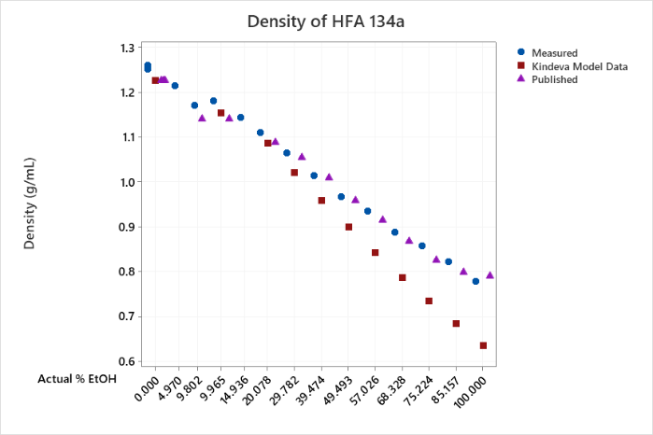
Figure 1: Density of HFA 134a

To verify methodology, published data [3] were plotted against experimentally determined values, which confirmed a strong correlation (r=0.997). The historic Kindeva modelled data covering 0 - 20% (w/w) Ethanol with HFA 134a showed good correlation with experimental data obtained in this study (r=0.998). After 20% Ethanol, the correlation declines.
See Figure 2 below for experimental data collected for HFA 227.
Figure 2: Density of HFA 227
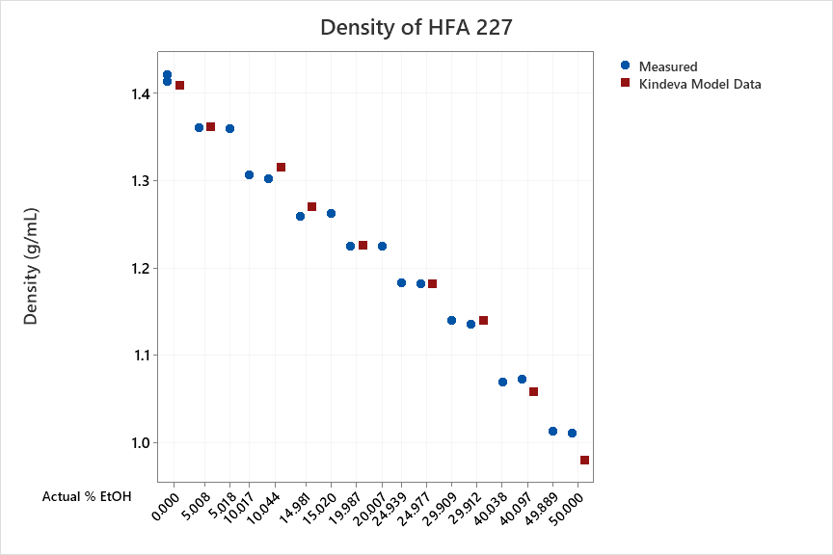

Data generated prove measured values are well aligned with the historic Kindeva model calculation, showing good correlation (r=0.997). Based on this, the experiment was widened to assess the density of HFA 152a and HFO 1234ze(E) at a range of Ethanol levels to establish a suitable model for use when formulating using these propellants. These data are presented in Figures 3 & 4.
Figure 3: Density of HFA 152a
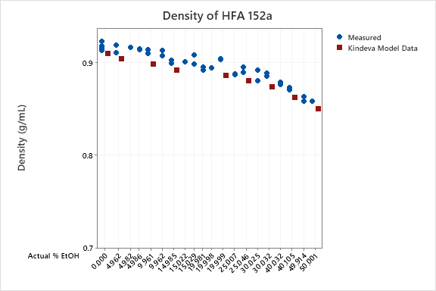
When assessing the formulation density with increasing levels of Ethanol in HFA 152a, the density was found to decrease with the addition of Ethanol. Based on the experimentally derived data, a model was determined. Model data and experimental data are closely correlated (r=0.993).
Figure 4: Density of HFO 1234ze(E)
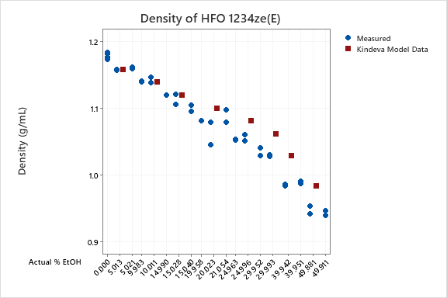
Figure 4 presents data for HFO 1234ze(E), showing measured values alongside Kindeva model data. Kindeva Model Data for HFO 1234ze(E) was not an accurate representation of the experimental values. Therefore, Kindeva are currently working on an alternative model for HFO 1234ze(E).

Conclusions
Historically, Kindeva used a predictive model to estimate the formulation density inside MDI canisters during development programmes. However, the model had to be re-evaluated for HFA 152a and HFO 1234ze(E) due to the differences in propellent characteristics. The historic model was compared to experimentally derived data generated for HFA 134a and HFA 227 and found to be in close correlation.
Across all propellants there is a decrease in overall density as Ethanol concentration increases. HFA 152a was the least effected in terms of overall density reduction of the formulation with increase in Ethanol % w/w, followed by HFO 1234ze(E), HFA 227 and HFA 134a.
However, the historic model was not appropriate for the new propellants, HFA 152a and HFO 1234ze(E) and it was clear from experimental data gathered that a new model was required to calculate density.
By measuring the formulation density with increasing levels of Ethanol in new greener propellants HFA 152a and HFO 1234ze(E), it has been possible to highlight the need for a new model for use in development programmes as a predictive tool, for formulation activities.

References
[] Alexander J K Wilkinson, Rory Braggins, Ingeborg Steinbach, James Smith, Costs of switching to low global warming potential inhalers. An economic and carbon footprint analysis of NHS prescription data in England BMJ Open 2019;9: e028763. doi: 10.1136/bmjopen-2018-028763 (online)
[2] Lemmon, E.W., Bell, I.H., Huber, M.L., McLinden, M.O. NIST Standard Reference Database 23: Reference Fluid Thermodynamic and Transport Properties-REFPROP, Version 10.0, National Institute of Standards and Technology, Standard Reference Data Program, Gaithersburg, 2018. doi: https://doi.org/10.18434/T4/1502528 (online only)
[3] Rob Johnson, Daniel I. Lewis, Paul M. Young, Henk K. Versteeg, Graham Hargrave: Determination of Density and Surface Tension in Ethanol and HFA 134a Mixtures (Article). Respiratory Drug Delivery 2018. (online)

