Development of a Mathematical Model To Estimate Droplet Size Distribution of a Pressurised Metered Dose Inhaler in the Near-Orifice Region

Hossain Chizari¹, Barzin Gavtash¹ , Benjamin Myatt¹, Weeratunge Malalasekera² & Hendrik K Versteeg²

¹ Kindeva Drug Delivery, Derby Road, Loughborough, LE11 5SF, UK

² Wolfson School of Mech, Elec & Man Eng, Loughborough University, Loughborough, Leics, LE11 3TU, UK

Summary
In a pMDI a range of droplet sizes will be created. In previous models, the mean droplet size was calculated and compared with PDA data. In the current study, we estimate a droplet distribution from the proposed model. This will generate more understanding of how a pMDI works and pave the path to the full model for ACI/NGI in the future.
Key Message
In this study, the droplet size distribution for any instance during a pMDI actuation is estimated, based on first principle of wave instabilities. GSD can be predicted within 5% of error in comparison with experimental data for the full range of droplets at 25mm from the spray orifice.

Introduction
Mathematical modelling and digital engineering is moving into the respiratory drug delivery space for two reasons: (i) experimental testing is expensive and time consuming, (ii) the information that can be obtained from a compendial test of an aerosol product with a cascade impactor is limited. Aerosols produced by pressurised Metered Dose Inhalers (pMDIs) are produce self-propelled and highly dynamic aerosols. Computational Fluid Dynamics (CFD) modelling is starting to be used to calculate the development of pMDI aerosol plumes [1, 2], but full CFD modelling of all the pMDI actuator components starting from the metering chamber to the human mouth/throat and upper airway is still too challenging. Gavtash [3] developed a mathematical model of the thermo-fluid dynamic processes inside a pMDI actuator, which can predict the temporal profiles of pressure and temperature within the metering chamber and expansion chamber as well as instantaneous emitted mass flow rate, velocity, and mean droplet size at the spray orifice exit. These models were validated against phase Doppler Anemometry (PDA) data [4, 5, 6] showing good agreement with trends of instantaneous mean aerosol droplet size and mean velocity.
The main limitation of the numerical model is that it does not predict the spread of the aerosol size distribution. This is significant, because pMDIs are known to produce broad distributions of droplet size. The ability of a pMDI model to represent the spread of the distribution accurately is necessary if its output is to be compared with compendial test results. In this paper, we present an improvement of the atomisation models by [4, 5] and test the idea that the variability of the instantaneous droplet size can be represented using an additional physics-based assumption. We present a preliminary comparison of the predicted Geometric Standard Deviation (GSD) with typical values obtained in compendial testing of a HFA134a pMDI product.

Method
The numerical model presented in [3] assumes that the atomisation mechanism in the spray orifice of a pMDI is aerodynamic in nature [4, 5, 7, 8]. Liquid surfaces entering the spray orifice undergo the following instability sequence: waves form due to shear between the fast-moving propellant vapour stream and the slower-moving liquid. The amplitude of the waves grows, ligaments are formed, followed by Rayleigh instability of ligament and breakup into individual droplets. Amplification of different wave frequencies will depend on the liquid/vapour density ratio, Reynolds number and Weber number [8]. One frequency will be amplified most strongly; the wavelength associated with this frequency is used in the model to generate a length scale to predict the instantaneous mean droplet size in the model. The outcome of the model is a mean droplet size which varies as a function of time, but the variation of this mean droplet size is relatively modest and cannot explain the spread of droplet sizes in an actual pMDI aerosol.
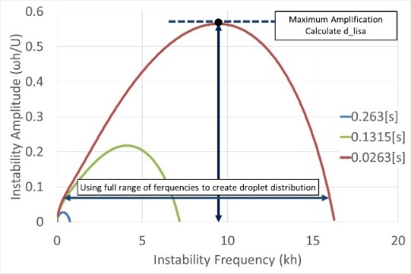 | 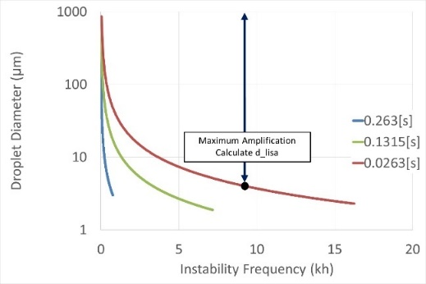
Figure 1 - Distribution of different frequencies (left) which will result in a spectrum of diameters (right). Note that three colours in each figure is illustrating specific time (0.0263, 0.1315, 0.263 second)
Visualisations of flows inside pMDI spray orifices show a highly turbulent and disturbed two-phase flow [9]. This would suggest that the wave selection and growth processes in a pMDI spray orifice may not occur in the orderly sequence presented above. In this work we propose that the turbulent flow environment inside a pMDI spray orifice will enable the amplification of a range of wavelengths centred around the most amplified wavelength. Figure 1 demonstrates the steps in which the distribution is calculated for three specific instants in time (0.0263, 0.1315, 0.263 seconds) corresponding to the start, quasi-steady and final phases of the actuation event. The x-axis shows different instability frequencies. Figure 1 (left) shows the estimate of different wave amplitudes for each instability frequency. Note that in our previous model the instability frequency corresponding to the maximum amplification was used to calculate the instantaneous mean droplet size droplet [8]. The figure also indicates the range of frequencies considered in the present model. Figure 1 (right) shows the associated droplet size for each frequency. The calculation steps of the new model of the instantaneous droplet size distribution are described below.
- The instantaneous droplet size is assumed to have a log-normal distribution:
$$p(d)=\frac{1}{\sqrt{2π}\left(\ln{σ}\right)d}e^{-\frac{1}{2}{\left(\frac{\ln{d}-\ln{d_{a}}}{\ln{σ}}\right)}^{2}}$$ | (1)
Where, the $d_{a}=d_{lisa}$ is the average diameter and $σ$ is the standard deviation. The instantaneous mean droplet diameter is based on the most amplified wavelength using the LISA model [4, 5, 8].
- Two ways of calculating length scales associated with droplet size were indicated in [10], namely (i) the instability length scale $d_{lisa}$ indicated by the original analysis of [6] and (ii) the ligament diameter $d_{ligament}$. The actual flow could generate droplets with size in between these two estimations, we propose that the difference of these two estimations can be used as the standard deviation of the modelled droplet size distribution (Fig 2). Hence,
$$σ=d_{ligament}-d_{lisa}$$ | (2)
- Calculate the probability spectrum for each possible droplet sizes from Eq. 1. Then, the number of each droplet size will be the normalized probability, hence,
$$\tilde{n(d)}=\frac{p(d)}{\sum_{d}{p(d)}}$$ | (3)
- The tilde ∼ in $\tilde{n(d)}$ is to show this is a normalized value. For each droplet size we can find its mass for a certain number of the droplet as following,
$$\tilde{m(d)}=\tilde{n(d)}\left(\frac{ρπd^{3}}{6}\right)$$ | (4)
The total mass of all the droplets will be,
$$\tilde{m_{t}}=\sum_{d}{\tilde{m(d)}}$$ | (5)
- The total mass here should be exactly same as the total mass coming out of the spray orifice ($m_{so}$); hence one can scale the $m_{t}$ into $m_{so}$ with the following coefficient,
$$f_{m}=\frac{m_{so}}{\tilde{m_{t}}}$$ | (6)
Then we will work backward to find the droplet numbers for each size, therefore,
$$n\left(d\right)=f_{m}×\left(\frac{\tilde{m(d)}}{\frac{ρπd^{3}}{6}}\right)$$ | (7)
Consequently, with this distribution, the mass conservation will be satisfied.
- The instantaneous size and number of droplets can now be estimated according to equation (7). To visualise the droplet size distribution of the entire aerosol cloud generated during a pMDI actuation event, the instantaneous droplet size distributions are classified into small buckets with a width 0.1 µm,
$$d∈\left(0.1, 0.2, 0.3, …, 30.0\right) μm$$ | (8)
At the end of the actuation, the total droplet numbers for each size bucket are cumulated and reported by the model.
- The results of the model will be compared with experimental data at 25mm from the spray orifice, there should be an extra modelling of momentum/evaporation to mimic the conditions from the spray orifice to 25mm further downstream [11]. Details are omitted for the sake of brevity. The main assumptions are: (a) droplets are spherical, (b) the surrounding temperature is 293.15 K, (c) concentration of vapor HFA134a in the surroundings is zero. Please note that even though these assumptions are a good starting point, nonetheless, they are likely to somewhat over-predict the evaporation rate of the aerosol droplets between the spray orifice exit and the measurement location at 25mm axial distance.

Results
Model results are generated for an actuation event of a test case with the following pMDI actuator parameters.
Propellant | HFA134a
Metering Chamber Volume | 50 mm³
Valve Orifice Diameter | 0.62 mm
Expansion Chamber Volume | 24.6 mm³
Spray Orifice Diameter | 0.30 mm
Table 1 – pMDI system parameters
Figures 2a-c compare the computed and experimental distributions of expansion chamber pressure and temperature and the spray velocity at the orifice exit, respectively, as a function of time. Figure 2d shows the predicted minimum and maximum instantaneous drop diameter, which are used to generate the standard deviation of the lognormal distributions of instantaneous droplet size.
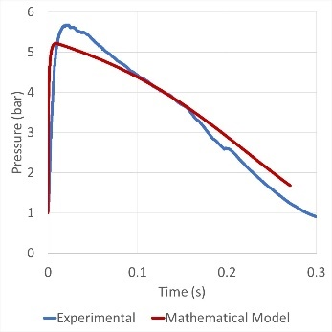 | 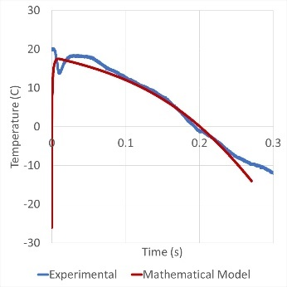 | 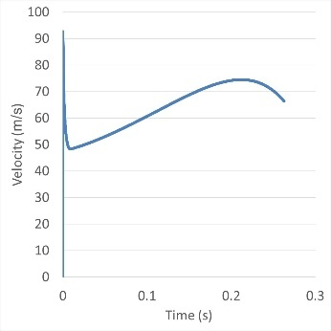 | 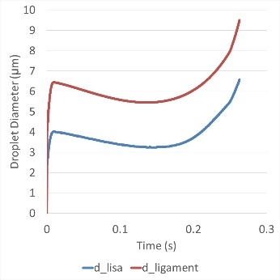
Figure 2 - Experimental vs Mathematical Model (MM) predictions of temporal distributions of (a) pressure and (b) temperature in the expansion chamber and (c) spray velocity and (d) minimum and maximum droplet size in the near-orifice region.
After accumulating droplet diameters/numbers for all the time steps in accordance with the procedure described in the previous section, the droplet diameters are classified. The results are compared with experimental results from [10] in Figure 3.
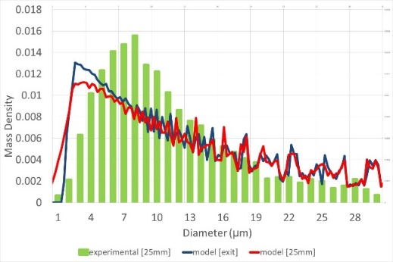 | 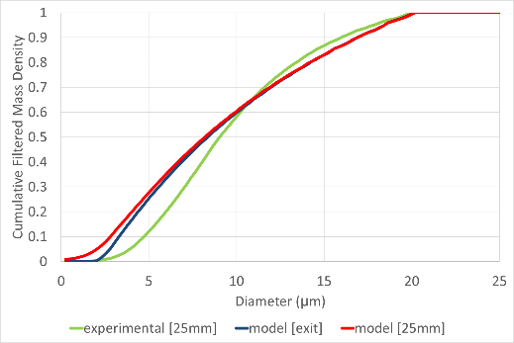
Figure 3 - Mass density of droplets for the size spectrum on the solution comparing with experimental results (left). Cumulative filtered mass density (below 20μm) (right).
Figure 3 (left) illustrates the mass density of the spray droplet distribution. The green bars show aggregated and classified PDA data [10] taken at a single location in the centre of the spray plume at an axial distance of 25mm from the spray orifice exit. The two solid lines show the results from the proposed model in this study (blue = spray orifice exit; red = 25mm with account of evaporation). The predicted spread of the droplet size distributions agrees reasonably well with experiments, expect that the mode of the experimental mass density is at higher droplet size than the values predicted by the model. The results show that there are very few droplets less than 1 micron at the spray orifice exit, but these appear at 25 mm distance due to evaporation, but it is likely that our very simple momentum/evaporation model generates excessive numbers of sub-micron droplets due to over-prediction of the evaporation rate.

Parameter | Experimental (PDA) [25mm] | Model [exit] | Model [25mm]
Mass d₅₀ | 15.43 | 18.17 | 18.03
Mass d₅₀ (filtered at 20 µm) | 9.04 | 8.36 | 8.19
Mass d₁₆ | 1.48 | 2.26 | 0.90
Mass d₈₄ | 6.73 | 4.77 | 4.45
GSD | 2.13 | 1.45 | 2.22
Mass d₁₆ (filtered at 20 µm) | 5.50 | 3.95 | 3.54
Mass d₈₄ (filtered at 20 µm) | 14.28 | 15.27 | 15.22
GSD (filtered at 20 µm) | 1.61 | 1.97 | 2.07
Table 2 – Comparison of experimental and numerically predicted aerosol droplet size metrics
Figure 3 (right) shows the cumulative distribution of mass density filtered to remove droplets larger than 20 microns. This enables us to generate aerosol metrics that can be compared with cascade impactor measurements for typical pMDI aerosol products. The cumulative distribution of droplets predicted by the model at 25mm of the spray orifice shows similar d₅₀ to the experimental measurements, but the droplet content < 1-2 µm is over-predicted for reasons outlined above. More precise accounts of momentum transfer and evaporation would enable us to improve these predictions. In Table 2, the mass d₁₆, d₅₀, d₈₄, and GSD are shown for the filtered data and full data. Predicted GSD at 25 mm is stable after implementing the momentum transfer and the evaporation model.

Conclusion
In this paper, we have improved the atomization model of Gavtash [4, 5] by including a model of the spread of the droplet size/mass distribution. For each time step, this model will generate a spectrum of droplet sizes. This computes the properties of the aerosol cloud produced by a pMDI and enables comparison of the numerical droplet size model directly with the experimental results of an ACI/NGI. The method is not limited by specific assumption about the propellant/mixture; hence, this method can be used for any pMDI formulation for which thermophysical, and transport properties are available.

Acknowledgement
The authors gratefully acknowledge the financial support of Innovate UK in the form of funding of Knowledge Transfer Partnership KTP012178.

References
[1] L. Bartolucci, R. Scarcelli, T. Wallner, A. Swantek, D. Duke, A. Kastengren, C. F. Powell, “Gaseous Direct Injection from an Outward Opening Injector: CFD and X-ray Analysis”, SAE Technical Paper 2016-01-0850, presented at the SAE World Congress, Detroit, MI, April 2016.
[2] Kolanjiyil, A. & Hosseini, S. & Alfaifi, A. & Farkas, D. & Walenga, R. & Babiskin, A. & Hindle, M. & Golshahi, L. & Worth Longest, P. (2021). Validating CFD Predictions of Nasal Spray Deposition: Inclusion of Cloud Motion Effects for Two Spray Pump Designs. Aerosol Science and Technology. 56. 1-26. 10.1080/02786826.2021.2011830.
[3] Gavtash, B. CFD Simulation Of Pressurised Metered-Dose Inhaler (pMDI), Wolfson School Of Mechanical, Loughborough University, 2016 (Issue May).
[4] Gavtash, B., Versteeg, H. K., Hargrave, G., Myatt, B., Lewis, D., Church, T., & Brambilla, G. Transient aerodynamic atomization model to predict aerosol droplet size of pressurized metered dose inhalers (pMDI). Aerosol Science and Technology, 2017, 51(8), 998–1008. https://doi.org/10.1080/02786826.2017.1327121.
[5] Gavtash, B., Versteeg, H. K., Hargrave, G., Myatt, B., Lewis, D., Church, T., & Brambilla, G. A model of transient internal flow and atomization of propellant/ethanol mixtures in pressurized metered dose inhalers (pMDI). Aerosol Science and Technology, 2018, 52(5), 494–504. https://doi.org/10.1080/02786826.2018.1433814.
[6] Gavtash, B., Versteeg, H. K., Hargrave, G., Myatt, B., Lewis, D., Church, T., & Brambilla, G.. Transient flashing propellant flow models to predict internal flow characteristics, spray velocity, and aerosol droplet size of a pMDI. Aerosol Science and Technology, 2017, 51(5), 564–575. https://doi.org/10.1080/02786826.2017.1282151
[7] R.D. Reitz, F.V.Bracco, Mechanism of atomization of a liquid jet, 1982, Phys. Fluids, 25 (10), Pages 1730-1742, View online: https://doi.org/10.1063/1.863650
[8] P.K. Senecal, D.P. Schmidt, I. Nouar, C.J. Rutland, R.D. Reitz, M.L. Corradini, Modeling high-speed viscous liquid sheet atomization, International Journal of Multiphase Flow, 1999, Vol 25, Issues 6–7, Pages 1073-1097
[9] Myatt, B.J. A Fundamental Study of the Primary Atomisation Mechanism and Aerosol Plume Development of the Pressurised Metered Dose Inhaler, Wolfson School Of Mechanical, Loughborough University, 2017.
[10] Versteeg, Hendrik; Hargrave, Graham; Myatt, Ben; Lewis, David; Church, Tanya; Brambilla, G. (2017): Using phase Doppler anemometry & high-speed imaging to analyze MDI spray plume dynamics. Loughborough University, 2017, Conference contribution. https://hdl.handle.net/2134/24258
[11] F.P. Incropera, D.P. Dewitt, T.L. Bergman, A.S. Lavine, Fundamental of Heat and Mass Transfer (6th edition), 2007, John Wiley & Sons

