The relevance of non-standardised in vitro nasal cast models in product development

Lucas Silva¹, Nathalie Hauchard², Nuria Manzano¹ & Gonçalo Farias²

¹Nanopharm Ltd, Franklin House, Grange Road, Cwmbran, NP44 3WY, UK

²Aptar Pharma, Route des Falaises, Le Vaudreuil, 27100, France

Summary
More realistic in vitro tools are being explored to facilitate product development by providing a better link between in vitro studies and in vivo outcomes. Standardisation is usually seen as a major challenge for these novel tools.
In this study, the nasal regional deposition of two distinct nasal products (liquid and powder) was evaluated in two different nasal cast models: one sophisticated model validated in vivo (Aeronose™) and one idealised model (AINI). Both nasal casts were able to track differences in regional deposition of two products with comparable results in anterior and posterior deposition. Nonetheless, a different deposition on the olfactory region was observed, possibly related to differences in adhesion of the powder to the nasal cast. Standardisation of realistic in vitro tools might be useful from a quality control perspective particularly by using idealised models. However, it might not be required during product development, where sophisticated and complete geometry models that can be built to be representative of certain target populations could be used as long as those models are validated with in vivo studies.
Key Message
Two distinctly different, validated nasal cast models were able to similarly discriminate differences in the regional deposition of two nasal products. Different nasal cast models could be used during product development studies as long as these have been validated with in vivo studies.

Introduction
Similar to orally inhaled drug products, the regional deposition of nasal droplets plays a major role in absorption and bioavailability [1]. Thus, both in silico models and realistic in vitro tests have been proposed to better understand the regional deposition of nasal drug products [2,3].
Nasal casts are more realistic in vitro techniques that model a real nasal cavity and provide more information on the deposition profile of a nasal product [4]. These nasal casts were mostly built from medical databases compiling imagery nasal data from computed tomography, magnetic resonance imaging scans and sectioned scans [2].
One key challenge of using a nasal cast to evaluate regional deposition is the difficulty of standardisation: it might be challenging to make a representative nasal cast that covers a wide range of people given the tremendous interindividual differences in nasal geometry and to account for the mucus and mucociliary clearance [5]. Furthermore, several actuating parameters should be controlled such as the tilt angle, actuation force, insertion depth in the nostrils and airflow applied. To overcome some of these challenges, different solutions have been envisioned such as the development of idealised models based on computational fluid dynamics (CFD) simulations and validating sophisticated models with in vitro in vivo correlation studies [6,7].
The goal of this study was to compare two different nasal cast models with two distinct device / formulation combination products to understand if both models are similarly able to track differences between these products.

Materials & Experimental Methods
Nasal delivery devices and formulations
The regional deposition of model formulations being dispersed with two different nasal devices was investigated. A multidose liquid nasal spray pump (VP7 pump fitted with a 232 actuator, Aptar Pharma, Le Vaudreuil, France) was used to deliver 50 µL of a fluorescein solution. This nasal solution was prepared by dissolving fluorescein sodium (Merck KGaA, Darmstadt, Germany) in Milli-Q water with a concentration of 75 g/L. A unit dose powder device (UDS powder, Aptar Pharma, Le Vaudreuil, France) was used to deliver 10 mg of pure fluorescein sodium powder with a particle size distribution within the nasal range (10 µm – 100 µm).
In Vitro Nasal Regional Deposition with a Validated Sophisticated Complete Geometry Model
In vitro deposition of model formulations being dispersed from two nasal devices was characterised in an adult male nasal cast (Aeronose™, courtesy of Aptar/DTF/Univ. of Tours) with chemical quantification (Figure 1 A). The nasal cast model used was designed from Computed Tomography images (CT scan) of a plastinated head model [8] and was previously validated as a predictive model for nasal aerosol deposition [6].
One device was manually actuated into both nostrils of the nasal cast with an accurately defined insertion depth of 10 mm for the liquid device and 15 mm for the powder device and a delivery angle (horizontal plane) of 45° and a fixed angle from the centre wall of 5° for both products. For the powder device testing, the nasal cast was humidified with water with a nebuliser (AMGH, DTF, Saint-Etienne, France) for 10 min at 3 liters per minute (nebuliser output). The analysis was performed in triplicate per configuration (three devices for the multidose pump and six devices for the unit dose powder device). No flow rate was applied throughout the casts in this study.
The different regions of interest (nose area, olfactory area, turbinates including the nasal floor, rhinopharynx and lungs) were rinsed with different volumes of water. Those samples were then quantified on a spectrophotometer at λ=487 nm (Light Wave II, Bioserv, Morangis, France) with a calibration curve ranging from 0.1 to 10 µg/mL.
In Vitro Nasal Regional Deposition with an Idealised Model
The Alberta Idealized Nasal Inlet (AINI, Copley Scientific Ltd., Nottingham, UK) was also used to characterise the regional deposition of both products with chemical quantification. This nasal cast model is based on CFD deposition simulations based on CT scans of different subjects [7, 9]. This nasal cast is composed by four separate parts: vestibule/nostril (nose area on Aeronose™), turbinates, olfactory area and rhinopharynx (Figure 1 B).
One device was manually actuated into the single nostril of the nasal cast with an approximated angle of 45° and insertion depth around 10 mm for both devices since it was not possible to achieve higher insertion depths (visually assessed). For the powder device testing, the nasal cast was coated with 1% w/v of glycerol in ethanol to allow a better adhesion of the formulation to the different regions of the nasal cast and prevent rebounding due to differences in materials used between both nasal cast models. No airflow was applied. The analysis was performed in triplicate per configuration (three devices for both products). The nasal cast was dismantled and the different regions were recovered in crystallisation dishes with water. Those samples were then quantified on a spectrophotometer with a calibration curve ranging from 0.1 to 10 µg/mL.
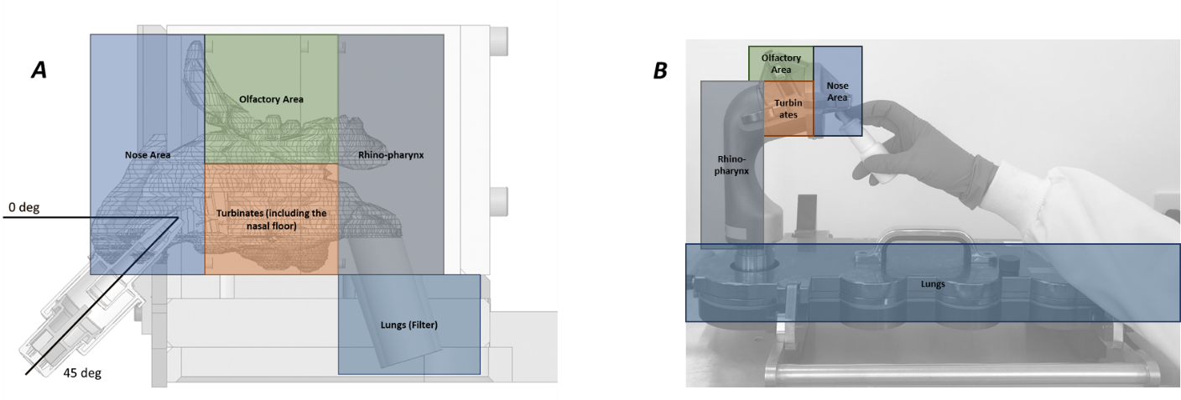
Figure 1 - (A) 3D representation for the nasal cast Aeronose™ and nasal regions used for quantification. (B) Experimental set-up of AINI nasal cast and nasal regions used for quantification.

Results & Discussion
Figure 2 presents the regional deposition of two nasal sprays (VP7/232 and UDSp) in two different nasal cast models (Aeronose™ and AINI). All configurations had a negligible postnasal deposition (deposition lower than 5%). The liquid nasal device had a higher deposition area in the nose (~54%) compared to the powder device (~24%) which was comparable between both casts (student's t-test, p=0.55 and p=0.49 for liquid and powder device, respectively). Consequently, the nasal deposition in the posterior region (turbinates, olfactory area and rhinopharynx) of the nasal cavity was significantly higher (student's t-test, p< 0.01) for the UDSp (~76%) compared to the VP7/232 device (~46%) which was comparable between both casts. Nonetheless, a higher deposition on the olfactory area for the Aeronose was observed compared to the AINI, particularly for the UDSp (~47% for Aeronose compared to ~2% for the AINI). This gap of deposition in the olfactory region may be related to the differences in adhesion of the powder into the nasal cast (different materials and coating agents), differences in the cavity (particularly on the volume / surface area) and, less probably, due to the inability of reaching equivalent insertion depths. Evaluating further coating agents with further replicates might be required to confirm this differences in deposition in the olfactory region.

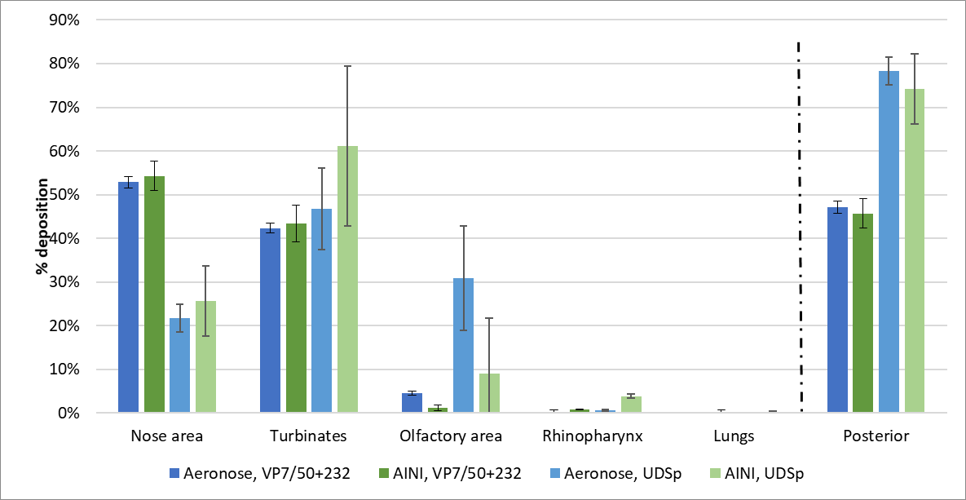
Figure 2 - Mean in vitro deposition from two different nasal sprays (VP7/232 and UDSp) in two different nasal cast models (Aeronose™ and AINI). Error bars show standard deviations (n = 3). The posterior region corresponds to the deposition in the turbinates, olfactory area and rhinopharynx.

Conclusion
The regional nasal deposition was evaluated on two different nasal cast models with two different nasal products. Even though both nasal cast models have considerable differences (an idealised model with a single nostril and a sophisticated full nasal geometry model), both nasal casts had a comparable deposition in the anterior and posterior regions of the nasal cavity and were able to detect differences between both nasal products. However, differences in deposition on the olfactory region, probably related to the adhesion of the powder to the cavity and/or to the nasal cast dimensional differences (surface area), were observed and should be further investigated.
Although standardisation might be a challenge for nasal cast deposition studies, this study suggests that different nasal cast models are able to equally discriminate differences in the regional deposition of two different nasal drug products (powder and liquid). Hence, these realistic in vitro tools could provide valuable insights into the regional deposition by facilitating device and formulation screening studies during early development stages of nasal drug products Although an idealised nasal cast model could be more important for quality control type of testing, a sophisticated and complete geometry individual model could also be considered, particularly when targeting specific anatomies and when developing personalised drug product applications. Nevertheless, in vitro in vivo validation studies should be considered during the development of these realistic in vitro tools.

References
[1] Forbes B, Bommer R, Goole J, Hellfritzsch M, De Kruijf W, Lambert P, Caivano G, Regard A, Schiaretti F, Trenkel M, Vecellio L, Williams G, Sonvico F. A Consensus Research Agenda for Optimising Nasal Drug Delivery. Expert Opinion on Drug Delivery 2020, 17 (2): pp. 127–132.
[2] Le Guellec S, Ehrmann S, Vecellio L. In vitro – in vivo correlation of intranasal drug deposition. Advanced Drug Delivery Reviews 2021, 170: pp. 340-352.
[3] Rygg A, Hindle M, Longest PW. Linking Suspension Nasal Spray Drug Deposition Patterns to Pharmacokinetic Profiles: A Proof-of-Concept Study Using Computational Fluid Dynamics. Journal of Pharmaceutical Sciences, 2016, 105(6): pp. 1995–2004.
[4] Williams G, Suman JD. In Vitro Anatomical Models for Nasal Drug Delivery. Pharmaceutics 2022, 14 (7): pp 1353.
[5] Salade L,Wauthoz N, Goole J, Amighi K. How to Characterize a Nasal Product. The State of the Art of In Vitro and Ex Vivo Specific Methods. International Journal of Pharmaceutics, 2019, 561, pp. 47–65.
[6] Williams G, Cabrera M, Graine L, Le Guelle S, Hauchard N, Jamar F, Pardessus J, Le Pennec D, Reychler G. In Vitro and In Vivo Assessment of Regional Nasal Deposition using Scintigraphy from a Nasal Spray and a Nasal Powder. Respiratory Drug Delivery 2021, 1: pp. 135–40.
[7] Finlay WH, Chen J, Kiaee M, Martin AR. Development of an Idealized Nasal Geometry for Estimation of Regional Deposition of Nasal Sprays. Respiratory Drug Delivery 2021, 1: pp 127-134.
[8] Durand M, Pourchez J, Louis B, Pouget J-F, Isabey D, Coste A, Prades JM, Rusch P, Cottier M. Plastinated nasal model: a new concept of anatomically realistic cast. Rhinology. International and European Rhinologic Societies 2011, 49: pp 30–36.
[9] Chen JZ, Kiaee M, Martin AR, Finlay WH. In vitro assessment of an idealized nose for nasal spray testing: Comparison with regional deposition in realistic nasal replicas. International journal of pharmaceutics, 2020, 582: pp.119341.

