Development and activity testing of spray dried Phosphorylated Hexaacyl Disaccharide for nasal administration
Jasmine Ahad¹, Jack Sorrell¹, Laura Mason¹, Kristine Storey² & Joe Ninosky²
¹Upperton Pharma Solutions, Albert Einstein Centre, Nottingham Science and Technology Park, Nottingham, NG7 2TN, United Kingdom
²Revelation Biosciences Inc., 11011 Torreyana Road, Suite 102, San Diego, CA 92121, United States
Summary
Derived from the lipopolysaccharide fraction of the cell walls within Gram negative bacteria, Phosphorylated Hexaacyl Disaccharide (PHAD) activates Toll-like receptor 4 (TLR4) leading to the production of cytokines, activation of CD4+ and CD8+ T cells, and the activation of the adaptive immune response. This has potential applications for the prevention and/or treatment of respiratory viral infection and allergies, and so a product for nasal administration is targeted. However, PHAD is poorly soluble in aqueous formulations, and may incur stability issues due to hydrolysis. Thus, investigations were conducted to produce a dry powder PHAD formulation (2:49:49 %w/w/w PHAD:Hydroxypropyl-β-Cyclodextrin:Trehalose) by spray drying to increase long-term stability and improve aqueous solubility. The optimum feed solution preparation process to generate micellar PHAD for spray drying has been investigated. Reconstitution of the resultant powder formulations at 0.6 mg/mL PHAD in water found that decreasing the concentration of PHAD within the spray drying feed solution resulted in improved reconstitution of the spray dried PHAD formulation, with faster dissolution and reduced solution turbidity observed. In addition, micelle diameter distributions by dynamic light scattering (DLS) showed a trend towards uniformity as the feed solution concentration was reduced. As a result, it was identified that a concentration of 0.5 mg/mL PHAD in the initial spray drying feed solution balanced spray drying efficiency and quality of micelles when reconstituted. Spray dried PHAD also maintained similar biological activity to unprocessed PHAD in solution. The spray dried PHAD will be further investigated as a stable form of PHAD that can be administered intranasally, either as a reconstituted solution or as a powder.
Key Message
Spray dried PHAD formulation has been developed for administration as a micellar nasal spray to treat viral respiratory infections and allergies. Investigations found that PHAD concentration within spray drying feed solutions influenced the reconstitution properties of the resultant powder formulations, with reconstitution time, solution turbidity and micelle uniformity affected.
Introduction
Monophosphoryl lipid A (MPLA) is a derivative of lipid A, the biologically active section of a Gram-negative bacterial lipopolysaccharide endotoxin with potential immunostimulatory activity ^{[1]}. A synthetic structural analogue of MPLA, Phosphorylated Hexaacyl Disaccharide (PHAD), has been developed to enhance the immune response, and when in micellar form, it activates Toll-like receptor 4 (TLR4), leading to the production of protective cytokines and chemokines, and activation of CD4+ and CD8+ T-cells ^{[2,3]}. However, it is believed that PHAD must be in particle form, like a micelle, for best recognition and binding to TLR4, possibly as the micellar shape mimics a globular protein ^{[4]}. Micelles can be prepared by wetting PHAD with a solvent (ethanol) and adding water. However, when prepared as a liquid solution this has shown poor solubility and high irritation on administration due to the presence of the non-aqueous solvent. The aim of this study was to spray dry PHAD in its micellar form to produce a powder formulation that would reconstitute in water back to its original micellar form and produce an immune response. If successful, this would result in increased stability of the drug product and improved patient compliance due to removal of ethanol. In order to prepare the feed solutions, PHAD concentration would need to be considered as this could affect the size and quality of the assembled micelle ^{[5]}.

Experimental methods
Materials
Phosphorylated Hexaacyl Disaccharide (PHAD - Avanti) was provided by Revelation Biosciences, 95% ethanol (Fisher Scientific, United Kingdom), Water for Injection (Cytiva, United States), Hydroxypropyl-β-Cyclodextrin (Roquette, France), Trehalose dihydrate (Hayashibara, Japan), Murine J774A.1 macrophages (ATCC, Manassas, Virginia, United States), DMEM medium (Corning, Corning, NY), 10% foetal bovine serum (FBS, HyClone, Logan, UT).
Preparation of Micellar Feed Solution for the Spray Drying of 2:49:49 (%w/w/w) PHAD:HP-β-CD:Trehalose Formulation
Micellar feed solutions were prepared at PHAD concentrations varying from 0.3 to 1.0 mg/mL PHAD. Due to poor solubility of PHAD in water, higher ethanol contents were required for increased PHAD concentrations, as detailed in Table 1. PHAD was sonicated (Proclean 28.0M, Ulsonix) at 40°C in 95% ethanol to produce a turbid nanosuspension. An excipient solution consisting of Hydroxypropyl-β-Cyclodextrin (HP-β-CD) (a solubilising/ stabilising agent) and Trehalose Dihydrate (Trehalose) (a stabilising agent) in Water for Injection (WFI) was heated to 40°C and added to the ethanolic PHAD at 10 g/min via a peristaltic pump while sonicating at 40°C. Following addition, the micellar feed solution was further sonicated at 40°C for 15 minutes and then equilibrated to room temperature.
Table 1: Composition of spray drying feed solutions at varying PHAD concentrations
Feed Solution Batch codes | PHAD Concentration (mg/mL) | HP-β-CD Concentration (mg/mL) | Trehalose Concentration (mg/mL) | WFI in PHAD solution (%) | 95% Ethanol in PHAD solution (%)
A-Feed | 1.0 | 24.5 | 24.5 | 50 | 50
B-Feed | 0.8 | 19.6 | 19.6 | 60 | 40
C-Feed | 0.6 | 14.7 | 14.7 | 70 | 30
D-Feed | 0.5 | 12.3 | 12.3 | 75 | 25
E-Feed | 0.4 | 9.8 | 9.8 | 80 | 20
F-Feed | 0.3 | 7.4 | 7.4 | 85 | 15
Spray Drying of Micellar Feed Solutions
Micellar feed solutions were spray dried using the ProCepT 4M8-Trix Spray Dryer fitted with a two-fluid nozzle (0.8 mm tip) (ProCepT, Zele, Belgium), according to the target spray drying parameters outlined in Table 2 below, to produce white cohesive powders of 70-80% yields.
Table 2: Target Spray Drying Parameters for PHAD Feed Solutions
Inlet temperature  (°C) | Outlet temperature (°C) | Nozzle air (bar) | Cooling air (bar) | Drying airflow (m³/min) | Liquid feed rate (g/min)
113-120 | 70 | 1.0 | 0.5 | 0.7 | 7.5-8.0
Reconstitution of Spray Dried PHAD Formulations and Analysis of Micelles by Dynamic Light Scattering (DLS)
The spray dried PHAD formulations were reconstituted in triplicate at 0.6 mg/mL PHAD in WFI with light vortexing. Dissolution time (vortexing time required until no visible particulates observed) and visual observations of the resultant dispersion were recorded. Dispersions were analysed via DLS with backscatter at 20˚C (Malvern Instruments Zetasizer Nano S, United Kingdom) to compare average size distribution by intensity, micelle z-average and Polydispersity Indexes (PdIs).
In Vitro Comparison of Liquid and Spray Dried PHAD Formulations
Murine J774A.1 macrophages were cultured in DMEM medium containing 10% foetal bovine serum. One hundred thousand cells were plated per well of a 24-well plate and treated with 50 ng/mL PHAD in a liquid solution (ethanol in water) or spray dried and reconstituted in water. Cells were harvested 24 hours after seeding and pelleted by centrifugation at 250 x g. Supernatant was collected and centrifugation at 250 x g was performed to remove any residual cells. Supernatant was then analysed per manufacturer’s protocols for the presence of IP-10 or TNFɑ using Invitrogen (Waltham, MA) and R&D Systems (Minneapolis, MN) ELISA kits.

Results and Discussion
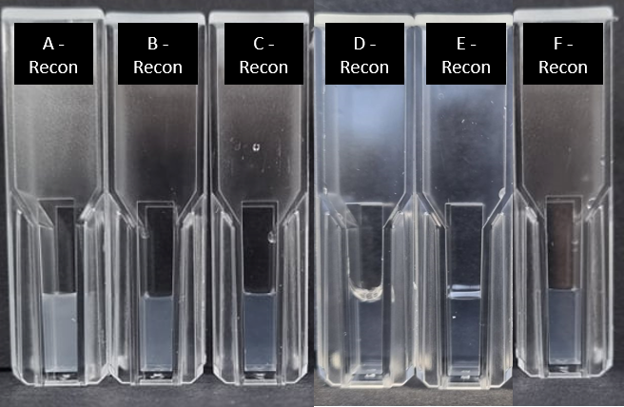
Figure 1: Replicate 1 of reconstituted spray dried PHAD formulations at 0.6 mg/mL PHAD in WFI. Reconstituted batch codes correspond to feed solution batch codes outlined in Table 1. Initial PHAD concentrations in feed solutions (in mg/mL): A:1.0, B:0.8, C:0.6, D:0.5, E:0.4 and F:0.3
PHAD concentrations within the initial feed solutions were altered to increase overall feed solids and therefore reduce spray drying processing times. However, increased feed concentrations were observed to have had an effect on the reconstitution properties of the resultant spray dried formulations. Figure 1 shows a visual decrease in turbidity of the reconstituted spray dried PHAD as the initial PHAD concentration in the feed solution decreased. It was also observed that the ease of dissolution increased with decreasing initial PHAD concentration, with less time required to reconstitute samples by vortexing (see Table 3).
Table 3: Summary of feed solution batches and their reconstitution times, Z-averages and PdI values.
Batch | PHAD concentration in feed solution | DLS - Size Distribution by Intensity |  | Reconstitution time (seconds)
Batch | PHAD concentration in feed solution | Z-Avg (d.nm) | PdI | Reconstitution time (seconds)
A | 1.0 | 854.2 | 1.000 | 122
B | 0.8 | 213.6 | 0.769 | 35
C | 0.6 | 150.8 | 0.350 | 29
D | 0.5 | 130.4 | 0.287 | 25
E | 0.4 | 133.4 | 0.239 | 31
F | 0.3 | 124.1 | 0.221 | 34

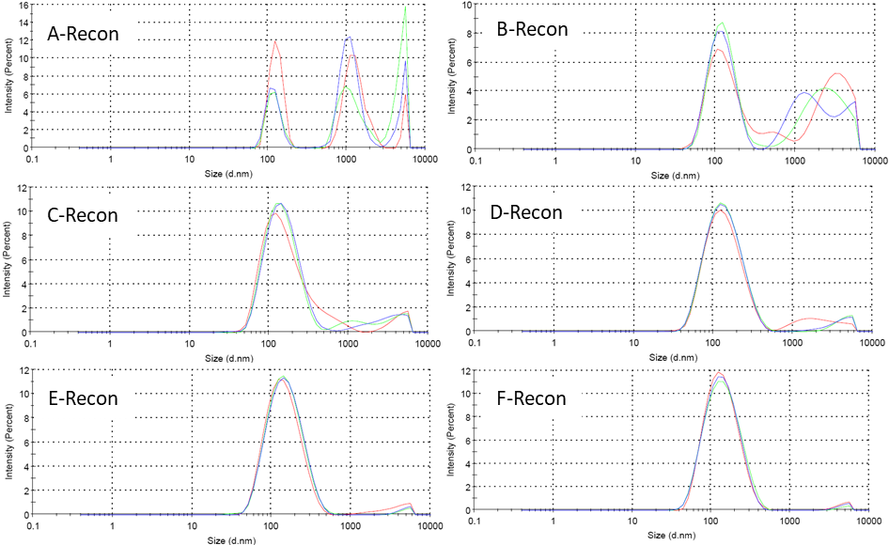
Figure 2: Size distribution by intensity traces of spray dried PHAD formulations reconstituted at 0.6 mg/mL PHAD in WFI (3 average measurements per batch).
Figure 2 and Table 3 also show the effect of PHAD feed concentration on the size and uniformity of reconstituted micelles, which is believed to be important for the efficacy of PHAD. Formulations spray dried using higher concentration PHAD feed solutions (A & B) produced multimodal micelles with high PdI values, whilst formulations spray dried from lower concentration feed solutions appeared more monodisperse, with lower PdI values observed.
Results for in-vitro activity testing of reconstituted samples in J774A.1 macrophages are shown in Figure 3. Results show that in vitro activity was maintained after spray drying. Secreted IP-10 and TNFɑ levels were determined by ELISA after 24 hours and demonstrated that when prepared to an equivalent concentration, PHAD in an ethanol solution and spray dried PHAD reconstituted in water both mediated similar levels cytokine of production following treatment.
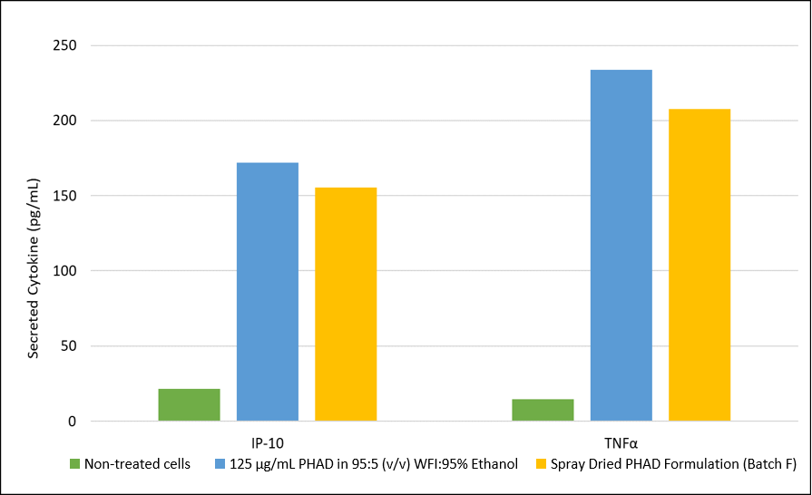
Figure 3: Levels of IP-10 and TNFα following 24-hour treatment of J774A.1 macrophages with 50 ng/mL of a 125 µg/mL PHAD in 95:5 WFI:95% Ethanol (v/v) and spray dried PHAD formulation (Batch F) (n=1).

Conclusion
Varying the PHAD concentration within the initial feed solution was investigated and resultant spray dried powders were reconstituted in water and analysed via DLS. Decreasing the initial PHAD concentration resulted in reduced reconstitution times and decrease in turbidity of the micellar solutions. It was also found that decreasing the PHAD concentration produced micelles which were uniform and monomodal in size, with lower PdI values. From the concentration range investigated, a feed solution concentration of 0.5 mg/mL PHAD was shown to be the most effective in maintaining the balance of spray drying processing times without compromising the integrity of the reconstituted micelles. These reconstituted solutions were also shown to maintain in vitro activity, being able to produce a cytokine response comparable to the original PHAD in ethanolic solution. The powder will be further investigated as a stable form of PHAD that can be administered intranasally, either as a reconstituted solution or as a powder.
References
[1] National Cancer Institute. (2022, July 12). Definition of monophosphoryl lipid A - NCI Drug Dictionary - NCI. National Cancer Institute. Retrieved July 12, 2022, from https://www.cancer.gov/publications/dictionaries/cancer-drug/def/monophosphoryl-lipid-a
[2] Casella, C. R., and Mitchell, T. C. (2008, August). Putting endotoxin to work for us: Monophosphoryl lipid A as a safe and effective vaccine adjuvant. Cellular and Molecular Life Sciences, 65, 3231 – 3240. DOI: 10.1007/s00018-008-8228-6
[3] Kamphuis, T., Meijerhof, T., Stegmann, T., Lederhofer, J., Wilschut, J., and de Haan, A. (2012, May). Immunogenicity and Protective Capacity of a Virosomal Respiratory Syncytial Virus Vaccine Adjuvanted with Monophosphoryl Lipid A in Mice. PLOS ONE, 7(5), e36812. DOI: 10.1371/journal.pone.0036812
[4] Ho Min, K., Beom Seok, P., Jung-In, K., Judong, L., Se Cheol, O., Purevjav, E., Norio, M., Hayyoung, L., Ook Joon, Y., and Jie-Oh, L. (2007, September 7). Crystal Structure of the TLR4-MD-2 Complex with Bound Endotoxin Antagonist Eritoran. Cell, 130 (5), 906-917. DOI: 10.1016/j.cell.2007.08.002
[5] Yang, L., Ershaui, Z., Jianhai, Y., and Zhiqiang, C. (2018, August). Strategies to improve micelle stability for drug delivery. Nano Research, 11(10), 4985–4998. DOI: 10.1007/s12274-018-2152-3

