Development of Inhaled Platelet-based Therapy to Repair Damaged Lungs

Ziru Xu, Ben Forbes, Simon Pitchford & Magda Swedrowska

King’s College London, Institute of Pharmaceutical Science, London SE1 9NH, UK

Summary
As the first defence line in the lungs, the epithelium can be damaged by infections, inflammation, toxic compounds, and trauma. It is critical to recover a healthy epithelial barrier after lung injury. Platelets produce many different types of growth factors which promote cell growth and tissue regeneration. The aim of this project was to investigate the regenerative role of platelet extract on lung alveolar epithelial cells and the potential for development into an inhaled medicine. To gain the extract, platelets were subjected to ultrasound sonication to release their cell contents. Cell proliferation assays using A549 cells showed that sonicated platelet extract enhanced alveolar epithelial cell growth in a time- and concentration- dependent manner. The extract also accelerated closure of a scratched wound on the monolayer of A549 cells. When nebulised with an Aerogen Pro® mesh nebuliser, the extract produced an aerosol with a fine particle fraction below 5 µm of ca. 50% and no loss of activity in bioassay. In conclusion, sonicated platelet extract was effective at promoting alveolar epithelial cell growth and can be nebulised to form a bioactive respirable aerosol.
Key Message
Lung injury is associated with high morbidity and mortality and there are currently limited pharmacological options for treatment. Platelet-derived therapy has proven a regenerative action in non-respiratory disease, and this work describes the production of formulation that will enable proof-of-concept testing for application in lung injury.

Introduction
Platelets are being recognizing as a contributor to tissue regeneration after injury or inflammatory responses besides their primary role in haemostasis.¹ Many platelet-derived biologics have been developed and are widely used in sport medicine.² These autologous products are cost-effective and without any immune rejection reaction. It is believed that abundant growth factors and other cytokines within the granules of platelets could regulate cell growth and division.² To concentrate platelet-derived factors for delivery to the site of action, the content within platelets was harvested as platelet extract.
To maintain lung structure and functions, various types of epithelial cells form the intact blood-air barriers from the upper respiratory tract to the alveoli. Many lung diseases damage the epithelial barrier integrity, of which the most notable is acute lung injury. It is a disorder of acute inflammation causing disruption of the capillary endothelial and alveolar epithelial barriers and presents clinically as respiratory failure. The morbidity and mortality of acute lung injury is high due to diagnostic uncertainty and lack of specific pharmacologic therapy.³ Platelet-derived therapy may contribute to lung homeostasis through induction of cell proliferation and migration.
Pulmonary delivery is an effective method to deliver medicines to the lungs directly for rapid drug action. The licensed inhaled biological, Pulmozyme® is exclusively available for nebulization and many others in development are designated for nebulization.⁴ Compared with other nebuliser devices, vibrating mesh nebulisers produce a low shear stress and have lower requirement of concentration in the reservoir, so it is proper for bioproduct delivery.⁵
The purpose of this study was to develop a novel therapy with capacity to restore the lung mucosal barrier after lung injuries. The first step was to prepare platelet extract and investigate its activity in cell proliferation assays. The second step was to investigate whether it is feasible to generate a respirable aerosol without losing bioactivity.

Methods
Preparation of sonicated platelet extract
The blood collection from healthy donors was approved by the national research ethics committee at Guy’s and St. Thomas’ Hospitals (Research Ethics Committee: 10/H0807/99). Fresh human blood (9 ml) mixed with 1 ml acid citrate dextrose (ACD) was centrifuged at 800 g for 20 min to remove red blood cells and then at 2000 g for 10 min to get the pellet of platelets. The platelet pellet was resuspended in PBS as a platelet concentrate. Platelet numbers were counted using a haemocytometer and diluted to 500×10⁶ platelet per ml. Aliquots (0.5 ml) of platelet suspension were sonicated with an ultrasonic probe (Sonics & Materials, USA) at the amplitude of 20% for 15 s in total (rested for 5 s between 3 x 5 s bursts). The optical densities of 100 μl suspension were determined at 595 nm. After 5 min centrifugation at 10,000 g, the supernatant was collected as platelet extract. Total protein levels of sonicated platelet extract were measured by QuantiPro BCA assay kit (SIGMA-ALDRICH, USA). Samples were frozen at -80˚C until use
Cell proliferation assay
A549 cells were used between the passage number of 55 to 80. A549 cells were seeded in 96-well plates at 5000 cells/well overnight. FBS-free minimum essential medium (MEM) (ThermoFisher, USA) was used as a control. Sonicated platelet extract was diluted to 10 or 100 μg/ml with MEM according to the total protein level in the extract and 100 μl was applied to cells in each well for 24 or 48 h. Cell proliferation was determined by Alamar-Blue assay (R&D Systems, USA).
Inflammation-induced damage model
THP-1 monocytes (8x10⁵/ml) were treated with 10μg/ml O111:B4 lipopolysaccharides (LPS) in RPMI-1640 medium (SIGMA-ALDRICH, USA) for 4h. The medium was collected by centrifugation and frozen at -80˚C until use. After seeding in 96-well plates overnight, 4000 cells A549 per well were treated with LPS-stimulated THP-1 conditioned medium for 24h first and then 100μg/ml platelet extract for 48h. The percentage of viable cells compared with control group were calculated based on the results of Alamar-Blue assay.
Scratched barrier damage model
A549 cells were seeded (1.5x10⁵ cells per well) into 24-well plates for 24 h to form a confluent monolayer. A pipette tip (200 μl) was used to scratch a wound on the midline of the culture well. The cells were then washed three times with PBS before and after scratch. Treatments included medium containing 0% or 2% FBS and 10 or 100 μg/ml platelet extract. The photos were captured by a Nikon Ts2R epifluorescence inverted microscope at 0 and 48 h and analysed by ImageJ. The extent of wound closure was calculated based on images of the wound areas.
Bioactivity of nebulised platelet extract
Sonicated platelet extract was diluted to 100 μg/ml with PBS. The nebulised platelet extract output of an Aerogen Pro® nebuliser was collect and the protein levels were measured by QPBCA assay. The nebulised sample was diluted with FBS-free MEM to contain 10 μg protein/ml and applied to A549 cells for 48 h in the cell proliferation assay.
Aerodynamic particle size characterization using next generation impactor and
The platelet extract was diluted to 400 μg/mL with PBS first. After chilling at 4 °C for 90 min, next generation impactor (Copley Scientific, UK) was operated under an adult tidal respiratory flow rate of 15 L/min and over nebulization rates of approximately 0.38 ml/min for 1 ml sample. The deposition on the stages of the NGI was measured both gravimetrically and by assay of protein concentration quickly to avoid evaporation. The % deposition in each stage was used to calculate aerosol characteristics such as mass median aerodynamic diameter (MMAD) and fine-particle fraction (FPF).

Results
Sonication ruptures platelets and releases cell contents
The optical densities of platelet suspension, read at the wavelength of 595 nm, were decreased from 0.50 OD to 0.13 OD after sonication, an indication that platelets were ruptured and no longer provided the same impediment to light transmission (Fig 1). Concomitantly, the total protein levels increased from 33.6 μg/ml before sonication to 530.0 μg/ml after, confirming the release the contents of the platelets. It still needs further studies of what specific components contained in platelet extract.
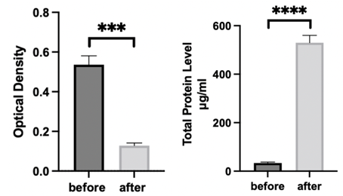
Fig. 1. The optical density (left) and protein level (right) of PBS-based platelet suspension before and after sonication. Platelet suspension was diluted to 500x10⁶ platelet per ml. Each 0.5 ml sample was sonicated at the amplitude of 20% for 15 s. Data represent mean ± SEM, n=3. Statistical differences at p < 0.001 (three symbol) and p < 0.0001 (four symbols) were determined by paired student’s t test.
Sonicated platelet extract promotes the proliferation of A549 cells
The protein level of the sonicated platelet extract was measured and adjusted with FBS-free medium to 10 or 100 μg protein/ml. A549 cells treated with FBS-free medium was regarded as a control group. Compared with control, the sonicated platelet extract promoted the cell proliferation after 24 h treatment with the higher concentration producing a greater effect (Fig 2). The results also showed time-dependency with longer treatment time producing more cell growth.
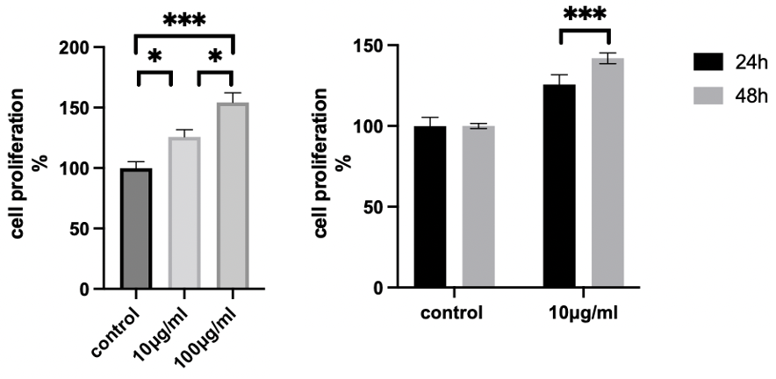
Fig. 2. The proliferation of A549 cells after treatment with different concentrations of sonicated platelet extract (left) for different periods of time (right). Sonicated platelet extract was diluted to 10 or 100 μg protein/ml. A549 cells proliferation was tested by Alamar-Blue assay. Data represent mean ± SEM, n=5. Statistical difference at p < 0.05 (one symbol) and p < 0.001 (three symbols) was determined by paired one-way ANOVA and unpaired student’s t test to understand the effect of concentration and time, respectively.
Sonicated platelet extract induces cell growth in the inflammation environment
A549 cell responsiveness to LPS is still debated.⁶ LPS-stimulated THP-1 monocyte can boost the inflammation cytokines and produce Fas ligand which amplifies the inflammation and causes alveolar epithelial cell death.^{7,8} There are more cells grown by platelet extract after the cell viability of A549 cells was decreased by LPS-stimulated THP-1 conditioned medium.
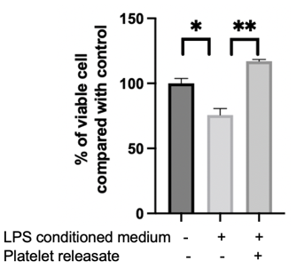
Fig. 3. The proliferation of A549 cells after treatment with LPS–stimulated conditioned medium of THP-1 and sonicated platelet extract A549 cells (4000/well in 96-well plates) were treated with LPS-stimulated THP-1 conditioned medium for 24 h first and then 100 μg/ml platelet extract for 48 h. The viable cell level was tested by Alarm-Blue and compared with control group. Data represent mean ± SEM, n=3. Statistical difference at p < 0.05 (one symbol) and p < 0.01 (two symbols) was determined by unpaired student’s t test.
Sonicated platelet extract demonstrates in vitro wound healing capacity
To investigate repair damaged lung epithelium, A549 cell monolayers were scratched with pipette tips to create a simulated wound. After 48 h, there was no significant difference from control (FBS-free medium) in wound-closing capacity for the 10 μg protein /ml extract, but the wounds treated with 100 μg protein/ml extract showed significantly better wound closure (Fig 4). The best effect occurred in positive control group because FBS contains more growth factors than calf and adult bovine serum and its total protein level can reach 32,000 μg/ml to 42,000 μg/ml.^{9,10} Although FBS is widely used as a growth promotor for in vitro cell culture, its production process, contamination risks and ill-defined nature make it entirely unsuitable for clinical application in humans.^{11,12}
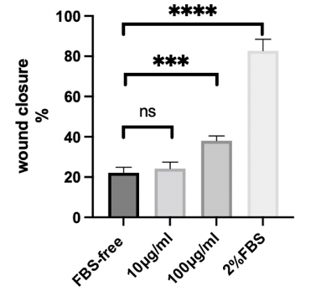
Fig. 4. Effect of platelet extract on wound closure of scratched A549 cell monolayers over 48 h presented as ‘% wound closure’ (left) and representative images (right). ‘Scratch wounds’ made in A549 cell monolayers were treated with FBS-free medium (negative control), 10 or 100 μg protein/ml platelet extract or 2% fetal bovine albumin (positive control) for 48 h. Data are expressed mean ± SEM, n=3. Statistical differences at p < 0.001 (three symbol) and p < 0.0001 (four symbols) were determined by unpaired student’s t test.
Nebulised platelet extract retains bioactivity
Compared with FBS-free control group, sonicated platelet extract 10 μg protein /ml retained the ability to promote the proliferation of A549 alveolar epithelial cells before and after nebulisation (Fig 5). The aerodynamic size distribution of the nebulised platelet extract was determined by recovery on the stages of an NGI, measured gravimetrically and by assay for protein concentration. Both methods showed the similar drug distribution, with the majority deposited in Stage 4 (5.39 - 3.30 μm). The proportion of droplets with a diameter below 5 μm, i.e., the fine particle fraction (FPF), was 48% and 54% measured gravimetrically and by protein assay, respectively, corresponding to median mass aerodynamic diameters of 5.47 μm and 4.86 μm.
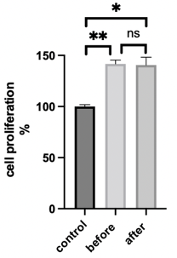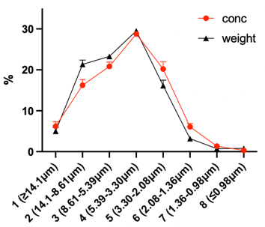
Fig. 5. The effect of sonicated platelet extract on cell proliferation before and after nebulisation (left) and deposition profile in the Next Generation Impactor (right). Platelet extract (100 μg protein/ml was aerosolised by an Aerogen Pro® and retained the proliferative effect on A549 cell. Cell proliferation was measured after 48 h via Alamar-Blue assay with the effect of platelet extract compared to FBS-free medium as control. Data represent mean ± SEM, n=4. Statistical differences at p < 0.05 (one symbol) and p < 0.01 (two symbols) were determined by paired student t test between each group. The deposition of the nebulized platelet extract in the Next Generation Impactor was measured by weight or protein quantification Data represent mean ± SEM, n=5.

Conclusion
Platelet extract was produced by ultrasound sonication of a concentrated suspension of human platelets. The platelet extract promoted concentration- and time-dependant cell proliferation in alveolar epithelial cells and promoted closure of a ‘scratch wound’ made in an alveolar epithelial cell monolayer. The platelet extract retained its bioactivity after nebulisation produced a fine respirable fraction of ca 50%. These data provide encouragement that platelet-derived therapies could be developed as a regenerative therapy for lung injury and provide a foundation for proof-of-concept studies to further evaluate their potential in this area of unmet clinical need.

Reference
1. Etulain J. Platelets in wound healing and regenerative medicine. Platelets. 2018;29(6):556-568. doi:10.1080/09537104.2018.1430357
2. Bava ED, Barber FA. Platelet-rich plasma products in sports medicine. Phys Sportsmed. 2011;39(3):94-99. doi:10.3810/psm.2011.09.1925
3. Cross LJM, Matthay MA. Biomarkers in Acute Lung Injury: Insights into the Pathogenesis of Acute Lung Injury. Crit Care Clin. 2011;27(2):355-377. doi:10.1016/j.ccc.2010.12.005
4. Hertel SP, Winter G, Friess W. Protein stability in pulmonary drug delivery via nebulization. Adv Drug Deliv Rev. 2015;93:79-94. doi:10.1016/j.addr.2014.10.003
5. Pritchard JN, Hatley RHM, Denyer J, von Hollen Di. Mesh nebulizers have become the first choice for new nebulized pharmaceutical drug developments. Ther Deliv. 2018;9(2):121-136. doi:10.4155/tde-2017-0102
6. Nova Z, Skovierova H, Strnadel J, Halasova E, Calkovska A. Short-term versus long-term culture of A549 cells for evaluating the effects of lipopolysaccharide on oxidative stress, surfactant proteins and cathelicidin LL-37. Int J Mol Sci. 2020;21(3). doi:10.3390/ijms21031148
7. Chanput W, Mes J, Vreeburg RAM, Savelkoul HFJ, Wichers HJ. Transcription profiles of LPS-stimulated THP-1 monocytes and macrophages: A tool to study inflammation modulating effects of food-derived compounds. Food Funct. 2010;1(3):254-261. doi:10.1039/c0fo00113a
8. Mizuta M, Nakajima H, Mizuta N, et al. Fas Ligand Released by Activated Monocytes Causes Apoptosis of Lung Epithelial Cells in Human Acute Lung Injury Model in Vitro. Biol Pharm Bull. 2008;31(3):386-390. doi:10.1248/BPB.31.386
9. Fang CY, Wu CC, Fang CL, Chen WY, Chen CL. Long-term growth comparison studies of FBS and FBS alternatives in six head and neck cell lines. PLoS One. 2017;12(6). doi:10.1371/journal.pone.0178960
10. Zheng X, Baker H, Hancock WS, Fawaz F, McCaman M, Pungor E. Proteomic analysis for the assessment of different lots of fetal bovine serum as a raw material for cell culture. Part IV. Application of proteomics to the manufacture of biological drugs. Biotechnol Prog. 2006;22(5):1294-1300. doi:10.1021/bp060121o
11. Castells-Sala C, Martorell J, Balcells M. A human plasma derived supplement preserves function of human vascular cells in absence of fetal bovine serum. Cell Biosci. 2017;7(1). doi:10.1186/s13578-017-0164-4
12. Witzeneder K, Lindenmair A, Gabriel C, et al. Human-derived alternatives to fetal bovine serum in cell culture. Transfusion Medicine and Hemotherapy. 2013;40(6):417-423. doi:10.1159/000356236

