Aerosol deposition in a mechanically ventilated ex vivo porcine lung using a vibrating mesh nebuliser and a pressurized metered dose inhaler

Ronan MacLoughlin¹, C Champigny², J Montharu², L Vecellio², & E Dalloneau³

¹Research and Development, Science and Emerging Technologies, Aerogen Limited, IDA Business Park, H91 HE94 Galway, Ireland
² Université de Tours, Plateforme Scientifique et Technique Animaleries (PST-A), 37032, Tours, France
³Inhalation solutions, 37510, Tours, France

Summary
Introduction: Despite its frequency of use aerosol delivery during mechanical ventilation of the anesthetised patient is not yet well described in humans. Porcine lungs are known to approximate the airway diameters, branching geometries and volumes of the human lung and ex-vivo lung models have shown utility across several studies. Here, we applied scintigraphic imaging in an ex vivo porcine lung model in the characterisation of aerosol delivery performance of the vibrating mesh nebuliser (VMN) and pMDI during simulated adult mechanical ventilation. Methods: Two groups of three lungs from Large White pigs were used (body weight 102-126 kg). Ventilation parameters were fixed using volume control ventilation. V_{t} 800, I:E 1:2, BPM 15, PEEP 5cmH₂0. 5 mg/5 mL of salbutamol with 0.1mL of ^{99m}Tc-DTPA (37mBq) was loaded into the VMN (Aeroneb Solo, Aerogen, Ireland). 10 puffs of ^{99m}Tc-DTPA labelled salbutamol were delivered by the pMDI (Ventolin®, GSK, UK). Ventilator Circuit resistance was measured pre, during and post dosing to quantify any change. Results: For both VMN and pMDI no change in ventilator circuit resistance was noted. Aerosol deposition obtained in the porcine lung was higher with VMN than pMDI (11.59 ± 1.25% vs 1.31 ± 0.46%). Conclusion: The choice of aerosol drug delivery device has a significant bearing on the amount of drug delivered to the ventilated lung. These findings may be of use in the design and optimisation of clinical interventions but may also inform device selection criteria during pharmaceutical development of therapeutics indicated for use in mechanically ventilated patients.

Key Message

During mechanical ventilation in an ex vivo model of adult lung a vibrating mesh nebuliser delivered significantly more aerosolised drug than a pMDI. Neither device was shown to adversely affect ventilation parameters. These findings are of use in the optimisation of clinical interventions and development of therapeutics indicated for ventilated patients.

Introduction
Aerosol therapy during mechanical ventilation is a commonly prescribed intervention in the treatment of both respiratory (local targeting) and non-respiratory (systemic targeting) conditions. Several devices exist that may be used to administer aerosolised drugs, however, as highlighted during the COVID-19 pandemic, the ability to deliver sufficient drug without the risk of bystander infection from patient derived bioaerosols became a key device selection criterium. The Aerogen Solo, a vibrating mesh nebuliser (VMN), has been shown maintain a sealed patient circuit during ventilation and has been recommended by guidance documents globally for use during mechanical ventilation [1–3]. Despite their lower dose volume, and the fact that they require the patient circuit to be opened for administration (thus increasing the risk of bioaerosol escape) pMDIs remain the device of choice in many clinical institutions [4]. Both VMN and pMDI are reported to be widely used but apart from a limited number of bench studies, very little information is available on the relative drug delivery performance of each in the ventilated patient.
The objective of this study was to compare the deposition of drug in an intubated ex vivo lung model, when delivered by both VMN and pMDI during mechanical ventilation.

Experimental methods
Mechanical Ventilation of the ex vivo lung
Two groups of three ex vivo lungs from Large White pigs were included in this study (body weight range 102-126 kg). Lungs were intubated and ventilated and placed in a container filled with saline maintained at 39°C.
The lungs were intubated using an endotracheal tube (ETT) (2219, Diameter: 8mm; Securimed; Cappelle la Grande, France). The ventilator circuit (RT380 Fischer & Paykel Healthcare) was connected to an intensive care unit ventilator (AVEA®, VIASYS Respiratory Care Inc.) (Figure1). The exhalation port filter was placed at the ventilator. A humidifier (MR850AFU, Fisher & Paykel Healthcare) was connected between the ventilator and the inspiratory branch of the ventilation circuit, and maintained a humidification of 100%. See Figure 1.
A volume control ventilation (VCV) mode was used in order fix the applied tidal volume. This allowed for a direct comparison of lung dose recorded in lungs from animals of differing body weights. Tidal volume was fixed at 800 mL. Positive end expiratory pressure (PEEP) was set to 5 cm H₂O. The Inspiratory / Expiratory ratio (I:E) was 1:2. Respiratory rate was 15 breaths per minute, with an insufflation time of 33%. T-pause was set to zero. Representative of clinical practice, a single recruitment manoeuvre was conducted prior to aerosol delivery to ensure the patency of the airways. Ventilator circuit resistance was recorded from the ventilator user interface to determine whether the drug delivery influenced ventilation parameters.
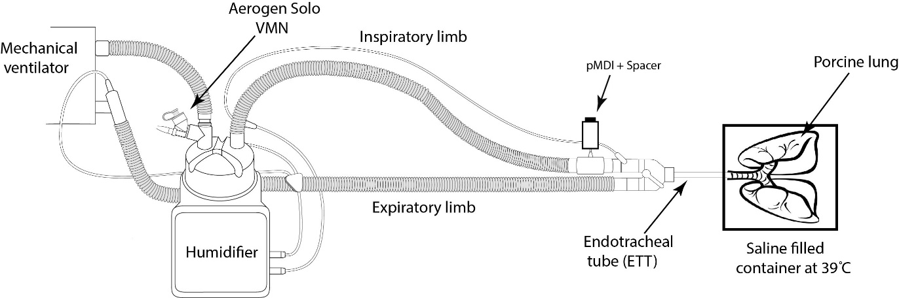
Figure 1: Experimental set up

Aerosol Drug Delivery
The VMN (Aeroneb Solo, Aerogen, Ireland) was connected to the dry side of the humidifier and loaded with 5 mg/5 mL of salbutamol with 0.1mL of ^{99m}Tc-DTPA (37mBq) added.
The pMDI (Ventolin®, GSK, UK) was connected at the ventilator side of the patient wye using a MinispacerTM pMDI ventilator adapter. To ensure sufficient radioactivity per delivered puff, it was necessary to reduce the quantity of drug in the canister before tracing it with the 99mTc. Thus, 150/200 doses were manually discharged before placing the canister in liquid nitrogen (-196°c) for 15min. The canister was then pierced and 0.2mL (150MBq) of 99mTc introduced. The canister was resealed and thawed. Before each dose administration, the canister was shaken for 5 seconds to homogenize the suspension and a 20 second delay before actuation observed. 10 actuations were required to obtain a sufficient quality image for the pMDI (as opposed to the prescribed 4 therapeutic doses). In line with best practice and manufacturer recommendations, each pMDI actuation was delivered at the beginning of the inspiratory phase.
Lung dose characterisation
Immediately following aerosol delivery, the lung and trachea were scanned using a gamma camera (Orbiter 75 Ecam, Siemens healthcare, Erlangen, Germany) to quantify the ^{99m}Tc-DTPA signal. For optimal image acquisition and sensitivity in quantitative analysis, the post-anterior static scintigraphy acquisition was performed for 120 seconds and 360 seconds for the VMN and pMDI respectively. As is standard practice, the radioactivity deposited into the lung and trachea was determined by taking into consideration the decay of technetium and background levels.

Results
Effect of device selection on ventilator circuit resistance
For both VMN and pMDI no change in ventilator circuit resistance was noted over the time course of the administered aerosol doses. At the beginning, middle and end of dosing, resistances of 5.4 ± 1.6, 5.9 ± 0.4, 5.8 ± 0.9 and 6.9 ± 1.1, 5.9 ± 1.9, 5.9 ± 1.7 cmH₂0/L/sec were recorded for VMN and pMDI respectively.
Lung dose characterisation
Aerosol deposition obtained in porcine lung was higher with VMN than pMDI (11.59 ± 1.25% vs 1.31 ± 0.46%). The aerosol deposition distribution indicates a higher relative deposition in the trachea versus lung when using pMDI (1:0.80), whereas the use of VMN shows a higher relative deposition in the lung versus trachea (4.25:1).
When expressing aerosol deposition in terms of mass of salbutamol delivered (using our known ratio of ^{99m}Tc-DTPA:salbutamol), ~600µg was deposited in the lungs with the VMN whereas only ~10µg of salbutamol was delivered to the lung after 10 puffs of pMDI, which is notably low.
Figure 2 presents the scintigraphic images generated for each experiment.
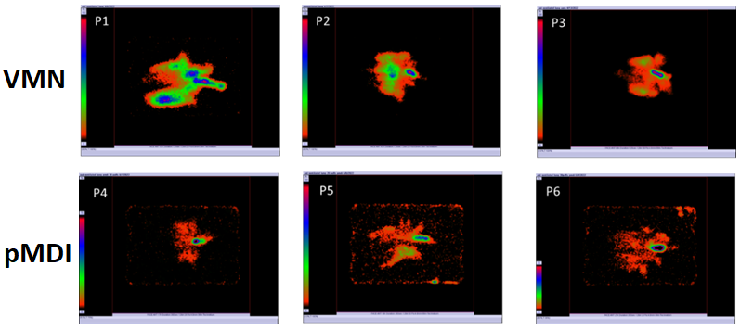
Figure 2: Scintigraphic deposition (lung+ trachea) in mechanical ventilated ex vivo porcine lungs obtained using a VMN (Aerogen Solo, Aerogen, Ireland) and a pMDI (10 doses) ((Ventolin®, GSK, UK).

Discussion
Despite its frequency of use, due to ethical, practical and cost considerations, aerosol delivery during mechanical ventilation of the anesthetised patient is not yet well described in humans. Porcine lungs are known to approximate the airway diameters, branching geometries and volumes of the human lung and ex-vivo lung models have shown utility across several studies. Here, we applied an ex vivo porcine lung model in the understanding of aerosol delivery performance of two commonly used devices, the VMN and pMDI during simulated adult mechanical ventilation.
VMN performed better than pMDI with respect to total delivered dose. When we consider the corresponding delivered mass of salbutamol, the VMN delivered 579.5 ug versus 10 ug delivered by the pMDI (after 10 doses were administered). With respect to therapeutic potential in the clinical setting and the labelled maximum number of 4 doses (400 ug), ~1.31% (~5.2 ug) is at risk of being below the therapeutic threshold. Indeed, this level of dosing may be at further risk given the widely reported variability seen in dose delivery depending on whether the pMDI was used correctly or at the correct time during the inspiratory phase on ventilator [5,6].
We have obtained similar results to the single comparable published in vivo human deposition scintigraphy study (approximately 10-15% deposition) as well as another published ex-vivo model [7,8]. Both those studies also used the same VMN (Aerogen Solo, Aerogen Ireland) which gives confidence in our lung model with respect to its relevance in predicting human lung deposition for the pMDI [9].
In our study using a clinically relevant ex vivo lung we have, for the first time, confirmed that there is no significant effect on ventilator circuit resistance for either VMN or pMDI. This is a key finding when one considers that a total dose of 5.1 mL and 1 mL, for VMN and pMDI, respectively were introduced into the ventilator circuit. Concurrent nebuliser therapy is often considered the root cause of increased ventilator circuit resistance, and the resulting increased frequency of exhalation port filter changes (with consequent opening of the patient circuit, which is to be avoided if possible) [10]. These findings would suggest that further investigation is warranted.

Conclusion
In this study using a radiolabelled aerosol tracer in an ex-vivo porcine lung, we report similar total lung deposition rates for both VMN and pMDI as previously reported. However, we now have a greater understanding of the relative distribution of aerosol throughout the airways following mechanical ventilation-mediated aerosol delivery using both of these devices. These findings will aid in closing the in vitro in vivo correlation gap, and provide greater insight into the ultimate fate of aerosol within the mechanically ventilated lung.

References
[1] Joyce M, Mcgrath JA, Mac M, Eain G, O’sullivan A, Byrne M, et al. Nebuliser Type Influences Both Patient-Derived Bioaerosol Emissions and Ventilation Parameters during Mechanical Ventilation 2021. https://doi.org/10.3390/pharmaceutics13020199.
[2] British Thoracic Society. COVID-19: information for the respiratory community. Advice about the safety of nebuliser use. 2021.
[3] Respiratory Care Committee of Chinese Thoracic Society. [Expert consensus on preventing nosocomial transmission during respiratory care for critically ill patients infected by 2019 novel coronavirus pneumonia]. Zhonghua Jie He He Hu Xi Za Zhi 2020;43:288–96. https://doi.org/10.3760/cma.j.cn112147-20200304-00239.
[4] Mac Giolla Eain M, Joyce M, MacLoughlin R. An in vitro visual study of fugitive aerosols released during aerosol therapy to an invasively ventilated simulated patient. Drug Deliv 2021;28:1496–500. https://doi.org/10.1080/10717544.2021.1951893.
[5] Qaqish R, Berlinski A. Effects of Shake-Actuation Delay on Delivered Dose and Aerosol Characteristics of an Albuterol Suspension From a Pressurized Metered-Dose Inhaler. Respir Care 2021;66:1315 LP – 1322. https://doi.org/10.4187/respcare.08838.
[6] Naughton PJ, Joyce M, Mac Giolla Eain M, O’sullivan A, Macloughlin R. Evaluation of aerosol drug delivery options during adult mechanical ventilation in the covid-19 era. Pharmaceutics 2021;13. https://doi.org/10.3390/PHARMACEUTICS13101574.
[7] Dugernier J, Reychler G, Wittebole X, Roeseler J, Depoortere V, Sottiaux T, et al. Aerosol delivery with two ventilation modes during mechanical ventilation: a randomized study. Ann Intensive Care 2016;6:73. https://doi.org/10.1186/s13613-016-0169-x.
[8] Montigaud Y, Georges Q, Pourchez J, Leclerc L, Goy C, Clotagatide A, et al. Aerosol delivery during invasive mechanical ventilation: development of a preclinical ex vivo respiratory model for aerosol regional deposition n.d. https://doi.org/10.1038/s41598-019-54480-9.
[9] Weda M, Zanen P, De Boer AH, Gjaltema D, Ajaoud A, Barends DM, et al. Equivalence testing of salbutamol dry powder inhalers: in vitro impaction results versus in vivo efficacy. Int J Pharm 2002;249:247–55. https://doi.org/10.1016/S0378-5173(02)00533-1.
[10] Tonnelier A, Lellouche F, Bouchard PA, L&#039;Her E. Impact of Humidification and Nebulization During Expiratory Limb Protection: An Experimental Bench Study. Respir Care 2013;58:1315 LP – 1322. https://doi.org/10.4187/respcare.01785.

